
Coherence and Alignment Among Science Curriculum, Instruction, and Assessment (CASCIA) Project

Grade 5 Unit 3: Earth Systems and the Solution of Water Problems

Family Guidance and Learning Resources for Performance Category 2

January 2024

Grade 5 Unit 3: Earth Systems and the Solution of Water Problems, Family Guidance and Learning Resources for Performance Category 2 was developed with funding from the U.S. Department of Education under the Competitive Grants for State Assessments Program CFDA 84.368A. The contents of this paper do not represent the policy of the U.S. Department of Education, and no assumption of endorsement by the Federal government should be made.
All rights reserved. Any or all portions of this document may be reproduced and distributed without prior permission, provided the source is cited as: Coherence and Alignment Among Science Curriculum, Instruction, and Assessment (CASCIA) Project. (2023). Grade 5 Unit 3: Earth Systems and the Solution of Water Problems, Family Guidance and Learning Resources for Performance Category 2. Lincoln, NE: Nebraska Department of Education.
Purpose
The purpose of this document is to help families understand their student’s performance on the Grade 5 Unit 3 Science Assessment and to provide resources and recommendations for engaging their student in science learning at home.
Unit Overview
By engaging in this unit, students deepen their knowledge of the interconnectedness of Earth’s systems, how different Earth systems interact with each other, and how water plays an important role for each system, especially the biosphere. With a focus on defining problems, finding solutions, and comparing multiple solutions using criteria and constraints, students engage in real-world problem-solving of human impacts on Earth’s systems.
Performance Category 2: Design the Best Solution to a Problem Involving Human Impacts on Earth Systems
Prompts for this performance category require students to design a solution to a problem involving human impacts on Earth systems by:
- combining and synthesizing information on the effects of a human activity on the environment
- gathering relevant information to affect positive changes through conservation of fresh water
- explaining information to affect positive changes through protection of fertile soil by reducing the effects of wind erosion
- identifying the criteria that can be used to draw conclusions about the solution’s effectiveness

Grade 5 Unit 3: Earth Systems and the Solution of Water Problems
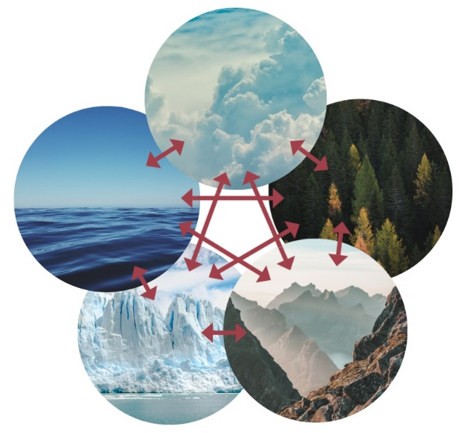 Image: Climate System Credit: Femkemilene
Source: Own work License: CC BY-SA 4.0

Instructions for Parents/Guardians
- Refer to your student’s score report to determine their instructional needs level—green, yellow, or red—for this performance category.
- Use the Interpretive Guidance (see pages 2-3) to understand what your student likely knows and is able to do based on their instructional needs level.
- Use the Family Resources and Recommendations (see pages 4-6) to engage with and support your student’s science learning at home.

Interpretive Guidance for Performance Category 2:
Design the Best Solution to a Problem Involving Human Impacts on Earth Systems
Red (0-4 score points earned)  - Extensive additional instruction and reteaching of these skills is recommended.  - The student needs significant opportunities to reinforce and apply these skills in future learning. | Yellow (5-8 score points earned)  - Moderate additional instruction on these skills is recommended.  - The student needs additional opportunities to strengthen these skills in future learning. | Green (9-11 score points earned)  - Minimal to no additional instruction on these skills is recommended.  - The student is ready to extend these skills in future learning.
What These Results Mean
This student is likely able to:  - Select or partially describe a design solution to a problem related to the impact of human activity on the environment supported with limited or unrelated evidence.  - Attempt to create a solution that addresses few or no constraints to a problem involving human impacts on Earth systems.  - Recognize and apply some of the criteria or constraints of the problem to partially explain a benefit of a solution.  - Attempt to describe a method or data needed to test the functioning of a design solution with limited connection to relevant criteria or constraints of the problem. | This student is likely able to:  - Evaluate and explain the relative usefulness of a design solution to limit the impact of human activity on the environment supported with some relevant evidence to most specified design parameters.  - Apply information to create a solution that appropriately addresses some design constraints to a problem involving human impacts on the environment and accurately compare which solutions support a design problem or which do not.  - Apply scientific ideas to solve design problems involving human impacts on the environment and explain why some criteria are chosen over others.  - Describe an appropriate method for testing a design solution and the data needed to draw conclusions about the functioning of the design solution. | This student is likely able to:  - Accurately evaluate and articulate the relative usefulness of a design solution by effectively utilizing evidence relevant to all specified design parameters.  - Appropriately combine and synthesize information to create a solution that completely and accurately addresses all design constraints to a problem involving human impacts on the environment and accurately determine which solutions support a design problem and which do not.  - Apply scientific ideas to solve design problems involving human impacts and correctly explain why some criteria are chosen over others in light of relevant constraints.  - Describe an appropriate and systematic method for testing the functioning of a proposed solution and accurately describe the expected patterns or trends in data that reflect a successful solution.

Family Resources and Recommendations for Performance Category 2:
Design the Best Solution to a Problem Involving Human Impacts on Earth Systems
Resources and Recommendations to Support Science Learning at Home
Engage in the Topic  Why is Earth’s water system important to preserve?  How do humans impact Earth’s water system? | Watch this video [1:50] with your student.  - Make a list of at least five ways you have used water or something produced with water in the last 24 hours.  Discuss the following with your student: Humans can negatively and positively impact natural resources like water. What are some examples, both positive and negative?  Imagine you are an environmental engineer working for your town. A new shopping center and recreation center are being built on an empty field that was once a park. Your job is to research how this could impact the water supply in and around your town and propose a design plan.
Explore the Topic  How do buildings and large concrete paved areas impact water resources? | Watch this video [1:32] with your student. Why would stormwater runoff concern you as an environmental engineer on this project? (The shopping and recreation center will cover the ground, and water will have to run into storm drains. Stormwater can have a negative impact on the environment.)  - Encourage and support your student to gather information to understand how stormwater runoff can impact your town. Print or draw a Three Column Chart for a notetaking organizer.  - Label each column in the chart with the following research questions: 1. What is the problem? 2. Who has the problem? 3. Why is it important to solve?  Watch Video 1 [2:13] and read Article 1 with your student [Sections: Why is Green Infrastructure Important?; Stormwater Runoff; and Stormwater Pollution]. Take notes in the three columns of the table to answer the guiding research questions.
Explain the Topic  Why is stormwater runoff an important consideration for environmental engineers? | Have your student use the information from their completed table to explain why stormwater runoff is important to environmental engineers. Students can summarize the information aloud or in writing. (Example: Stormwater runoff is a fast-growing source of pollution in the U.S. It happens in paved areas because there is nowhere for the water to soak into the ground. This is a problem for the builders, the townspeople, and the surrounding areas. It is important to solve this problem because stormwater can cause flooding and pollute waterways, making them dangerous for people and the environment.)
Explore the Topic  How can data be used to show the problem with stormwater runoff? | Watch the following videos with your student: Video 2 [1:31 – 2:39 AND 3:32 – 5:52] and Video 3 [3:07]. The videos show two different investigations involving stormwater runoff. (Explain to students that spawning is when the salmon come to the location to lay their eggs.)  - Use a Venn Diagram to gather data from the investigations shown in the videos.  - Capture notes from Video 2 in the left circle and Video 3 in the right circle. Use the overlapping center to combine similar data and ideas shared in both videos.  - Have your student use the information from their completed Venn Diagram to answer this question: How can you, the engineer, use the data from these investigations to design a solution to the problem?  (When defining the problem, I can show the environmental impact. One hundred percent (100%) of the fish in the polluted water died, and one hundred percent (100%) survived in the water filtered through a soil system. This applies to other living things. This shows that most water ran off the cemented area, and less ran off in the area with bushes. This relates to the concrete sidewalks and parking lots.)
Extend the Topic  Can engineers design solutions to slow or stop stormwater runoff? | Many communities are turning to green infrastructure to solve water runoff problems. Green infrastructure refers to humans using nature in a system to solve environmental issues. When engineers research problems to be solved, they look at solutions already designed. Watch this video [2:11] with your student and read about types of green infrastructure in this article (scroll down to the examples). Have your student draw a design using two or more solutions for the shopping/rec center and explain why they chose these solutions.

Resources
- Water Facts! – Infographics
[https://www.youtube.com/watch?v=PjSUg6JsLYw]
- What Is Stormwater? – YouTube
[https://www.youtube.com/watch?v=nmUFg37bGrw]
- Three Column Chart – PDF
[https://mccleskeyms.typepad.com/files/threecolumnchart.graphico.pdf]
- Where Does Stormwater Go? - ACT Healthy Waterways
[https://www.youtube.com/watch?v=BliZY3k_u1w]
- Green Infrastructure: How to Manage Water in a Sustainable Way - Natural Resources Defense Council, [https://www.nrdc.org/stories/green-infrastructure-how-manage-water-sustainable-way#whatis]
- Solving Stormwater – YouTube
[https://www.youtube.com/watch?v=1JDsFJJJHSY]
- The Runoff Experiment - Chesapeake Bay Foundation
[https://www.youtube.com/watch?v=sG7lcSOO-k4]
- Venn Diagram - Student Handouts.com
[https://www.studenthandouts.com/00/200811/venn2.pdf]
- Types of Green Infrastructure - Complete Communities
[https://www.youtube.com/watch?v=_9z_dD6hTM8&t=22s]
- What is Green Infrastructure – EPA
[https://19january2017snapshot.epa.gov/green-infrastructure/what-green-infrastructure_.html]

