
Coherence and Alignment Among Science Curriculum, Instruction, and Assessment (CASCIA) Project

Grade 5 Unit 3: Earth Systems and the Solution of Water Problems

Scoring and Reporting Workbook Instructions

June 2025

Grade 5 Unit 3: Earth Systems and the Solution of Water Problems, Scoring and Reporting Workbook Instructions was developed with funding from the U.S. Department of Education under the Competitive Grants for State Assessments Program CFDA 84.368A. The contents of this paper do not represent the policy of the U.S. Department of Education, and no assumption of endorsement by the Federal government should be made.
All rights reserved. Any or all portions of this document may be reproduced and distributed without prior permission, provided the source is cited as: Coherence and Alignment Among Science Curriculum, Instruction, and Assessment (CASCIA) Project. (2025). Grade 5 Unit 3: Earth Systems and the Solution of Water Problems, Scoring and Reporting Workbook Instructions. Lincoln, NE: Nebraska Department of Education.

Introduction
The scoring and reporting workbook is designed to help educators efficiently manage and communicate results from the Grade 5 Unit 3 End-of-Unit (EOU) Science Assessment: Matter and Its Interactions. Educators can use the workbook to enter individual student scores, generate Individual Student Reports (ISRs), compile a Classroom Roster Report (CRR), and send reports to parents or guardians via email. These tools support educators in making timely, informed instructional decisions and promoting effective communication with families.
This guide provides step-by-step instructions on how to access the scoring and reporting workbook on Google Drive, enter students’ scores, and generate both individual student reports and a classroom roster report. It also explains how to use the workbook to email individual score reports directly to parents or guardians.

Accessing the Grade 5 Scoring and Reporting Workbook
To generate student reports, you’ll first need to create your own copy of the scoring and reporting workbook and authorize the script that enables automated report generation. Follow the steps below to set up the workbook in your Google Drive and grant the necessary permissions.
Step 1: Click on this link.
Step 2: Click on “Make a copy”
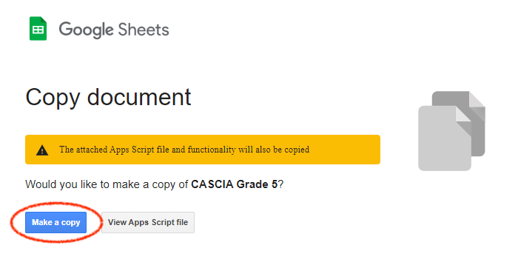
Important Note: The file will be placed on your Google Drive. You can rename the file if needed.

Step 3: Open the file and go to the “Student Result” tab.
Step 4: Click “Generate Student Report”
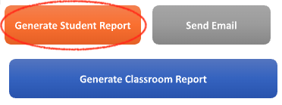
Step 5: Click “Continue”
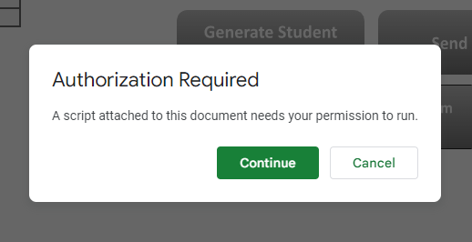

Step 6: Click on your account.
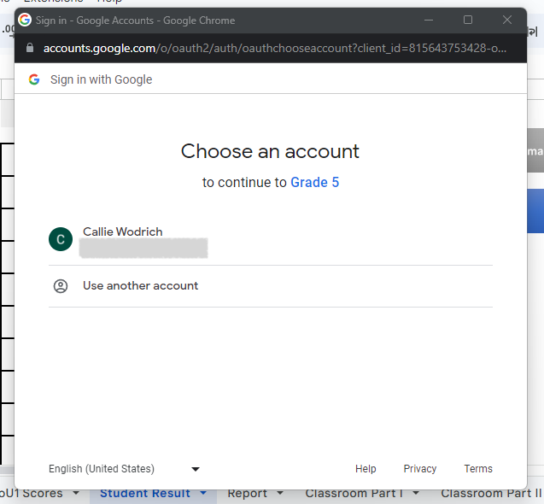
Step 7: Click “Advanced”
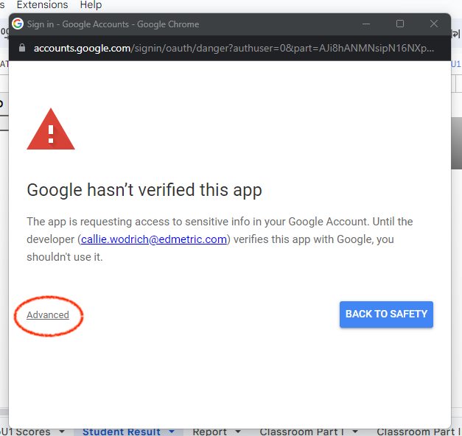

Step 8: Click “Go to Grade 5 (unsafe)”
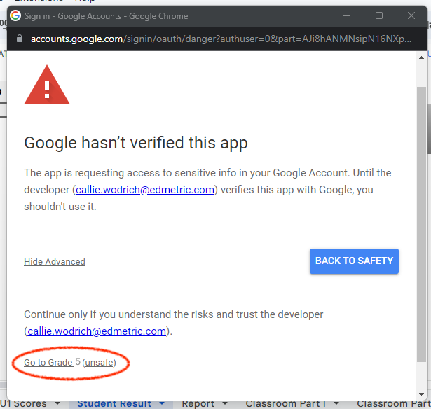
Step 9: Click “Allow”
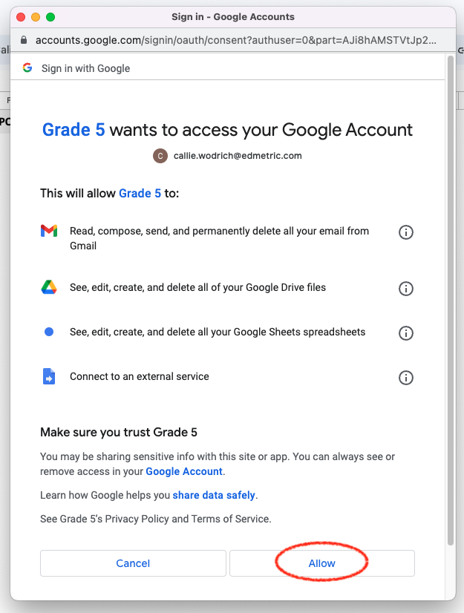

Preparing the Workbook: Inputting Student Information and Scores
Before generating reports or using the email feature, you must first populate key data in the workbook. This includes adding student names and parent/guardian emails (if applicable) and entering student assessment scores. Accurate and complete data entry ensures that individual student reports and the classroom roster report reflect each student’s performance and can be shared appropriately with families. Follow the steps below to set up the workbook for scoring and reporting.
Complete the Parent/Guardian Emails Sheet
Navigate to the “Parent/Guardian Emails” sheet and complete the following:
- Column A – Student Name: Use Rows 2-31 to enter each student's full name (first and last).
- Column B – Parent/Guardian Emails: If using the email feature, enter each parent or guardian’s email address next to their student’s name. Separate multiple addresses with a semicolon and space (e.g., parent1@email.com; parent2@email.com).
Note:
- If not using the email feature, you still must complete Column A with student names.
- Do not enter email addresses for students who did not complete the entire assessment.
- Reports should only be generated for students who completed all three tasks of the EOU3 assessment. Do not generate or send reports for students who were absent for any part.
Enter Student Scores in the “EoU3 Scores” Sheet
Use the EOU3 Assessment Scoring Guide to evaluate student responses. Then, enter data into the “EoU3 Scores” sheet:
- Column A – Student Name: Auto-populated from the “Parent/Guardian Emails” sheet.
- Column B – Present/Not Present:
  - Select "Present" if the student completed the full assessment.
  - Select "Not Present" if the student missed any part.
- Column C – Administration Notes: Optional. Use to document accommodations, behavior, attendance, etc.
- Columns D–M – Prompt Scores:
  - Leave cells blank if the student was “Not Present.”
  - Select "No Response" if the student attempted the assessment but skipped a prompt.
  - Enter scores using dropdowns per the scoring rubric.
  - Use "0" if a student attempted but earned no credit.
- Column N – Teacher Name: Enter your name in each row. Max: 30 characters.
- Column O – School Name: Enter the school name in each row. Max: 30 characters.
- Column P – Date: Enter the date in MM/DD/YYYY or Month D, YYYY format. This date appears on each student's report.
Note:
- Only students marked “Present” will have reports generated.

Generating and Sharing Student Reports
Once all student information and scores have been entered, you’re ready to generate the individual student reports (ISRs) and the classroom roster report (CRR). These reports provide meaningful feedback on student performance and support instructional planning. You can also use the workbook’s built-in email feature to send each student’s report directly to their parent(s) or guardian(s). Follow the steps below to generate and distribute the reports efficiently. Please note that reports should only be created and shared for students who completed the entire assessment.
Generate Student and Classroom Reports
Navigate to the “Student Result” sheet.
Individual Student Report (ISR)
- Click “Generate Student Report.”
- If prompted by Google, click “Continue > Choose your account > Advanced > Go to Grade 5 (unsafe) > Allow”.
- Return to the sheet and click “Generate Student Report” again.

- A Grade 5 Student Report folder will appear in your Google Drive, containing PDFs organized by school and student.
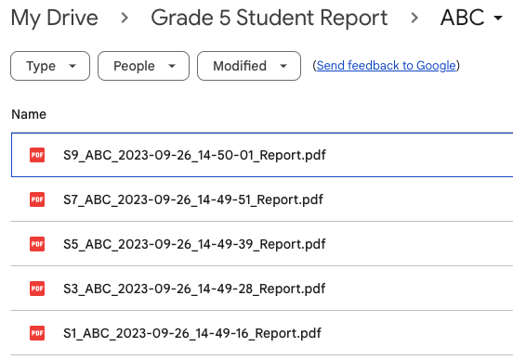
Note: Only students marked as “Present” will have reports generated.
Classroom Roster Report (CRR)
- On the same “Student Result” sheet, click “Generate Classroom Report.”
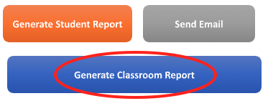
- Once completed, a Grade 5 Classroom Report folder will be created in your Drive with the compiled classroom PDF.
Note: The student ID in cell “D1” does not affect CRR generation.
Send Individual Reports via Email (Optional)
To use the email feature:
- In the “Student Result” sheet, select the student’s name from the dropdown in cell “D1”.
  - The corresponding email(s) from the “Parent/Guardian Emails” sheet will auto-populate in cell “H2”.
- Click “Send Email.”
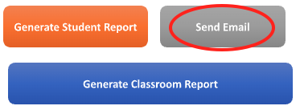
- Repeat for each student.
Important: Only send emails for students marked as “Present.” Students who missed any part of the assessment should not receive a report.
Email Message Sent to Parents/Guardians
Subject: Your Student’s Grade 5 Science Assessment Report
Dear Parent/Guardian,
The attached report summarizes your student’s recent performance on the Grade 5 Unit 3 Science Assessment, “Earth Systems and the Solution of Water Problems.” This report provides guidance for interpreting your student’s results and offers learning resources to support your student’s science learning at home.
This assessment is the third of four quarterly assessments your student will complete this school year. Results from this quarterly assessment will be used to monitor your student’s progress and plan meaningful learning opportunities to ensure your student is on track to achieve end-of-year learning goals in science.
Please contact your student’s science teacher if you have questions regarding your student’s assessment results.
Additional Reminders
- Do not use the Send Email feature for students marked “Not Present.”
- The “Teacher” and “School” names must not exceed 30 characters or they will be cut off on reports.
- Only one student report can be emailed at a time.

