Coherence and Alignment Among Science Curriculum, Instruction, and Assessment (CASCIA)  Grade 5 Unit 2  End-of-Unit Assessment  Task Interpretation Guide  October 2023  The Grade 5 Unit 2 End-of-Unit Assessment Task Interpretation Guide was developed with funding from the U.S. Department of Education under the Competitive Grants for State Assessments Program, CFDA 84.368A. The contents of this guide do not represent the policy of the U.S. Department of Education, and no assumption of endorsement by the Federal government should be made. |  |   All rights reserved. Any or all portions of this document may be reproduced and distributed without prior permission, provided the source is cited as: Coherence and Alignment Among Science Curriculum, Instruction, and Assessment (CASCIA) Project. (2023). Grade 5 Unit 2 End-of-Unit Assessment Task Interpretation Guide. Lincoln, NE: Nebraska Department of Education.

Table of Contents
Introduction 1
Purpose 1
Contents 2
SIPS Grade 5 Unit 2 EOU Assessment Task 1: What it Takes to Grow 3
Task 1 Prompt 1 3
Task 1 Prompt 2 5
Task 1 Prompt 3 – Parts A and B 7
SIPS Grade 5 Unit 2 EOU Assessment Task 2: Our Friend the Worm 11
Task 2 Prompt 1 – Part A 11
Task 2 Prompt 1 – Part B 14
Task 2 Prompt 2 16
Task 2 Prompt 3 – Parts A and B 18
SIPS Grade 5 Unit 2 EOU Assessment Task 3: Cycling Through a System 22
Task 3 Prompt 1 22
Task 3 Prompt 2 – Part A 24
Task 3 Prompt 2 – Part B 28
Task 3 Prompt 3 30

Introduction  The use of formative assessment practices, with informative and immediate feedback that leads to adjustments to instructional next steps, has been shown to be effective in helping students learn (Black & Wiliam, 1998; Wylie & Lyon, 2009; Heritage, 2010). Interim or large-scale summative assessments, such as those required under the Every Student Succeeds Act of 2015 (ESSA), cannot and are not meant to inform daily instruction because of how and when they are administered. These forms of assessment can bring value to an assessment system, but only if coordinated and meaningfully aligned within a comprehensive, coherent system.  The Coherence and Alignment Among Science Curriculum, Instruction, and Assessment (CASCIA) Project brings together three partner states—Nebraska, Alabama, and Alaska—with a team of researchers and experts to establish science assessment resources that are coordinated and aligned across all parts of the assessment system. With coherence as the guiding principle, these state-level educators and national science education and measurement experts have joined with hundreds of local educators to address states’ need for quality, standards-aligned science assessments that generate meaningful, interpretable, and actionable results, and to design a scoring and score reporting framework that builds educators’ capacity to track, interpret, and communicate students’ learning in science and to offer effective instruction for all students.  Purpose  The purpose of the Grade 5 Unit 2 End-of-Unit Assessment Task Interpretation Guide is to support educators’ understanding of the Grade 5 Unit 2 End-of-Unit assessment tasks and prompts, their features, and the evidence (i.e., knowledge and skills) they are designed to elicit about student learning, and how the assessment and the information it provides can be used to plan instruction and learning opportunities for students, whether it involves planning for instruction prior to teaching the instructional unit, reflecting on the quality and sufficiency of prior instruction and instructional materials or planning additional student |  | learning opportunities or interventions in the subsequent unit (e.g., SIPS Unit 3).  The Grade 5 Unit 2 Science Assessment includes three science tasks, each including multiple scorable prompts. Task 1, What it Takes to Grow, includes three prompts and 10 possible score points; Task 2, Our Friend the Worm, includes three prompts and 11 possible score points with two of the three prompts having two parts—Part A and Part B; Task 3, Cycling Through a System, includes three prompts and 13 possible score points, with one prompt having a Part A and Part B.  Prompts from the three tasks that measure similar combinations of dimensions (i.e., Disciplinary Core Ideas, Science and Engineering Practices, and Crosscutting Concepts) from the Next Generation Science Standards (NGSS) are organized into three performance categories. The NGSS Performance Expectations (PEs) are addressed in one or more performance categories to provide multiple opportunities to demonstrate flexible thinking and competency in different situations and contexts.
  Performance Category | NGSS PEs | Prompts in Performance Category | Points Possible
  Support Arguments  About Energy and  Matter Flow Among  Plants and Animals | 5-LS1-1  5-LS2-1  5-PS3-1 | Task 1, Prompt 1  Task 1, Prompt 2  Task 3, Prompt 3 | 11 points
  Model Relationships  in Ecosystems | 5-LS2-1 | Task 2, Prompt 1A  Task 2, Prompt 1B  Task 2 Prompt 2  Task 3, Prompt 1 | 11 points
  Model Energy and  Matter Flow Among  a System of Plants,  Animals, and  Decomposers | 5-LS1-1  5-LS2-1  5-PS3-1 | Task 1, Prompt 3  Task 2, Prompt 3  Task 3, Prompt 2A  Task 3, Prompt 2B | 12 points
Contents  This document includes interpretive guidance to support educators’ understanding of each prompt on the Grade 5 Unit 2 EOU Assessment, its features, and the evidence it is designed to elicit about students’ learning, and offers important connections to the learning goals, formative assessment opportunities, and lesson descriptions within the SIPS Grade 5 Unit 2 Map / Instructional Framework as well as connections to future learning opportunities in the next unit.  For each prompt, the following information is provided:  - Performance Category – A classification of prompts within the EOU based on similarities in knowledge, skills, and abilities for which the prompts were designed to measure.  - Acquisition Goals – Specific goals that describe what students should understand, know, and be able to do at the end of a unit or course of instruction. The acquisition goals are derived from Stage 1 of the unit map / instructional framework that the prompt is intended to measure.  - Prompt Knowledge and Skills for Measurement – The evidence of student learning the prompt is designed to elicit.  - Prompt and Exemplar Response – The prompt consists of one to three sentences that raises an issue or asks a question to which students need to respond. An exemplar response represents a high-quality response that provides evidence that students have demonstrated the knowledge, skills, and abilities assessed by the prompt. Student exemplars are intended to assist in understanding the nature and expectations of the prompt. However, students may respond with other relevant scientifically accurate responses, evidence, observations, and ideas.  In general, a full-point exemplar response meets expectations and is:  - scientifically accurate  - complete  - coherent |  | - consistent with the type of student evidence expected as described in the rubric  For examples of student responses for each prompt representative of the full range of score points possible based on the scoring rubric, access the Grade 5 Unit 2 EOU Assessment Scoring Guide.  - Prompt Complexity – The sophistication of students’ ability to demonstrate sense-making is characterized by their ability to (a) use disciplinary core ideas (DCIs), scientific and engineering practices (SEPs), and crosscutting concepts (CCCs) together in the service of sense-making about a phenomenon or problem, and (b) engage with and respond to items and tasks designed using variable features representing combinations of Low, Moderate, and High complexity designations. These combinations of features are based on the SIPS Complexity Framework.  Adapted from the Cambridge Alignment Methodology (Forte, 2021) and informed by aspects of Achieve’s Framework to Evaluate Cognitive Complexity in Science Assessments (Achieve, 2019), the SIPS Complexity Framework is grounded in sense-making and students’ ability to flexibly apply knowledge through the integration of the same and new/different combinations of dimensions within the PEs from a unit bundle, in the context of a phenomenon or phenomenon-rooted design problem based on the focal DCIs.  - Prompt Connections to the Unit Map / Instructional Framework – A high-level overview of the evidence elicited by the prompt related to the acquisition goals, connections to the instructionally-embedded formative assessment opportunities within stage 2 of the unit map, and connections to opportunities to learn based on the lesson descriptions within stage 3 of the unit map.  For each of the three tasks, the following information is provided:  - Connections to Future Learning Opportunities – The knowledge, skills, and abilities elicited by the prompt that can be leveraged and extended in future learning. Unit connections highlight where and how an educator can emphasize connections for students in the next unit.
SIPS Grade 5 Unit 2 EOU Assessment Task 1: What it Takes to Grow  Task 1 Prompt 1  Performance Category: Support Arguments About Energy and Matter Flow Among Plants and Animals  Acquisition Goals  - A2: Analyze and interpret data to determine the role of food in growth and repair. *  - A15: Support an argument that plants get the materials they need for growth chiefly from air and water. [5-LS1-1]  Prompt 1 measures the students’ ability to:  - Support an argument with evidence, data, or a model to explain how plants get the materials they need for growth chiefly from air and water.  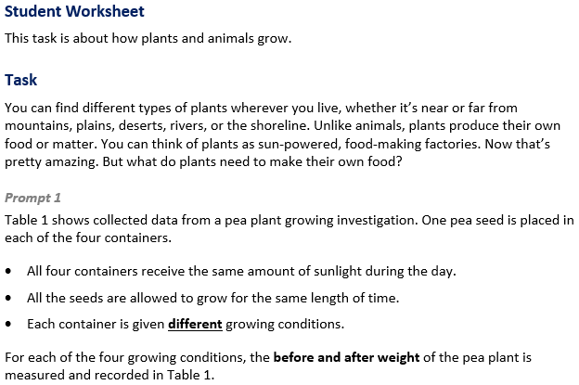 |  | 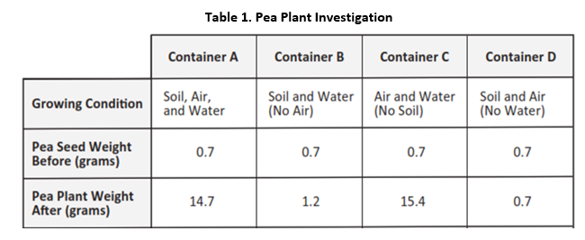  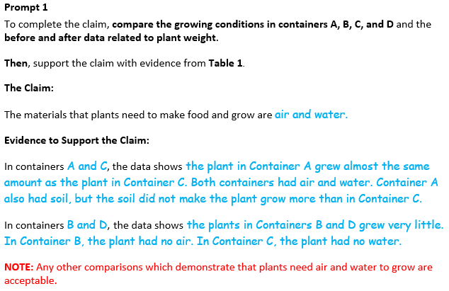
  Task 1 Prompt 1 Complexity
  Degree and Nature of Sensemaking | Moderate | This task…  - Requires integration of two dimensions in the service of sense-making
  Complexity of the Presentation | Moderate | - The amount and type of information provided in the scenario supports multiple evident connections among ideas or concepts  - Provides graphics/data/models
  Cognitive Demand of Response Development | Moderate | - Requires drawing relationships and connecting ideas and practices  - Requires a moderate level of sophistication with typical and relatively complex representation of ideas and application of skills
  Cognitive Demand of Response Production | Moderate | - Response includes one or more sentences or a paragraph
  Task 1 Prompt 1 Connections to the Instructional Framework
  Integration of Knowledge and Skills for Response Development
  - Students use the table to make a claim that plants get material for growth chiefly from air and water.
  - Students use weight differences as an indicator of plant growth.
  - Students analyze differences in environments between growing plants to show air and water are required for growth.
  - Students obtain evidence to show water weight changes more than soil weight during the experiment.
  - Students conclude that water is utilized more than soil in plant growth due to the differences in weight.
  - Students use that conclusion to support the claim that plants get their material for growth chiefly from air and water.
  - Students use their conclusion that water is utilized more than soil in plant growth due to the differences in weight, to support the conclusion that plants get the materials they need for growth chiefly from air and water.
  Formative Assessments | Opportunities to Learn
  Segment 1, pp. 8-9  Informal Assessment: The Role of Food in Growth, Repair, & Energy (A2)  - Students describe patterns in data related to the role of food in an animal’s growth and/or repair.  - Students use data to answer questions about the role of food in an animal’s growth and/or repair. | Segment 1, p. 20  Matter Matters (A2)  (Owl Pellet Dissection)  - Students use pellets to show that animals get matter from food to grow and survive.  - Students utilize weight differences as indicators for growth of organisms.  - Students compare data from investigation to informational text to show animals get the matter they need from their food.
 |  | Task 1 Prompt 2  Performance Category: Support Arguments About Energy and Matter Flow Among Plants and Animals  Acquisition Goals  - A17. Engage in argument from evidence about the role of air and water in the process of making food by plants. *  Prompt 2 measures the students’ ability to:  - Support an argument with evidence, data, or a model to explain how matter and/or energy cycles among plants and animals.  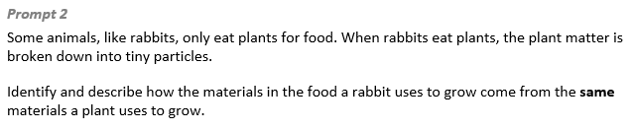  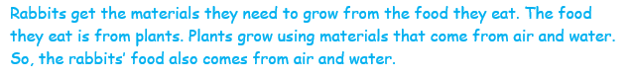
  Task 1 Prompt 1 Connections to the Instructional Framework
  Formative Assessments | Opportunities to Learn
  Segment 2, p. 11  Informal Assessment: Asking Questions about the Relationship between Food and Growth in Plants (A15)  Use this assessment to gauge students’ ability to:  - Identify information that describes the relationship between food and growth in plants.  - Describe patterns in data related to the role of sunlight in the process of making food by plants.  - Use observations and data to generate a conclusion about the role of air and water in plant growth. | Segment 2, p. 24  What do Plants Need to Survive? (A15)  - Students verify their understanding of plant needs by reading informational texts and comparing the information to investigation results. After conducting their research, students present evidence that either supports or refutes their findings from the plant experiments.
  Task 1 Prompt 2 Complexity
  Degree and Nature of Sensemaking | Low | This prompt…  - Requires one or two dimensions  - One dimension may have a greater degree of emphasis than another  - Requires previously learned ideas or concepts
  Complexity of the Presentation | Low | - The amount and type of information provided in the scenario supports limited simple connections among ideas or concepts  - Phenomenon or problem presented in a concrete way with high level of certainty
  Cognitive Demand of Response Development | Moderate | - Requires drawing relationships and connecting ideas and practices  - Response requires a moderate level of sophistication with typical but relatively complex representation of ideas and application of skills
  Cognitive Demand of Response Production | Moderate | - Response includes one or more sentences or a paragraph, a moderately complex graphic, or multiple steps in a simple or moderately complex process
  Task 1 Prompt 2
  Connections to the Instructional Framework
  Integration of Knowledge and Skills for Response Development
  - Students identify the evidence that supports the provided claim that plants and animals both use the same materials for growth.
  - Students determine if the evidence that they have identified supports the provided claim that plants and animals use the same materials for growth.
  - Students conclude that matter and/or energy cycles among plants and animals and that plants grow using materials that come from air and water.
  - Students use their conclusion that matter and/or energy cycles among plants and animals to explain that rabbits get energy (or materials they need to grow) from the food they eat (plants), which is grown using air and water.
  Formative Assessments | Opportunities to Learn
  Segment 2, pp.12-13  Formal Assessment: Conditions for Plant Growth (A17)  - Students identify and use evidence, data, or a model to support an argument that plants acquire the materials they need for growth chiefly from air and water. | Segment 2, p. 24  What do Plants Need to Survive? (A17)  - Students verify their understanding of plant needs by reading informational texts and comparing the information to investigation results. After conducting their research, students present evidence that either supports or refutes their findings.
Task 1 Prompt 3 – Parts A and B  Performance Category: Model Energy and Matter Flow Among a System of Plants, Animals, and Decomposers  Acquisition Goals  - A9. Analyze and interpret data to determine the role of sunlight in the process of making food by plants.  - A10. Engage in argument from evidence about the role of sunlight in the process of making food by plants.  - A14. Use models to describe that energy in animals’ food (used for body repair, growth, motion, and to maintain body warmth) was once energy from the sun. [5-PS3-1] *  - A16. Develop a model to describe the movement of matter among plants, animals, decomposers, and the environment. [5-LS2-1] *  Prompt 3 measures students’ ability to:  - Develop or use models to support descriptions and predictions of relationships about sunlight as the original source of energy for all life on Earth. |  | 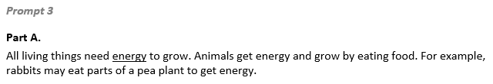  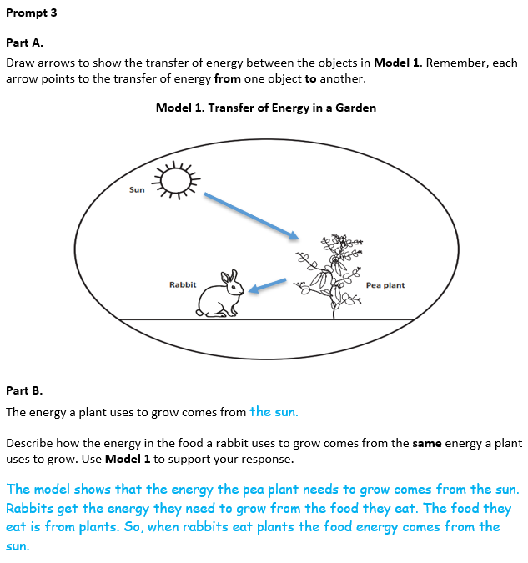
  Task 1 Prompt 3 Complexity
  Degree and Nature of Sensemaking | Moderate | This prompt…  - Requires integration of two dimensions in the service of sense-making
  Complexity of the Presentation | Moderate | - The amount and type of information provided in the scenario supports multiple evident connections among ideas or concepts  - Provides graphics/data/models  - Phenomenon or problem presented with some level of uncertainty
  Cognitive Demand of Response Development | Moderate | - Requires application of ideas and practices given cues and guidance  - Requires drawing relationships and connecting ideas and practices
  Cognitive Demand of Response Production | Moderate | - Response includes one or more sentences or a paragraph, a moderately complex graphic, or multiple steps in a simple or moderately complex process
  Task 1 Prompt 3
  Connections to the Instructional Framework
  Integration of Knowledge and Skills for Response Development
  - Students are provided a description of a produce and herbivore relationship and identify sunlight as the rabbit’s original energy source.
  - Students complete a model using arrows to show the transfer of energy across the components of the model.
  - Students interpret the model to show the cause/effect of the transfer of energy among its components.
  - Students use the model to show that through a chain of events that begins with plants, sunlight is the original source of energy for the rabbit.
  Formative Assessments | Opportunities to Learn
  Segment 2, p. 11  Informal Assessment: Asking Questions about the Relationship between Food and Growth in Plants (A9) / Formal Assessment: Conditions for Plant Growth (A9, A10)  - Students describe patterns in data related to the role of sunlight in the process of making food by plants.  - Students use data to answer questions related to the role of sunlight in the process of making food by plants. | Segment 2, p. 23  Conditions for Plant Growth (A9, A10, A14)  - Students are given seeds for garden plants and read what information is included in the packets about sunlight, water, soil, etc.  - Students are presented with seedlings they watch over time and track their growth. Students pick a variable, such as sunlight, and see how it affects seedling growth.  - Students engage in observations and gather data to address the needs of plants for growth and present their data to the class.
Task 1 Prompt 3
Connections to the Instructional Framework, Continued
Formative Assessments | Opportunities to Learn
Segment 2, pp. 12-13  Formal Assessment: Conditions for Plant Growth (A9, A10)  - Students use evidence, data, or a model to support an argument about the role of sunlight in the process plants use to make food.  - Students develop a model that can be used to show that plants get materials and energy they need for growth chiefly from air, water, and sunlight.  Segment 2, p. 15  Formal Assessment: Where Does the Energy and Matter an Owl Needs Come From? (A16)  - Students develop a model to describe the movement of matter among plants, animals, decomposers, and the environment.  - Students use models to show the cycling of matter in the system between plants, animals, decomposers, and the environment. | Segment 1, p. 22  The Importance of Plants in Food Webs (A14)  - Students return to their model of a food chain but expand it into a food web and learn that the foundation of the food web begins with the sun providing energy to plants.  Segment 2, p. 23  Where Does the Energy and Matter an Owl Needs Come From? (A14, A16)  - Students present and defend their models to the class based on matter and energy sources for plants and animals.

Future Learning Connected to evidence elicited in Task 1
Crosscutting Concepts
- In Unit 2, data analysis is confined to closed systems. Students use changes in weight to make claims about changes in plant growth. In Unit 3, Acquisition Goal 11 requires students to analyze how two systems interact. Students create a terrarium that includes four spheres. Students leverage prior knowledge about one system to analyze this more complex system (Earth’s Spheres in a Terrarium, p. 42).
Disciplinary Core Ideas
- In Unit 2, students grow plants in different conditions to analyze which variable most impacts plant growth. In Unit 3, Acquisition Goal 17 requires students to design an investigation to determine how various techniques can filter dirty water. Students leverage prior knowledge that water is central to plant growth to connect the idea that water filtration impacts growth of organisms and the health of ecosystems (You are What You Drink, pp. 36-37).
- In Unit 2, students discuss the importance of the sun for the growth of one organism or the functioning of one ecosystem. In Unit 3, Acquisition Goal 12 requires students to build terrariums to model the tandem functioning of four spheres. Students leverage prior knowledge of the sun’s role in matter and energy cycling to show the sun’s role in driving each of the four spheres (Earth’s Spheres in a Terrarium, p. 42).
Science and Engineering Practices
- In Unit 2, students develop models to show the cycling of matter and/or energy through an ecosystem. In Unit 3, Acquisition Goal 19 requires students to develop models in the form of terrariums and their school’s water usage system. Students expand their modeling from one system operating at a time to multiple systems operating simultaneously (Earth’s Spheres in a Terrarium, p. 42; Interaction of Earth’s Spheres, p. 42).

SIPS Grade 5 Unit 2 EOU Assessment Task 2: Our Friend the Worm  Task 2 Prompt 1 – Part A  Performance Category: Model Relationships in Ecosystems  Acquisition Goals  - A12: Develop a model to describe that matter cycles among living and non-living components within an ecosystem.  - A16. Develop a model to describe the movement of matter among plants, animals, decomposers, and the environment. [5-LS2-1]  Prompt 1 Part A measures students’ ability to:  - Develop or use models to support descriptions and predictions of relationships about the movement of matter among plants, animals, and decomposers. |  | 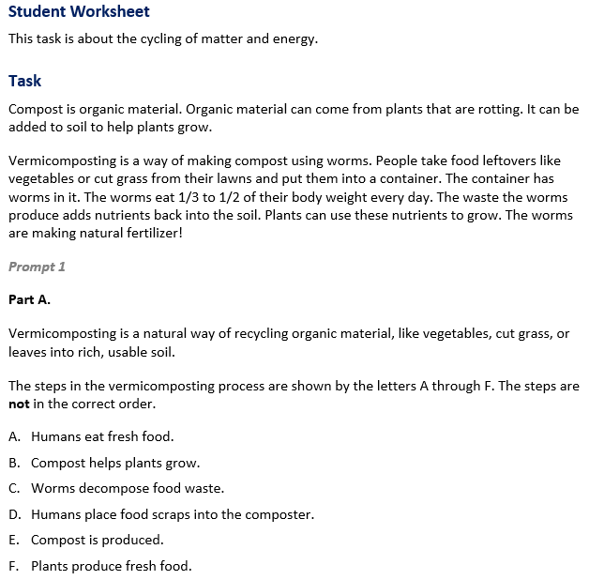

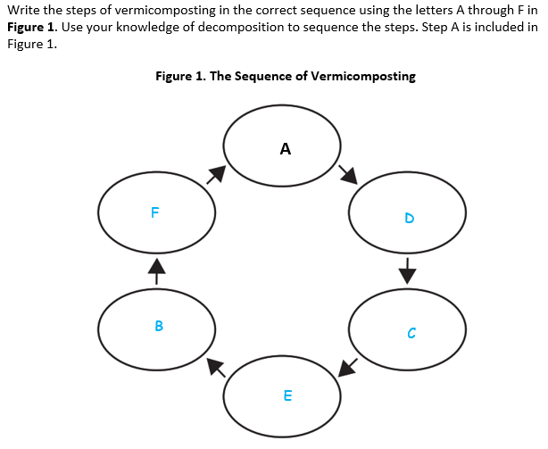
  Task 2 Prompt 1 Part A Complexity
  Degree and Nature of Sensemaking | Moderate | This task…  - Requires integration of two dimensions in the service of sense-making  - Requires integration of same or different combinations of dimensions as represented in the PE bundle
  Complexity of the Presentation | Moderate | - The amount and type of information provided in the scenario supports multiple evident connections among ideas or concepts  - Provides graphics/data/models  - Limited use of definitions or examples
  Cognitive Demand of Response Development | Moderate | - Requires application of ideas and practices given cues and guidance  - Requires drawing relationships and connecting ideas and practices
  Cognitive Demand of Response Production | Low | - Responses include selection from a small set of options presented as text (e.g., word, short phrase) or other formats (e.g., or a simple graphic or process)
  Task 2 Prompt 1 Part A
  Connections to the Instructional Framework
  Integration of Knowledge and Skills for Response Development
  - Students review the provided informational text and model about vermicomposting.
  - Students use the provided information about vermicomposting and apply this definition to what they have learned about matter transfer between decomposers, plants, and animals.
  - Students complete the model identifying the cycling of matter between the components of the ecosystem (humans, plants, worms, and the environment.
  Formative Assessments | Opportunities to Learn
  Segment 3, pp. 13-14  Informal Assessment: Asking Questions about How Matter Moves through an Ecosystem (A12)  - Students use models to show how matter cycles among biotic and abiotic components within an ecosystem.  Segment 3, pp. 14-15  Formal Assessment: Movement of Matter Through an Ecosystem: Can You Show It? (A16)  - Students develop a model to describe the movement of matter among plants, animals, decomposers, and the environment.  - Students use models to show the cycling of matter in the system between plants, animals, decomposers, and the environment. | Segment 1, pp. 20-21  Matter Matters (A16)  - Through reading and discourse in the class or groups, students explore the idea that animals need to consume matter to grow and heal and that animals’ food sources provide this matter.
  Task 2 Prompt 1 Part A
  Connections to the Instructional Framework, Continued
  Formative Assessments | Opportunities to Learn
  Segment 3, pp. 15-16  Formal Assessment: Where Does the Energy and Matter an Owl Needs Come From? (A12, A16)  - Students develop a model to describe the movement of matter among plants, animals, decomposers, and the environment.  - Students use models to show the cycling of matter in the system between plants, animals, decomposers, and the environment.  Segment 3, pp. 16-17  Formal Assessment: Movement and Decomposition of Matter in an Ecosystem (A12)  - Students use models to show how matter cycles among biotic and abiotic components within an ecosystem. | Segment 3, pp. 24-25  Movement of Matter Through an Ecosystem: Can You Show It? (A12, A16)  - In this lesson, students learn about the types of matter that move among producers, consumers, and decomposers. The goal is for students to describe the movement of matter among plants, animals, and decomposers. At the end of the lesson, students develop a model (e.g., diagram) to describe how matter cycles among the living and nonliving components within an ecosystem, showing how organisms have biological needs which must be met within their ecosystems.  Segment 3, pp. 25-26  Where Does the Energy and Matter an Owl Needs Come From? (A12, A16)  - Having worked over the last several weeks on their explanatory models showing movement of matter through the ecosystem, students present and defend their models to the class.
Task 2 Prompt 1 – Part B  Performance Category: Model Relationships in Ecosystems  Acquisition Goals  - A12: Develop a model to describe that matter cycles among living and non-living components within an ecosystem.  - A16. Develop a model to describe the movement of matter among plants, animals, decomposers, and the environment. [5-LS2-1]  Prompt 1 Part A measures students’ ability to:  - Develop or use models to support descriptions and predictions of relationships about the movement of matter among plants, animals, and decomposers.  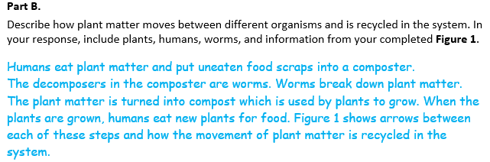
  Task 2 Prompt 1 Part B Complexity
  Degree and Nature of Sensemaking | Moderate | This prompt…  - Requires integration of two dimensions in the service of sensemaking  - Requires a combination of previously learned ideas or concepts and newly presented information
  Complexity of the Presentation | Low | - The amount and type of information provided in the scenario supports limited simple connections among ideas or concepts  - Phenomenon or problem presented in a concrete way with high level of certainty
  Cognitive Demand of Response Development | Moderate | - Requires drawing relationships and connecting ideas and practices  - Requires a moderate level of sophistication with typical and relatively complex representation of ideas and application of skills
  Cognitive Demand of Response Production | Moderate | - Response includes one or more sentences or a paragraph, a moderately complex graphic, or multiple steps in a simple or moderately complex process
  Task 2 Prompt 1 Part B
  Connections to the Instructional Framework
  Integration of Knowledge and Skills for Response Development
  - To explain what happens during decomposition, students interpret the model to show the cause/effect of the flow of the energy/matter.
  - Students use the model to describe the transfer of energy/matter and the relevance of the relationship between components across the model.
  Formative Assessments | Opportunities to Learn
  Segment 3, pp. 13-14  Informal Assessment: Asking Questions about How Matter Moves through an Ecosystem (A12)  - Students use models to show how matter cycles among biotic and abiotic components within an ecosystem.  Segment 3, pp. 14-15  Formal Assessment: Movement of Matter Through an Ecosystem: Can You Show It? (A16)  - Students develop a model to describe the movement of matter among plants, animals, decomposers, and the environment.  - Students use models to show the cycling of matter in the system between plants, animals, decomposers, and the environment. | Segment 1, pp. 20-21  Matter Matters (A16)  - Through reading and discourse in the class or groups, students explore the idea that animals need to consume matter to grow and heal and that animals’ food sources provide this matter.
  Task 2 Prompt 1 Part B
  Connections to the Instructional Framework, Continued
  Formative Assessments | Opportunities to Learn
  Segment 3, pp. 15-16  Formal Assessment: Where Does the Energy and Matter an Owl Needs Come From? (A12, A16)  - Students develop a model to describe the movement of matter among plants, animals, decomposers, and the environment.  - Students use models to show the cycling of matter in the system between plants, animals, decomposers, and the environment.  Segment 3, pp. 16-17  Formal Assessment: Movement and Decomposition of Matter in an Ecosystem (A12)  - Students use models to show how matter cycles among biotic and abiotic components within an ecosystem. | Segment 3, pp. 24-25  Movement of Matter Through an Ecosystem: Can You Show It? (A12, 16)  - In this lesson, students learn about the types of matter that move among producers, consumers, and decomposers. The goal is for students to describe the movement of matter among plants, animals, and decomposers. At the end of the lesson, students develop a model (e.g., diagram) to describe how matter cycles among the living and nonliving components within an ecosystem, showing how organisms have biological needs which must be met within their ecosystems.  Segment 3, pp. 25-26  Where Does the Energy and Matter an Owl Needs Come From? (A12, 16)  - Having worked over the last several weeks on their explanatory models showing movement of matter through the ecosystem, students present and defend their models to the class.
Task 2 Prompt 2  Performance Category: Model Relationships in Ecosystems  Acquisition Goals  - A11. Plan and carry out an investigation to obtain data about the role of decomposers within an ecosystem. *  - A20. Analyze and interpret data to make sense of the process of decomposition of matter, using logical reasoning.  - A16. Develop a model to describe the movement of matter among plants, animals, decomposers, and the environment. [5-LS2-1] *  Prompt 2 measures students’ ability to:  - Develop or use models to support descriptions and predictions of relationships about the role of decomposition in the cycling of matter, including restoring materials back to the soil.  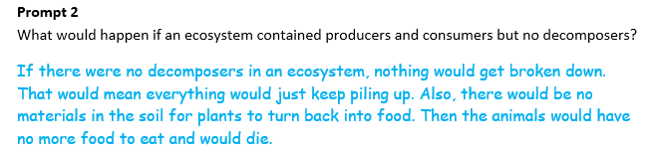
  Task 2 Prompt 2 Complexity
  Degree and Nature of Sensemaking | High | This prompt…  - Requires integration of three dimensions in the service of sensemaking  - Requires a combination of previously learned ideas or concepts and newly presented information
  Complexity of the Presentation | Low | - The amount and type of information provided in the scenario supports limited simple connections among ideas or concepts
  Cognitive Demand of Response Development | High | - Requires selection and application of multiple complex ideas and practices  - Requires high degree of sense-making, reasoning, and/or transfer
  Cognitive Demand of Response Production | Moderate | - Response includes one or more sentences or a paragraph, a moderately complex graphic, or multiple steps in a simple or moderately complex process
Task 2 Prompt 3 – Parts A and B  Performance Categories: Model Energy and Matter Flow Among a System of Plants, Animals, and Decomposers  Acquisition Goals:  - A14. Use models to describe that energy in animals’ food (used for body repair, growth, motion, and to maintain body warmth) was once energy from the sun. [5-PS3-1]  - A18. Develop a model to describe that plants get the materials and energy they need for growth chiefly from air, water, and sunlight.  Prompt 3 Parts A and B measure students’ ability to:  - Develop or use models to support descriptions and predictions of relationships about the ways energy is transferred between plants, animals, and decomposers in an ecosystem. |  | 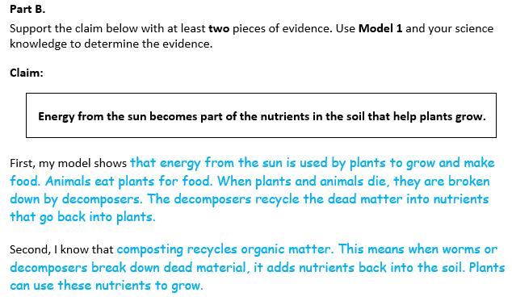  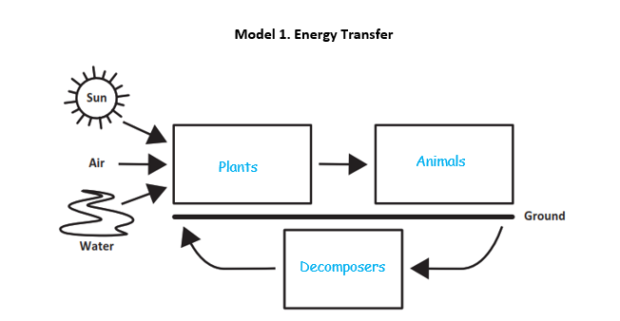  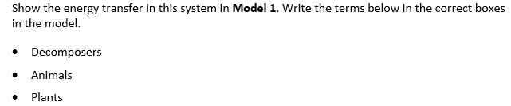  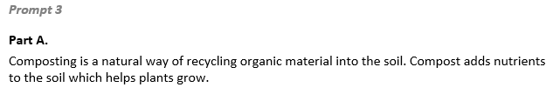
  Task 2 Prompt 2
  Connections to the Instructional Framework
  Integration of Knowledge and Skills for Response Development
  - Students interpret their model relating to the cause/effect of matter/energy transfer between decomposers, plants, and animals.
  - Students make a claim about the impact on the flow of energy/matter arising from the removal of decomposers from the ecosystem.
  - Students support their claim relating the process of matter and energy cycles from nutrients in the soil using evidence from the model.
  Formative Assessments | Opportunities to Learn
  Segment 3, pp. 15-16  Formal Assessment: Where Does the Energy and Matter an Owl Needs Come From? (A12, A16)  - Students use models to show the cycling of matter in the system between plants, animals, decomposers, and the environment. | Segment 3, p. 25  Matter Cycles through Decomposition: What’s the Breakdown? (A20)  - Students watch a video on decomposers and decomposition. As a whole class, students use what they saw in the video to predict what happens to a fruit that is left untouched for several weeks.  Segment 3, p. 25-26  Where Does the Energy and Matter an Owl Needs Come From? (A12, 16)  - Having worked over the last several weeks on their explanatory models showing movement of matter through the ecosystem, students present and defend their models to the class.
  Task 2 Prompt 2
  Connections to the Instructional Framework
  Formative Assessments | Opportunities to Learn
  Segment 3, pp. 16-17  Formal Assessment: Movement and Decomposition of Matter in an Ecosystem (A11, A16, A20)  - Students make observations and/or measurements to produce data about the role of decomposers within an ecosystem.  - Students identify information that shows the interactions in the system of plants, animals, and decomposers, in an environment that allows multiple species to meet their needs. | Segment 3, p. 26  Constructing an Ecosystem (A11, A20)  - Students attach two large plastic bottles to create a decomposition eco-column. Students revisit their understanding of living and nonliving factors within ecosystems and how plants and animals obtain and use energy to fulfill their needs.
  Task 2 Prompt 3 Parts A and B Complexity
  Degree and Nature of Sensemaking | High | This prompt…  - Requires integration of three dimensions in the service of sensemaking  - Requires a combination of previously learned ideas or concepts and newly presented information
  Complexity of the Presentation | Moderate | - The amount and type of information provided in the scenario supports multiple evident connections among ideas or concepts  - Provides graphics/data/models
  Cognitive Demand of Response Development | Moderate | - Requires drawing relationships and connecting ideas and practices  - Requires a moderate level of sophistication with typical and relatively complex representation of ideas and application of skills
  Cognitive Demand of Response Production | Moderate | - Response includes one or more sentences or a paragraph, a moderately complex graphic, or multiple steps in a simple or moderately complex process
  Task 2 Prompt 3 Parts A and B
  Connections to the Instructional Framework
  Integration of Knowledge and Skills for Response Development
  Part A
  - Students read the provided text to identify what is needed to complete the model.
  - Students interpret data and how it shows the cause/effect of the flow of energy.
  - Students develop a model to accurately represent the flow of energy between plants, animals, decomposers, and the environment.
  Part B
  - Students use the model to show that energy from the sun is transferred to animals through a chain of events involving plants, animals, and decomposers, and determine that the evidence in the model supports the claim.
  Formative Assessments | Opportunities to Learn
  Segment 2, pp. 11-12  Informal Assessment: Asking Questions about the Relationship between Food and Growth in Plants (A18)  - Students develop a model that can be used to show that plants get the materials and energy they need for growth chiefly from air, water, and sunlight. | Segment 1, p. 22  The Importance of Plants in Food Webs (A14)  - Students return to their model of a food chain but expand it into a food web and learn that the foundation of the food web begins with the sun providing energy to plants.
  Task 2 Prompt 3 Parts A and B
  Connections to the Instructional Framework, Continued
  Formative Assessments | Opportunities to Learn
  Segment 2, pp. 12-13  Formal Assessment: Conditions for Plant Growth (A18)  - Students develop a model that can be used to show that plants get materials and energy they need for growth chiefly from air, water, and sunlight. | Segment 2, p. 23  Conditions for Plant Growth (A14)  - Students are given seeds for garden plants and read what information is included in the packets about sunlight, water, soil, etc.  - Students are presented with seedlings they watch over time and track their growth. Students pick a variable, such as sunlight, and see how it affects seedling growth.  - Students engage in observations and gather data to address the needs of plants for growth and present their data to the class.  Segment 2, p. 24  What do Plants Need to Survive? (A18)  - Students verify their understanding of plant needs by reading informational texts and comparing the information to investigation results.
  Task 2 Prompt 3 Parts A and B
  Connections to the Instructional Framework, Continued
  Formative Assessments | Opportunities to Learn
  Segment 3, pp. 25-26
  Where Does the Energy and Matter an Owl Needs Come From? (A14)
  - Having worked over the last several weeks on their explanatory models showing movement of energy through the ecosystem, students present and defend their models to the class.

Future Learning Connected to evidence elicited in Task 2
Crosscutting Concepts
- In Unit 2, students focus on systems and system models. They model ecosystems and the multitude of components (biotic and abiotic) that interact to sustain life in the ecosystem. In Unit 3, students will focus on Systems and System Models by learning various Earth systems and the effects of human activities on these systems. In Unit 3, Acquisition Goal 9 requires students to obtain information from multiple sources to communicate information about the elements of the four major systems of the Earth. Students are given informal classroom check-ins to determine student understanding of Earth’s systems and their interactions and how human activities have influenced these interactions. (Informal Assessment: Earth’s Spheres: We Are All Connected!, pp. 21-22)
Disciplinary Core Ideas
- In Unit 2, students analyze and model food webs, including the materials and energy that plants need to grow, the energy that animals get from food, and the flow of energy and cycling of matter among the different organisms and environments that form ecosystems. In working with these disciplinary core ideas, students are positioned to make connections across organisms within an environment and to consider the (eco) system in which multiple organisms interact with each other and their environment. These ideas prepare students for Unit 3, in which they will consider other systems on Earth and the role of organisms in these systems. In Unit 3, Acquisition Goal 14 requires students to obtain and evaluate information from a variety of sources as the basis for claims about the positive or negative impact of human activities on Earth’s systems. (Formal Assessment: Explaining Impacts of Human Activity, pp. 15-16)
Science and Engineering Practices
- Over the course of this unit, students develop and use models of ecosystems and food webs and construct and support evidence-based arguments that center around ecosystems, food webs, and the materials and energy that organisms use to grow and survive. Students start with an anchoring activity in which they work in small groups to ask questions about the anchoring event. Students create an initial explanatory model to answer these questions. As students progress through the unit, they refine and add information to their model, adding complexity and refining their modeling practice. In Unit 3, Acquisition Goal 19 requires students to develop a model using an example to describe ways the geosphere, biosphere, hydrosphere, and/or atmosphere interact. [5-ESS2-1] (Formal Assessment: Earth’s Four Spheres Interaction Challenge, pp. 24-25)

SIPS Grade 5 Unit 2 EOU Assessment Task 3: Cycling Through a System  Task 3 Prompt 1  Performance Category: Model Relationships in Ecosystems  Acquisition Goals:  - A13. Support an argument that makes a claim that multiple organisms’ needs must be met within their ecosystem and the effects of introducing non-native species.  - A16. Develop a model to describe the movement of matter among plants, animals, decomposers, and the environment. [5-LS2-1]  Prompt 1 measures students’ ability to:  - Develop or use models to support descriptions and predictions of relationships about how a newly introduced species may disrupt the balance of a healthy ecosystem.  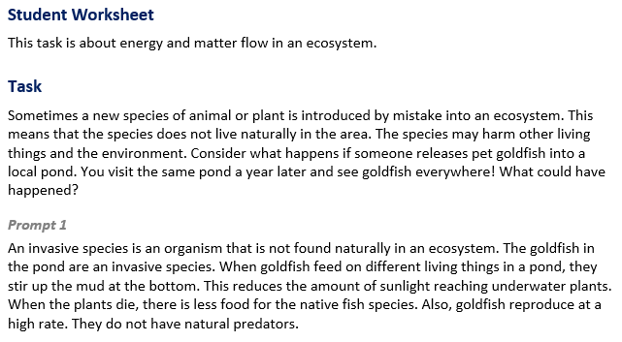 |  | 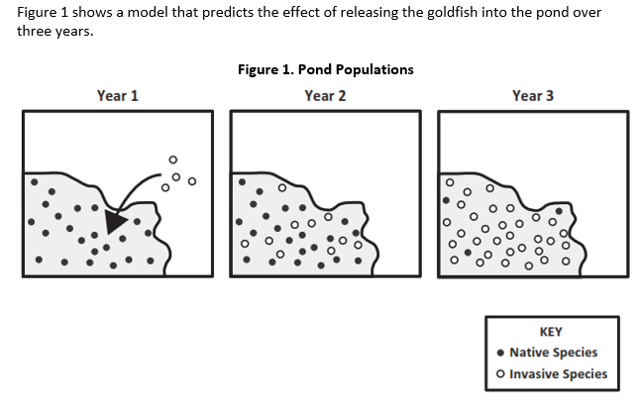  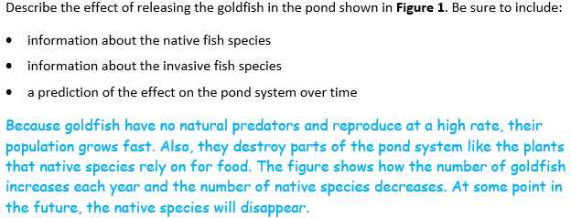
  Task 3 Prompt 1 Complexity
  Degree and Nature of Sensemaking | Moderate | This prompt…  - Requires integration of two dimensions in the service of sense-making
  Complexity of the Presentation | Moderate | - The amount and type of information provided in the scenario supports multiple evident connections among ideas or concepts  - Provides graphics/data/models
  Cognitive Demand of Response Development | Moderate | - Requires drawing relationships and connecting ideas and practices  - Requires a moderate level of sophistication with typical and relatively complex representation of ideas and application of skills
  Cognitive Demand of Response Production | Moderate | - Response includes one or more sentences or a paragraph, a moderately complex graphic, or multiple steps in a simple or moderately complex process
  Task 3 Prompt 1
  Connections to the Instructional Framework
  Integration of Knowledge and Skills for Response Development
  - Students are presented with an example scenario of an invasive species being introduced into an ecosystem.
  - Students use the model components to show relationships and interactions between the plant’s native species and the new species.
  - Students use the data to construct a claim about the impact of the introduction of the new species in the aquatic ecosystem.
  - Students explain their reasoning behind the effect of releasing the goldfish in the pond, as shown in Figure 1, indicating that the population will grow fast and that the goldfish will eat plants that the native species rely on for food, causing the native species to disappear over time.
  Formative Assessments | Opportunities to Learn
  Segment 3, pp. 13-14  Informal Assessment: Asking Questions about How Matter Moves through an Ecosystem (A13)  - Students identify what evidence supports an argument that makes a claim that multiple organisms' needs must be met within their ecosystem and the effects of introducing non-native species.  - Students use evidence, data, or a model to support a claim that multiple organisms' needs must be met within their ecosystem and the effects of introducing non-native species. | Segment 3, pp. 25-26  Where Does the Energy and Matter an Owl Needs Come From? (A13, A16*)  - Having worked over the last several weeks on their explanatory models showing movement of matter through the ecosystem, students present and defend their models to the class.

 |  | Task 3 Prompt 2 Part A  Performance Categories: Model Energy and Matter Flow Among a System of Plants, Animals, and Decomposers  Acquisition Goals:  - A12. Develop a model to describe that matter cycles among living and non-living components within an ecosystem.  - A14. Use models to describe that energy in animals’ food (used for body repair, growth, motion, and to maintain body warmth) was once energy from the sun. * [5-PS3-1]  - A16. Develop a model to describe the movement of matter among plants, animals, decomposers, and the environment. [5-LS2-1]  Prompt 2 Part A measures students’ ability to:  - Develop or use models to support descriptions and predictions of relationships about the role of plants, animals, and decomposers in the transfer of energy and movement of matter in an ecosystem.
  Task 3 Prompt 1
  Connections to the Instructional Framework, Continued
  Formative Assessments | Opportunities to Learn
  Segment 3, p. 17  Formal Assessment: Uninvited Guest: What Happens When Someone New Moves In? (A13)  - Students explain how non-native species introduced into an ecosystem can alter the living and non-living parts of an ecosystem, creating changes to the overall system. | Segment 3, pp. 26-27  Uninvited Guest: What Happens When Someone New Moves In? (A13)  - Students engage with resources to learn about the effects of invasive species on different environments. They do so by extending their understanding of an ecosystem to characterizing how new species can cause changes to the system.
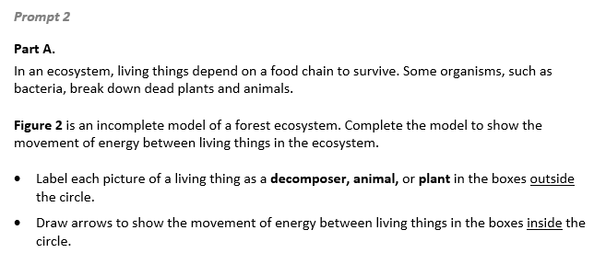  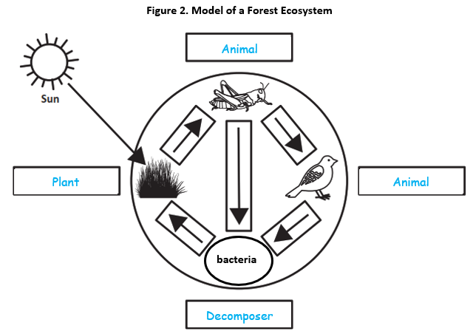
  Task 3 Prompt 2 Part A Complexity
  Degree and Nature of Sensemaking | Moderate | This prompt…  - Requires integration of two dimensions in the service of sensemaking  - Requires a combination of previously learned ideas or concepts and newly presented information
  Complexity of the Presentation | Low | - The amount and type of information provided in the scenario supports limited simple connections among ideas or concepts  - Phenomenon or problem presented in a concrete way with high level of certainty
  Cognitive Demand of Response Development | Moderate | - Requires drawing relationships and connecting ideas and practices  - Requires a moderate level of sophistication with typical and relatively complex representation of ideas and application of skills
  Cognitive Demand of Response Production | Low | - Responses include selection from a small set of options presented as text (e.g., word, short phrase) or other formats (e.g., or a simple graphic or process)
Task 3 Prompt 2 Part B  Performance Categories: Model Energy and Matter Flow Among a System of Plants, Animals, and Decomposers  Acquisition Goals:  - A12. Develop a model to describe that matter cycles among living and non-living components within an ecosystem  - A14. Use models to describe that energy in animals’ food (used for body repair, growth, motion, and to maintain body warmth) was once energy from the sun. [5-PS3-1]  - A16. Develop a model to describe the movement of matter among plants, animals, decomposers, and the environment. * [5-LS2-1]  Prompt 2 Part B measures students’ ability to:  - Develop or use models to support descriptions and predictions of relationships about the movement of matter and energy among plants, animals, and decomposers.  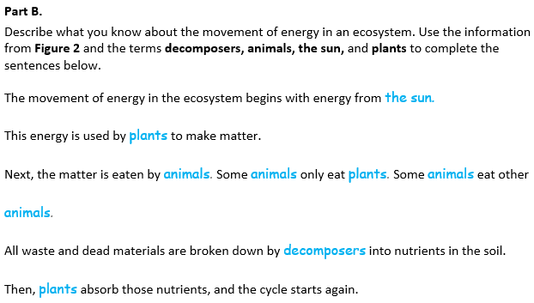  Task 3 Prompt 3  Performance Categories: Support Arguments About Energy and Matter Flow Among Plants and Animals  Acquisition Goals:  - A13. Support an argument that makes a claim that multiple organisms’ needs must be met within their ecosystem and the effects of introducing non-native species.  - A16. Develop a model to describe the movement of matter among plants, animals, decomposers, and the environment. [5-LS2-1]  Prompt 3 measures students’ ability to:  - Support an argument with evidence, data, or a model to explain how a newly introduced species may disrupt the balance of a healthy ecosystem. |  | 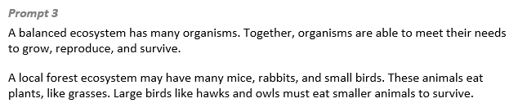  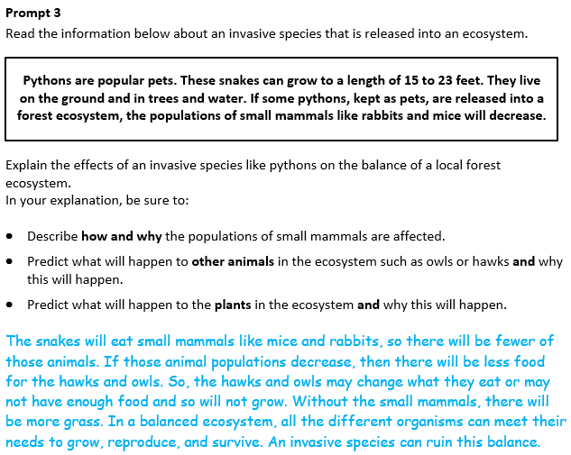
  Task 3 Prompt 2 Part A
  Connections to the Instructional Framework
  Integration of Knowledge and Skills for Response Development
  - Students read the prompt and recall what they know about energy transfer relationships among organisms and the sun.
  - Students use the model to identify relationships between organisms in an ecosystem.
  - Students complete the model to describe the movement of energy and matter in an ecosystem.
  Formative Assessments | Opportunities to Learn
  Segment 2, pp. 12-13  Formal Assessment: Conditions for Plant Growth (A18)  - Students develop a model that can be used to show that plants get materials and energy they need for growth chiefly from air, water, and sunlight.  Segment 3, pp. 14-15  Formal Assessment: Movement of Matter Through an Ecosystem: Can You Show It? (A16)  - Students develop a model to describe the movement of matter among plants, animals, decomposers, and the environment.  - Students use models to show the cycling of matter in the system between plants, animals, decomposers, and the environment. | Segment 1, pp. 20-21  Matter Matters (A16)  - Through reading and discourse in the class or groups, students explore the idea that animals need to consume matter to grow and heal and that animals’ food sources provide this matter.  Segment 1, p. 22  The Importance of Plants in Food Webs (A14)  - Students return to their model of a food chain but expand it into a food web and learn that the foundation of the food web begins with the sun providing energy to plants.
  Task 3 Prompt 2 Part A
  Connections to the Instructional Framework, Continued
  Formative Assessments | Opportunities to Learn
  Segment 3, pp. 24-25
  Movement of Matter Through an Ecosystem: Can You Show It? (A16)
  - In this lesson, students learn about the types of matter that move among producers, consumers, and decomposers. The goal is for students to describe the movement of matter among plants, animals, and decomposers. At the end of the lesson, students develop a model (e.g., diagram) to describe how matter cycles among the living and nonliving components within an ecosystem.
  Segment 3, pp. 25-26
  Where Does the Energy and Matter an Owl Needs Come From? (A12, A14, A16)
  - Having worked over the last several weeks on their explanatory models showing movement of energy through the ecosystem, students present and defend their models to the class
  Task 3 Prompt 2 Part B
  Connections to the Instructional Framework
  Integration of Knowledge and Skills for Response Development
  - Students read the prompt and identify relationships and interactions among decomposers, animals, plants, and the sun.
  - Students complete the sentences by accurately using the model to describe the relationship of the components for the phenomena of energy transfer in an ecosystem.
  Formative Assessments | Opportunities to Learn
  Segment 3, pp. 14-15  Formal Assessment: Movement of Matter Through an Ecosystem: Can You Show It? (A16)  - Students develop a model to describe the movement of matter among plants, animals, decomposers, and the environment.  - Students use models to show the cycling of matter in the system between plants, animals, decomposers, and the environment. | Segment 1, p. 22  The Importance of Plants in Food Webs (A14)  - Students return to their food chain model but expand it into a food web and learn that the foundation of the food web begins with the sun providing energy to plants.  Segment 2, p. 23  Conditions for Plant Growth (A14)  - Students are given seeds for garden plants and read what information is included in the packets about sunlight, water, soil.  - Students watch seedlings over time and track their growth. Students pick a variable, such as sunlight, and see how it affects seedling growth.  - Students engage in observations and gather data to address the needs of plants for growth and present their data to the class.
  Task 3 Prompt 3 Complexity
  Degree and Nature of Sensemaking | High | This prompt…  - Requires integration of three dimensions in the service of sensemaking  - Requires a combination of previously learned ideas or concepts and newly presented information
  Complexity of the Presentation | Low | - The amount and type of information provided in the scenario supports limited simple connections among ideas or concepts  - Phenomenon or problem presented in a concrete way with high level of certainty
  Cognitive Demand of Response Development | High | - Requires selection and application of multiple complex ideas and practices  - Requires high degree of sense-making, reasoning, and/or transfer
  Cognitive Demand of Response Production | Moderate | - Response includes one or more sentences or a paragraph, a moderately complex graphic, or multiple steps in a simple or moderately complex process
  Task 3 Prompt 3
  Connections to the Instructional Framework, Continued
  Formative Assessments | Opportunities to Learn
  Segment 3, p. 17  Formal Assessment: Uninvited Guest: What Happens When Someone New Moves In? (A13)  - Students explain how non-native species introduced into an ecosystem can alter the living and non-living parts of an ecosystem, creating changes to the overall system. | Segment 3, pp. 26-27  Uninvited Guest: What Happens When Someone New Moves In? (A13)  - Students engage with resources to learn about the effects of invasive species on different environments. They do so by extending their understanding of an ecosystem to characterizing how new species can cause changes to the system.
  Task 3 Prompt 2 Part A
  Connections to the Instructional Framework, Continued
  Formative Assessments | Opportunities to Learn
  Segment 3, p. 15  Where Does the Energy and Matter an Owl Needs Come From? (A12, A16)  - Students describe the relevant relationships between energy from the sun and how it is transferred to animals through a chain of events that begins with plants producing food then being eaten by animals as shown in a model (e.g., food web).  - Students describe that matter cycles among biotic and abiotic components within an ecosystem.  Segment 3, pp. 15-16  Formal Assessment: Where Does the Energy and Matter an Owl Needs Come From? (A16)  - Students develop a model to describe the movement of matter among plants, animals, decomposers, and the environment.  - Students use models to show the cycling of matter in the system between plants, animals, decomposers, and the environment. | Segment 2, p. 23  Conditions for Plant Growth (A14)  - Students are given seeds for garden plants and read what information is included in the packets about sunlight, water, soil, etc.  - Students are presented with seedlings they watch over time and track their growth. Students pick a variable, such as sunlight, and see how it affects seedling growth.  - Students engage in observations and gather data to address the needs of plants for growth and present their data to the class.
  Task 3 Prompt 2 Part B Complexity
  Degree and Nature of Sensemaking | Low | This prompt…  - Requires one or two dimensions  - One dimension may have a greater degree of emphasis than another  - Requires previously learned ideas or concepts
  Complexity of the Presentation | Low | - The amount and type of information provided in the scenario supports limited simple connections among ideas or concepts  - Phenomenon or problem presented in a concrete way with high level of certainty
  Cognitive Demand of Response Development | Moderate | - Requires drawing relationships and connecting ideas and practices  - Response requires a moderate level of sophistication with typical but relatively complex representation of ideas and application of skills
  Cognitive Demand of Response Production | Low | - Responses include selection from a small set of options presented as text (e.g., word, short phrase) or other formats (e.g., or a simple graphic or process)
  Task 3 Prompt 2 Part B
  Connections to the Instructional Framework, Continued
  Formative Assessments | Opportunities to Learn
  Segment 3, pp. 15-16  Formal Assessment: Where Does the Energy and Matter an Owl Needs Come From? (A12, A16)  - Students develop a model to describe the movement of matter among plants, animals, decomposers, and the environment.  - Students use models to show the cycling of matter in the system between plants, animals, decomposers, and the environment. | Segment 3, pp. 24-25  Movement of Matter Through an Ecosystem: Can You Show It? (A12, A16)  - Students learn about the types of matter that move among producers, consumers, and decomposers. Students describe the movement of matter among plants, animals, and decomposers. At the end of the lesson, students develop a model (e.g., diagram) to describe how matter cycles among the living and nonliving components within an ecosystem, showing how organisms have biological needs which must be met within their ecosystems.  Segment 3, pp. 25-26  Where Does the Energy and Matter an Owl Needs Come From? (A12, A14, A16)  - Having worked over the last several weeks on their explanatory models showing movement of energy through the ecosystem, students present and defend their models to the class.
  Task 3 Prompt 3
  Connections to the Instructional Framework
  Integration of Knowledge and Skills for Response Development
  - Students are presented with an example scenario of an invasive species (python) being introduced into an ecosystem.
  - Students use evidence from the information provided to construct a claim about the impact of the introduction of the new species in the aquatic ecosystem.
  - Students predict the effect of a newly introduced species (python) and its damage to the balance of an ecosystem by describing the reasoning behind the relevance of other components in the ecosystem.
  Formative Assessments | Opportunities to Learn
  Segment 3, pp. 13-14  Informal Assessment: Asking Questions about How Matter Moves through an Ecosystem (A13)  - Students identify what evidence supports an argument that makes a claim that multiple organisms' needs must be met within their ecosystem and the effects of introducing non-native species.  - Students use evidence, data, or a model to support a claim that multiple organisms' needs must be met within their ecosystem and the effects of introducing non-native species. | Segment 3, pp. 25-26  Where Does the Energy and Matter an Owl Needs Come From? (A13, A16)  - Having worked over the last several weeks on their explanatory models showing movement of matter through the ecosystem, students present and defend their models to the class.
Future Learning Connected to evidence elicited in Task 3
Crosscutting Concepts
- In Unit 2, students make frequent use of the Energy and Matter CCC as they trace the transfer/flow of energy from the sun to plants and then to animals. Likewise, students will trace the cycling of matter between the environment, plants, animals, and decomposers. Students also use the Cause-and-Effect CCC to consider, model, and argue for the causes and effects of changes in an ecosystem and/or the requirements for plants and animals to grow and survive. In Unit 3, their experience with these concepts will help them as they apply these concepts to the various Earth systems and the effects of human activities on these systems. In Unit 3, Acquisition Goal 9 requires students to obtain information from multiple sources to communicate information about the elements of the four major systems of the Earth. Students are given informal classroom check-ins to determine student understanding of Earth’s systems and their interactions and how human activities have influenced these interactions. (Informal Assessment: Earth’s Spheres: We Are All Connected!, pp. 21-22)
Disciplinary Core Ideas
- In Unit 2, students analyze and model food webs, including the materials and energy that plants need to grow, the energy that animals get from food, and the flow of energy and cycling of matter among the different organisms and environments that form ecosystems. In working with these disciplinary core ideas, students are positioned to make connections across organisms within an environment and to consider the (eco) system in which multiple organisms interact with each other and their environment. This will help students build future understanding in Unit 3, in which they will consider other systems on Earth and the role of organisms in these systems. In Unit 3, Acquisition Goal 13 requires students to construct an explanation to address a problem/challenge by using data on the interaction of two of Earth's systems under study. (Formal Assessment: Protecting Earth’s Environment!, pp. 23-24)
Science and Engineering Practices
- In Unit 2, students evaluate their model and peer models throughout the unit and then revise their model. This practice of review and revision supports students in developing their modeling practice as they create a more robust explanation over an extended time. Students will build on this practice in Unit 3 as they work on an engineering problem, starting with an explanatory model and then adding the engineering design process to find solutions related to the explanation. In Unit 3, Acquisition Goal 16 requires students to modify a design solution using information on the impact of human activities on the outcome of the solution, including specifying the way that the human activities can be reversed or addressed. Students pick a design solution and determine how humans have made an impact on this design. (Formal Assessment: Wrench in the Plans, pp. 18-19)

