Coherence and Alignment Among Science Curriculum, Instruction, and Assessment (CASCIA)  Grade 5 Unit 3  End-of-Unit Assessment  Task Interpretation Guide  December 2023  The Grade 5 Unit 3 End-of-Unit Assessment Task Interpretation Guide was developed with funding from the U.S. Department of Education under the Competitive Grants for State Assessments Program, CFDA 84.368A. The contents of this guide do not represent the policy of the U.S. Department of Education, and no assumption of endorsement by the Federal government should be made. |  |   All rights reserved. Any or all portions of this document may be reproduced and distributed without prior permission, provided the source is cited as: Coherence and Alignment Among Science Curriculum, Instruction, and Assessment (CASCIA) Project. (2023). Grade 5 Unit 3 End-of-Unit Assessment Task Interpretation Guide. Lincoln, NE: Nebraska Department of Education.

Table of Contents
Introduction 1
Purpose 1
Contents 2
SIPS Grade 5 Unit 3 EOU Assessment Task 1: Every Drop Counts 3
Task 1 Prompt 1 Parts A-D 3
Task 1 Prompt 1 Part E 6
Task 1 Prompt 2 – Parts A and B 9
Task 1 Prompt 2 – Part C 12
Task 1 Prompt 3 – Parts A-C 14
SIPS Grade 5 Unit 3 EOU Assessment Task 2: Searching for Freshwater 21
Task 2 Prompt 1 – Parts A-C 21
Task 2 Prompt 2 25
Task 2 Prompt 3 – Parts A and B 28
Task 2 Prompt 4 – Parts A-C 31
SIPS Grade 5 Unit 3 EOU Assessment Task 3: Protecting Earth’s Soil 36
Task 3 Prompt 1 Parts A and B 36
Task 3 Prompt 2 Parts A and B 41
Task 3 Prompt 3 Parts A-C 44
Task 3 Prompt 4 Parts A and B 48

Introduction  The use of formative assessment practices, with informative and immediate feedback that leads to adjustments to instructional next steps, has been shown to be effective in helping students learn (Black & Wiliam, 1998; Wylie & Lyon, 2009; Heritage, 2010). Interim or large-scale summative assessments, such as those required under the Every Student Succeeds Act of 2015 (ESSA), cannot and are not meant to inform daily instruction because of how and when they are administered. These forms of assessment can bring value to an assessment system, but only if coordinated and meaningfully aligned within a comprehensive, coherent system.  The Coherence and Alignment Among Science Curriculum, Instruction, and Assessment (CASCIA) Project brings together three partner states—Nebraska, Alabama, and Alaska—with a team of researchers and experts to establish science assessment resources that are coordinated and aligned across all parts of the assessment system. With coherence as the guiding principle, these state-level educators and national science education and measurement experts have joined with hundreds of local educators to address states’ need for quality, standards-aligned science assessments that generate meaningful, interpretable, and actionable results, and to design a scoring and score reporting framework that builds educators’ capacity to track, interpret, and communicate students’ learning in science and to offer effective instruction for all students.  Purpose  The purpose of the Grade 5 Unit 3 End-of-Unit Assessment Task Interpretation Guide is to support educators’ understanding of the Grade 5 Unit 3 End-of-Unit assessment tasks and prompts, their features, and the evidence (i.e., knowledge and skills) they are designed to elicit about student learning, and how the assessment and the information it provides can be used to plan instruction and learning opportunities for students, whether it involves planning for instruction prior to teaching the instructional unit, reflecting on the quality and sufficiency of prior instruction and instructional materials or planning additional student |  | learning opportunities or interventions in the subsequent unit (e.g., SIPS Unit 4).  The Grade 5 Unit 3 Science Assessment includes three science tasks, each including multiple scorable prompts. Task 1, Every Drop Counts, includes three prompts and 21 possible score points with Prompt 1 having a Part A through E and Prompts 2 and 3 having a Part A, B, and C; Task 2, Searching for Freshwater, includes four prompts and 19 possible score points with Prompt 1 having a Part A, B, and C, Prompt 3 having a Part A and B, and Prompt 4 having a Part A, B, and C; Task 3, Protecting Earth’s Soil, includes four prompts and 12 possible score points, with Prompts 1, 2, and 4 having a Part A and B and Prompt 3 having a Part A, B, and C.  Prompts from the three tasks that measure similar combinations of dimensions (i.e., Disciplinary Core Ideas, Science and Engineering Practices, and Crosscutting Concepts) from the Next Generation Science Standards (NGSS) are organized into three performance categories. The NGSS Performance Expectations (PEs) are addressed in one or more performance categories to provide multiple opportunities to demonstrate flexible thinking and competency in different situations and contexts.
  Performance Category | NGSS PEs | Prompts in Performance Category | Points Possible
  Analyze Data to Describe the Availability of Needed Natural Resources | 5-ESS2-2  5-ESS3-1 | Task 1, Prompt 1A-D  Task 1, Prompt 2AB  Task 2, Prompt 3AB  Task 1, Prompt 2C | 15 points
  Design the Best Solution to a Problem Involving Human Impacts on Earth Systems | 5-ESS3-1  3-5-ETS1-2 | Task 1, Prompt 1E  Task 1, Prompt 3A-C  Task 3, Prompt 3A-C  Task 3, Prompt 4AB | 16 points
  Model Relationships to Communicate Information about Earth’s Surface Materials and Processes | 5-ESS2-1 | Task 2, Prompt 1A-C  Task 2, Prompt 2  Task 2, Prompt 4A-C  Task 3, Prompt 1AB  Task 3, Prompt 2AB | 21 points
Contents  This document includes interpretive guidance to support educators’ understanding of each prompt on the Grade 5 Unit 3 EOU Assessment, its features, and the evidence it is designed to elicit about students’ learning, and offers important connections to the learning goals, formative assessment opportunities, and lesson descriptions within the SIPS Grade 5 Unit 3 Map / Instructional Framework as well as connections to future learning opportunities in the next unit.  For each prompt, the following information is provided:  - Performance Category – A classification of prompts within the EOU based on similarities in knowledge, skills, and abilities for which the prompts were designed to measure.  - Acquisition Goals – Specific goals that describe what students should understand, know, and be able to do at the end of a unit or course of instruction. The acquisition goals are derived from Stage 1 of the unit map / instructional framework that the prompt is intended to measure.  - Prompt Knowledge and Skills for Measurement – The evidence of student learning the prompt is designed to elicit.  - Prompt and Exemplar Response – The prompt consists of one to three sentences that raises an issue or asks a question to which students need to respond. An exemplar response represents a high-quality response that provides evidence that students have demonstrated the knowledge, skills, and abilities assessed by the prompt. Student exemplars are intended to assist in understanding the nature and expectations of the prompt. However, students may respond with other relevant scientifically accurate responses, evidence, observations, and ideas.  In general, a full-point exemplar response meets expectations and is:  - scientifically accurate  - complete  - coherent |  | - consistent with the type of student evidence expected as described in the rubric  For examples of student responses for each prompt representative of the full range of score points possible based on the scoring rubric, access the Grade 5 Unit 3 EOU Assessment Scoring Guide.  - Prompt Complexity – The sophistication of students’ ability to demonstrate sense-making is characterized by their ability to (a) use disciplinary core ideas (DCIs), scientific and engineering practices (SEPs), and crosscutting concepts (CCCs) together in the service of sense-making about a phenomenon or problem, and (b) engage with and respond to items and tasks designed using variable features representing combinations of Low, Moderate, and High complexity designations. These combinations of features are based on the SIPS Complexity Framework.  Adapted from the Cambridge Alignment Methodology (Forte, 2021) and informed by aspects of Achieve’s Framework to Evaluate Cognitive Complexity in Science Assessments (Achieve, 2019), the SIPS Complexity Framework is grounded in sense-making and students’ ability to flexibly apply knowledge through the integration of the same and new/different combinations of dimensions within the PEs from a unit bundle, in the context of a phenomenon or phenomenon-rooted design problem based on the focal DCIs.  - Prompt Connections to the Unit Map / Instructional Framework – A high-level overview of the evidence elicited by the prompt related to the acquisition goals, connections to the instructionally-embedded formative assessment opportunities within Stage 2 of the unit map, and connections to opportunities to learn based on the lesson descriptions within stage 3 of the unit map.  For each of the three tasks, the following information is provided:  - Connections to Future Learning Opportunities – The knowledge, skills, and abilities elicited by the prompt that can be leveraged and extended in future learning. Unit connections highlight where and how an educator can emphasize connections for students in the next unit.
SIPS Grade 5 Unit 3 EOU Assessment Task 1: Every Drop Counts  Task 1 Prompt 1 Parts A-D  Performance Category: Analyze Data to Describe the Availability of Natural Resources  Acquisition Goals  - A14: Obtain and evaluate information from a variety of sources as the basis for claims about the positive or negative impact of human activities on Earth’s systems. *  - A15: Design and carry out an investigation to characterize the impact of human activities on a particular design solution. *  Prompt 1 Parts A-D measure the students’ ability to:  - Analyze and interpret data and graphs to support conclusions about the effects of a given human activity on the environment. |  | 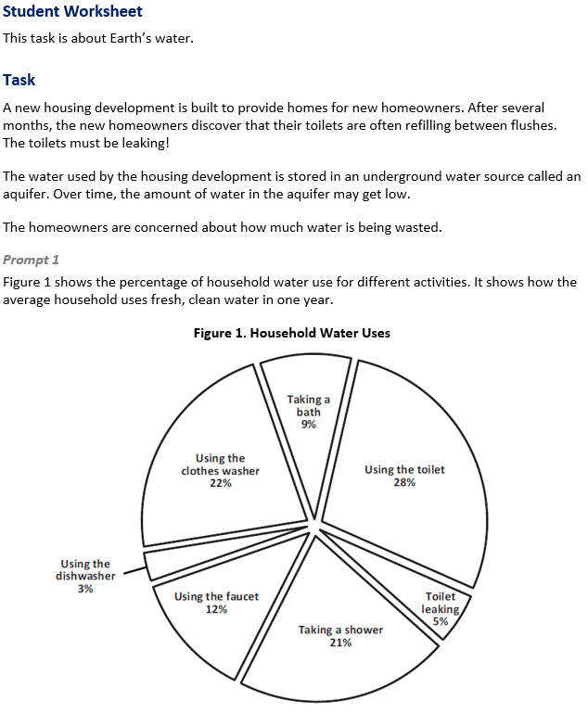
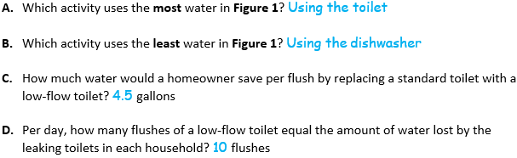  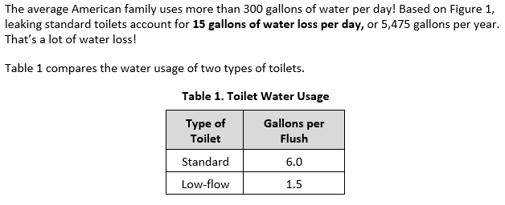
  Task 1 Prompt 1 Parts A-D Complexity
  Degree and Nature of Sensemaking | Moderate | This task…  - Requires integration of two dimensions in the service of sense-making
  Complexity of the Presentation | Moderate | - The amount and type of information provided in the scenario supports multiple evident connections among ideas or concepts.  - Provides graphics/data/models
  Cognitive Demand of Response Development | Moderate | - Requires drawing relationships and connecting ideas and practices.  - Requires a moderate level of sophistication with typical and relatively complex representation of ideas and application of skills
  Cognitive Demand of Response Production | Moderate | - Response includes multiple steps in a simple or moderately complex process
Task 1 Prompt 1 Part E  Performance Category: Design the Best Solution to a Problem Involving Human Impacts on Earth Systems  Acquisition Goals  - A14: Obtain and evaluate information from a variety of sources as the basis for claims about the positive or negative impact of human activities on Earth’s systems.  - A16: Modify a design solution using information on the impact of human activities on the outcome of the solution, including specifying the way that the human activities can be reversed or addressed.  Prompt 1 Part E measures the students’ ability to:  - Design a solution to a problem involving human impacts on Earth systems by combining and synthesizing information on the effects of a human activity on the environment.  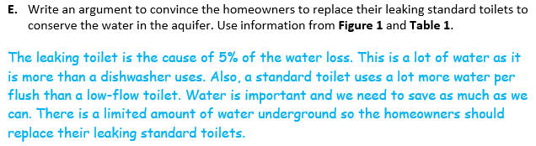
  Task 1 Prompt 1 Parts A-D
  Connections to the Instructional Framework
  Integration of Knowledge and Skills for Response Development
  - Students read the provided background information and Figure 1, which introduces a setting related to preventable loss of fresh water in the context of households.
  - Students interpret Figure 1 showing household water usage in percentages to answer Parts A and B, indicating which activities use the most and least amount of water.
  - Students combine information from the prompt with that contained in Table 1 showing toilet water usage in gallons per flush to answer Parts C and D, solving a problem in the context of gallons and flushes of water.
  Formative Assessments | Opportunities to Learn
  Segment 2, pp. 15-16  Formal Assessment: Explaining Impacts of Human Activity (A14, A15*)  - Students identify information from one or more sources that relate to how human activities affect the Earth system.  - Students evaluate information to determine whether or not the information supports claims for how human activities impact the Earth system. | Segment 2, pp. 36-37  You Are What You Drink (A14, A15*)  - This activity provides the opportunity to explore the problem of water pollution/purification.  - Students investigate the process and consequences of water contamination on the land, groundwater, and plants. Students review articles and media about pollution events and risks.  - Students consider these negative impacts and potential concerns for their own water reduction process and refine their solutions to the engineering problem to minimize negative impacts.
  Task 1 Prompt 1 Part E
  Connections to the Instructional Framework
  Integration of Knowledge and Skills for Response Development
  - Students refer to Figure 1 and Table 1 to reference the provided information on household water usage.
  - Students combine and synthesize information on the effects of leaking standard toilets related to the conservation of water in the aquifer to support an argument.
  - Students refer to Figure 1 by comparing water usage to another part of the pie chart or indicating that leaking represents 5% of all water usage and indicate that the standard toilet uses a lot more water than the low-flow toilet using information from Table 1.
  Formative Assessments | Opportunities to Learn
  Segment 2, pp. 15-16  Formal Assessment: Explaining Impacts of Human Activity (A14, A16)  - Students describe how human activities impact Earth system(s) based on information found from a variety of resources.  - Students modify a design solution to reduce the negative effect of human activities on a solution.  - Students describe how a design activity can help address or reverse negative effects of human activities. | Segment 2, pp. 36-37  You Are What You Drink (A14)  - Students explore the problem of water pollution/purification.  - Students consider negative impacts and potential concerns for their own water reduction process and refine their solutions to the engineering problem.  Segment 2, pp. 38-39  Nature Impact (A14)  - Students review news articles and resources on the impact of dams from both positive and negative aspects. The teacher provides students with several videos and articles that present this complex topic for them to consider.
  Task 1 Prompt 1 Part E
  Connections to the Instructional Framework, Continued
  Formative Assessments | Opportunities to Learn
  Segment 4, pp. 38-39
  Modeling Earth’s Systems (A14)
  - Students obtain information from multiple sources to be used in modifying a model of Earth’s systems and spheres. After modifying the model, students explain how the activities impact an Earth system (or systems).
  Task 1 Prompt 1 Parts A-D
  Connections to the Instructional Framework
  Formative Assessments | Opportunities to Learn
  Segment 3, pp. 16-17  Informal Assessment: Class Discussions (A14, A15*)  - Students identify information from one or more sources that relate to how human activities affect the Earth system.  - Students evaluate information to determine whether or not the information supports claims for how human activities impact the Earth system. | Segment 2, pp. 38-39  Nature Impact (A14, A15*)  - Students should review news articles and resources on the impact of dams from both positive and negative aspects. The teacher provides students with several videos and articles that present this complex topic for them to consider. The students then share their thinking about dams and their usage for water reservoirs, flood control, energy, and the impact that has on the local fish, wildlife, and people in those areas.  Segment 4, pp. 38-39  Modeling Earth’s Systems (A14)  - Students obtain information from multiple sources to be used in modifying a model of Earth’s systems and spheres. After modifying the model, students explain how the activities impact an Earth system (or systems).
  Task 1 Prompt 1 Part E Complexity
  Degree and Nature of Sensemaking | Moderate | This task…  - Requires integration of two dimensions in the service of sense-making
  Complexity of the Presentation | Moderate | - The amount and type of information provided in the scenario supports multiple evident connections among ideas or concepts.  - Provides graphics/data/models
  Cognitive Demand of Response Development | Moderate | - Requires drawing relationships and connecting ideas and practices  - Requires a moderate level of sophistication with typical and relatively complex representation of ideas and application of skills
  Cognitive Demand of Response Production | Moderate | - Responses include one or more sentences or a paragraph
  Task 1 Prompt 1 Part E
  Connections to the Instructional Framework, Continued
  Formative Assessments | Opportunities to Learn
  Segment 3, pp. 16-17  Informal Assessment: Class Discussions (A14, A16)  - Students describe how human activities impact Earth system(s) based on information found from a variety of resources.  - Students modify a design solution to reduce the negative effect of human activities on a solution.  - Students evaluate information to determine whether or not the information supports claims for how human activities impact the Earth system.  Segment 3, pp. 18-19  Formal Assessment: Wrench in the Plans (A16)  - Students modify a design solution to reduce the negative effect of human activities on a solution.  - Students describe how a design activity can help address or reverse negative effects of human activities. | - Students then share their thinking about dams and their usage for water reservoirs, flood control, energy, and the impact that has on the local fish, wildlife, and people in those areas.  Segment 3, p. 39  Investigating Efficacy of Design Solutions (A16)  - Students have been carrying out an engineering design challenge, iterating upon their prior design solution as they learn about additional factors related to the impact of human activities on the overuse of water drawn from the Ogallala Aquifer.  - Next, students determine how different conditions affect the impact/efficacy of their design solution. Students conduct an investigation to determine if their proposed solution to water conservation/protection may be effective using a prototype that they create. Following their investigation, students may again refine/revise their design.
Task 1 Prompt 2 – Parts A and B  Performance Category: Analyze Data to Describe the Availability of Needed Natural Resources  Acquisition Goals  - A1: Use mathematics to describe and graph quantities about the distribution of water on Earth.  - A3: Obtain information from multiple sources to communicate information about the sources and distribution of fresh water on Earth to illustrate that nearly all of Earth's available freshwater reserves are glaciers and groundwater.  Prompt 2 Parts A and B measure students’ ability to:  - Analyze and interpret data and graphs to support conclusions about the distribution of saltwater and freshwater reservoirs on Earth and the importance of maintaining supplies of fresh water.  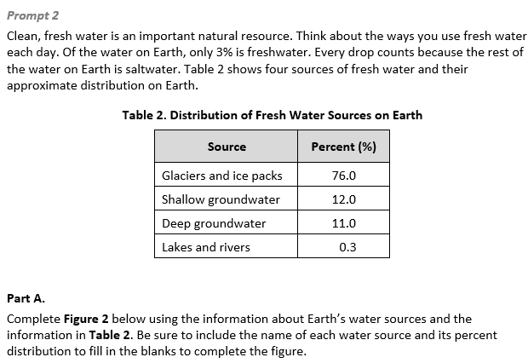 |  | 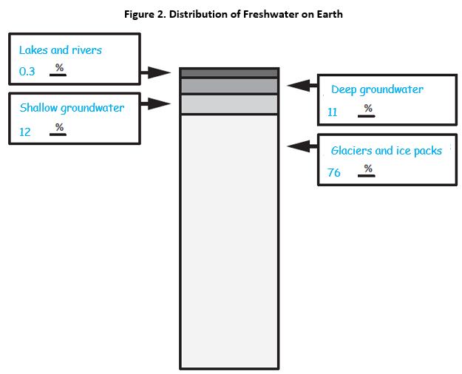  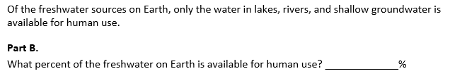
  Task 1 Prompt 2 Parts A and B Complexity
  Degree and Nature of Sensemaking | Low | This prompt…  - Requires one or two dimensions  - One dimension may have a greater degree of emphasis than another
  Complexity of the Presentation | Low | - The amount and type of information provided in the scenario supports limited simple connections among ideas or concepts.  - Provides few, simple graphics/data/models
  Cognitive Demand of Response Development | Moderate | - Requires application of ideas and practices given cues and guidance  - Requires drawing relationships and connecting ideas and practices
  Cognitive Demand of Response Production | Low | - Responses include selection from a small set of options presented as text (e.g., word, short phrase) or other formats (e.g., or a simple graphic or process)
  Task 1 Prompt 2 Parts A and B
  Connections to the Instructional Framework
  Integration of Knowledge and Skills for Response Development
  - Students are provided contextual information surrounding fresh water sources on Earth and percentages associated with sources in Table 2.
  - Students complete Figure 2 using the information about Earth’s fresh water sources and their percentage distribution in Part A.
  - Students answer Part B by combining information about the distribution of freshwater in lakes and rivers and shallow groundwater and the information provided in the prompt about the freshwater available for human use.
  Formative Assessments | Opportunities to Learn
  Segment 1, pp. 9-10  Informal Assessment: A Globe Full of Water (A1)  - Students use mathematics to describe the distribution of water on Earth.  - Students generate a graph that shows the distribution of water on Earth. | Segment 1, pp. 31-32  A Globe Full of Water (A1, A3)  - Students use small paper squares to cover the Earth in different colored papers and then use those papers to estimate the percentages of surface area of water on Earth. Then, students hypothesize and investigate a small-scale model of global water distribution in a liter bottle.  - Students continue with additional research of the volumes and percentages of salt and fresh water to develop graphs. Then, they observe and interpret other types of data infographics that show distributions, and/or create and share their own versions in infographics to illustrate the global water distribution data.
Task 1 Prompt 2 – Part C  Performance Category: Analyze Data to Describe the Availability of Needed Natural Resources  Acquisition Goals  - A14: Obtain and evaluate information from a variety of sources as the basis for claims about the positive or negative impact of human activities on Earth’s systems.  - A15: Design and carry out an investigation to characterize the impact of human activities on a particular design solution. *  Prompt 2 Part C measures students’ ability to:  - Analyze and interpret data and graphs to support conclusions about water conservation and human stewardship of Earth.  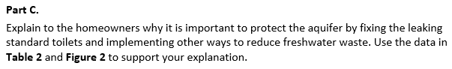  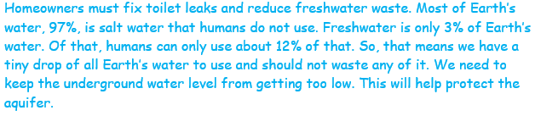  Task 1 Prompt 3 – Parts A-C  Performance Category: Design the Best Solution to a Problem Involving Human Impacts on Earth Systems  Acquisition Goals  - A15: Design and carry out an investigation to characterize the impact of human activities on a particular design solution.*  - A16: Modify a design solution using information on the impact of human activities on the outcome of the solution, including specifying the way that the human activities can be reversed or addressed.*  - A20: Obtain and combine information about ways individual communities use science ideas to protect the Earth’s resources and environment.  - A21: Generate and compare multiple solutions to a problem based on how well they meet the criteria and constraints of the design problem.  Prompt 3 Parts A, B, and C measure students’ ability to:  - Design a solution to a problem involving human impacts on Earth systems by gathering relevant information to affect positive changes through conservation of fresh water.  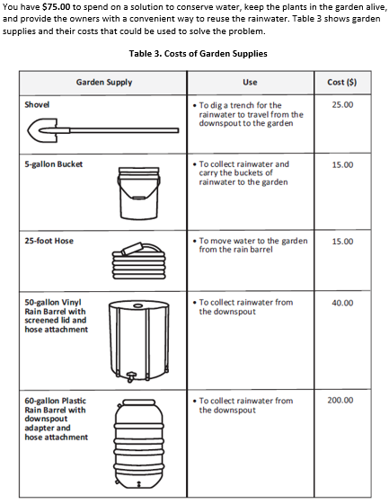 |  | 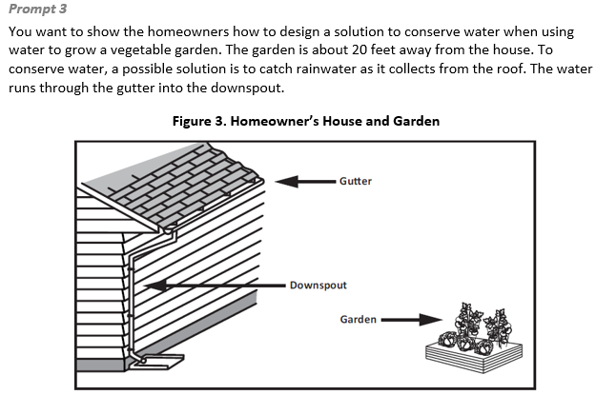  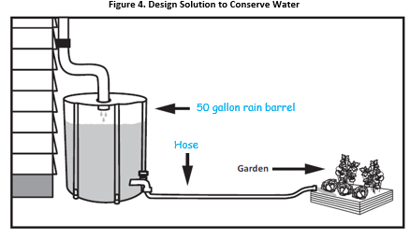  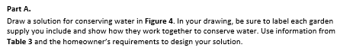  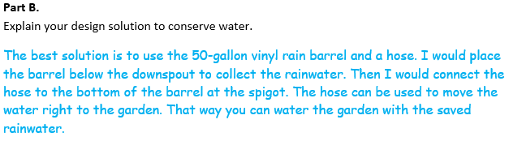  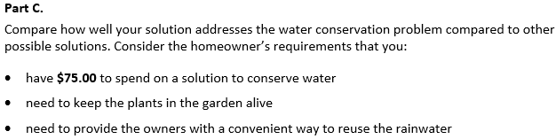  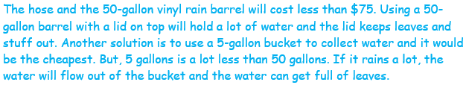
  Task 1 Prompt 2 Parts A and B
  Connections to the Instructional Framework, Continued
  Formative Assessments | Opportunities to Learn
  Segment 1, pp. 10-11  Formal Assessment: Where’s the Water (A1, A3)  - Students obtain information that supports the statement that most of Earth's available freshwater reserves are in glaciers and groundwater.  - Students use mathematics to describe the distribution of water on Earth.  - Students generate a graph that shows the distribution of water on Earth.  Segment 1, p. 11  Formal Assessment: Fresh Water by the Numbers (A1, A3)  - Students obtain information that supports a model that most of Earth's available freshwater reserves are in glaciers and groundwater.  - Students generate representations that show the sources of Earth’s fresh water.  - Students use mathematics to describe the distribution of water on Earth. | Segment 1, pp. 33-34  Water in the Snow, Glaciers, and Underground (A3)  - Students investigate how much water is in snow and ice with simple melting and measuring experiments, which can be extended with various types of snow and/or how long the melting takes.  - Students read about groundwater and water tables, and then design models of groundwater aquifers to educate younger students about groundwater.  Segment 1, p. 34  Our Glass of Water (A3)  - Students work to finalize their explanatory models about where a glass of water in their school comes from and where the water used in the school goes. Students give feedback to peers to help improve their explanatory models and then share their final models with the class.
  Task 1 Prompt 2 Part C
  Connections to the Instructional Framework
  Integration of Knowledge and Skills for Response Development
  - Students combine information from Table 2 and Figure 2 to answer the question of why it is important to protect the aquifer by fixing the leaking toilets and implement other ways of reducing freshwater waste.
  - Students analyze their data to answer questions about the distribution of Earth’s water resources.
  - Students explain that freshwater is only 3% of all Earth’s water, and that the amount of water humans can use is a small percent of the freshwater on Earth. Therefore, it is important to save water for the aquifer in support of the argument.
  Formative Assessments | Opportunities to Learn
  Segment 2, pp. 15-16  Formal Assessment: Explaining Impacts of Human Activity (A14, A15*)  - Students identify information from one or more sources that relate to how human activities affect the Earth system.  - Students evaluate information to determine whether or not the information supports claims for how human activities impact the Earth system. | Segment 2, pp. 36-37  You Are What You Drink (A14, A15*)  - Students explore the problem of water pollution/purification.  - Students investigate the process and consequences of water contamination on the land, groundwater, and plants. Students review articles and media about pollution events and risks.  - Students consider these negative impacts and potential concerns for their own water reduction process and refine their solutions to the engineering problem to minimize negative impacts.
  Task 1 Prompt 3 Part A Complexity
  Degree and Nature of Sensemaking | High | This task…  - Requires integration of three dimensions in the service of sense-making
  Complexity of the Presentation | Moderate | - The amount and type of information provided in the scenario supports multiple evident connections among ideas or concepts  - Provides graphics/data/models
  Cognitive Demand of Response Development | High | - Requires selection and application of multiple complex ideas and practices  - Requires high degree of sense-making, reasoning, and/or transfer
  Cognitive Demand of Response Production | Moderate | - Response includes a moderately complex graphic
  Task 1 Prompt 3 Part C Complexity
  Degree and Nature of Sensemaking | Moderate | This task…  - Requires integration of two dimensions in the service of sense-making
  Complexity of the Presentation | Low | - The amount and type of information provided in the scenario supports limited simple connections among ideas or concepts
  Cognitive Demand of Response Development | Low | - Requires well-defined set of actions or procedures  - Requires a connection or retrieval of factual information
  Cognitive Demand of Response Production | Moderate | - Responses include one or more sentences or a paragraph
  Task 1 Prompt 3 Parts A-C
  Connections to the Instructional Framework, Continued
  Formative Assessments | Opportunities to Learn
  Segment 2, pp. 15-16  Formal Assessment: Explaining Impacts of Human Activity (A15*, A16*, A20, A21)  - Students modify a design solution to reduce the negative effect of human activities on a solution.  - Students use scientific knowledge to generate design solutions.  - Students obtain and combine information from books and other reliable media about how individual communities can use scientific ideas and a scientific understanding of interactions between components of environmental systems to protect a natural resource.  Segment 3, pp. 16-17  Informal Assessment: Class Discussions (A16*, A20, A21)  - Students modify a design solution to reduce the negative effect of human activities on a solution.  - Students use scientific knowledge to generate design solutions. | Segment 2, pp. 34-35  Water, Water, Everywhere and Not a Drop to Drink (A21)  - The teacher shares with students the challenge of the Ogallala Aquifer, and how the level of water is dropping faster than it can be recharged.  - Students start brainstorming ideas for their solution with the understanding that they will learn more about the topic in heterogenous groups and refine their solution during the unit.  Segment 2, pp. 36-37  You Are What You Drink (A15*, A21)  - Students explore the problem of water pollution/purification.  - Students investigate the process and consequences of water contamination on the land, groundwater, and plants by reviewing articles and media about pollution events and risks.  - Students consider these negative impacts and potential concerns for their own water reduction process and refine their solutions to the engineering problem to minimize negative impacts.
  Task 1 Prompt 3 Parts A-C
  Connections to the Instructional Framework
  Formative Assessments | Opportunities to Learn
  - Students determine how a solution meets the success criteria and/or constraints of a problem.  - Students compare multiple design solutions, using information from available tests to determine which solution is more optimal.  Segment 4, pp. 23-24  Formal Assessment: Protecting Earth’s Environment (A20)  - Students identify information from sources to describe how a phenomenon or design solution addresses an effect of human activities on the environment.  - Students obtain and combine information from books and other reliable media about how individual communities can use scientific ideas and a scientific understanding of interactions between components of environmental systems to protect a natural resource and the environment in which the resource is found. | Segment 3, p. 39  Investigating Efficacy of Design Solutions (A16*, A21)  - Students have been carrying out an engineering design challenge, iterating upon their prior design solution as they learn about additional factors related to the impact of human activities on the overuse of water drawn from the Ogallala Aquifer.  - Next, students determine how different conditions affect the impact/efficacy of their design solution. Students conduct an investigation to determine if their proposed solution to water conservation/protection may be effective using a prototype that they create. Following their investigation, students may again refine/revise their design.
  Task 1 Prompt 2 Part C Complexity
  Degree and Nature of Sensemaking | Moderate | This task…  - Requires integration of two dimensions in the service of sense-making
  Complexity of the Presentation | Moderate | - The amount and type of information provided in the scenario supports multiple evident connections among ideas or concepts  - Provides graphics/data/models
  Cognitive Demand of Response Development | Moderate | - Requires drawing relationships and connecting ideas and practices  - Requires a moderate level of sophistication with typical and relatively complex representation of ideas and application of skills
  Cognitive Demand of Response Production | Moderate | - Responses include one or more sentences or a paragraph
  Task 1 Prompt 2 Part C
  Connections to the Instructional Framework, Continued
  Formative Assessments | Opportunities to Learn
  Segment 3, pp. 16-17  Informal Assessment: Class Discussions (A14, A15*)  - Students identify information from one or more sources that relate to how human activities affect the Earth system.  - Students evaluate information to determine whether or not the information supports claims for how human activities impact the Earth system. | Segment 2, pp. 38-39  Nature Impact (A14, A15*)  - Students review news articles and resources on the impact of dams from both positive and negative aspects. The teacher provides students with several videos and articles that present this complex topic for them to consider. Students then share their thinking about dams and their usage for water reservoirs, flood control, energy, and the impact that has on the local fish, wildlife, and people in those areas.  Segment 4, pp. 38-39  Modeling Earth’s Systems (A14)  - Students obtain information from multiple sources to be used in modifying a model of Earth’s systems and spheres.  - Students explain how the activities impact an Earth system (or systems).
  Task 1 Prompt 3 Part B Complexity
  Degree and Nature of Sensemaking | High | This task…  - Requires integration of three dimensions in the service of sense-making
  Complexity of the Presentation | Moderate | - The amount and type of information provided in the scenario supports multiple evident connections among ideas or concepts  - Provides graphics/data/models
  Cognitive Demand of Response Development | Moderate | - Requires drawing relationships and connecting ideas and practices  - Response requires a moderate level of sophistication with typical but relatively complex representation of ideas and application of skills
  Cognitive Demand of Response Production | Moderate | - Responses include one or more sentences or a paragraph
  Task 1 Prompt 3 Parts A-C
  Connections to the Instructional Framework
  Integration of Knowledge and Skills for Response Development
  Part A
  - Students are provided background context along with Figure 3 and Table 3. The provided information includes a simple engineering design problem and a set of meaningful criteria and constraints on a potential solution.
  - In Part A, students combine the information and use it to complete Figure 4 by generating a design solution that meets the criteria for success while staying within relevant constraints that use scientific ideas to conserve fresh water.
  - In their completed model, students include a means to collect rainwater, a means to transport the rainwater to the garden, and labels for all garden supplies included in the drawing.
  Part B
  - Students identify evidence from Figure 4 to support their design solution.
  - Students explain their design solution, indicating a clear connection between the drawing and the explanation and including a description of a viable solution to conserve water.
  Part C
  - Students identify evidence from Figure 4 and the text in the prompt to support their design solution.
  - Students explain the benefits of their design solution, based on prioritization of some criteria over others, to address human activities that can have positive environmental impacts from activities that have known negative impacts.
  - Students address the cost of their solution and state an advantage and disadvantage of their solution over another.
  Task 1 Prompt 3 Parts A-C
  Connections to the Instructional Framework, Continued
  Formative Assessments | Opportunities to Learn
  - Students obtain and combine information from books and other reliable media about:  - How a given human activity (e.g., in agriculture, industry, everyday life) affects the Earth’s resources and environments.  - How individual communities can use scientific ideas and a scientific understanding of interactions between components of environmental systems to protect a natural resource and the environment in which the resource is found.  - Students describe criteria and constraints, including quantification when appropriate and evaluate potential solutions.  Segment 3, pp. 18-19  Formal Assessment: Wrench in the Plans (A16*, A21)  - Students modify a design solution to reduce the negative effect of human activities on a solution.  - Students describe how a design activity can help address or reverse negative effects of human activities. | Segment 2, pp. 37-38  Can You Catch the Water (A16*)  - Students build three-dimensional models of water catchment basins and experiment to determine how they can be altered by natural and human activities, as well as how water can be caught and conserved for use without large impact to the environment.  Segment 2, pp. 38-39  Nature Impact (A15*, A21)  - Students explore digital resources provided by the teacher or use search engines to find resources that are reliable, and present other solutions to the problem presented by the Ogallala Aquifer/local water source. They should consider these solutions and then refine their solution based on what they see others are doing
Future Learning Connected to evidence elicited in Task 1
Crosscutting Concepts
- In Unit 3, students apply scale, proportion, and quantity as they graph quantities of water on Earth. Their experience with these concepts will help them as they apply these concepts in Unit 4 to learn about gravitational force, the distance between different stars, and how it impacts their apparent brightness from the Earth. In Unit 4, Acquisition Goal 3 requires students to represent data in graphical displays to reveal that the sun is closer than other stars and that the sun appears larger and brighter than other stars. Students graph the distances and the brightness of the stars. (Formal Assessment: Twinkle, Twinkle Little Star, p. 9)
- In Unit 3, students apply systems and system models as they study each of the Earth’s systems and deepen their understanding of the interactions across the different systems. Their experience with these concepts will help them as they apply these concepts in Unit 4 to learn about gravitational force, the distance between different stars, and how it impacts their apparent brightness from the Earth. In Unit 4, Acquisition Goal 11 requires students to use a model to describe that Earth's gravitational force pulls objects down to the Earth's surface. Students are asked to engage with data analysis, modeling, and supporting explanations to address concepts around how gravitational force acts on different objects and how it pulls objects down to the Earth’s surface. (Informal Assessment: Why Don’t We Fly Up Off the Earth’s Surface into the Sky? What’s Holding Us Down?, pp. 13-14)
Disciplinary Core Ideas
- In Unit 3, students demonstrate an understanding that nearly all of Earth’s available water is in the ocean and that most fresh water is in glaciers or underground and only a tiny fraction is in streams, lakes, wetlands, and the atmosphere. Students develop models and use mathematics and computational thinking with graphical displays of data of Earth’s systems and recognize the role of water in Earth’s processes. These ideas, especially understanding Earth’s major systems, prepare students for Unit 4 in which they will consider how Earth’s gravitational force pulls objects towards the planet’s center. In Unit 4, Acquisition Goal 12 requires students to analyze and interpret data to demonstrate that Earth's gravitational force pulls objects down to the Earth's surface. Students explore content that includes several pieces of evidence to support the claim that the Earth’s gravitational forces pull objects down to the Earth’s surface. (Formal Assessment: Which Way is Down?, pp. 14-15)
- In Unit 3, students demonstrate an understanding that human activities in agriculture, industry, and everyday life have had major effects on the land, vegetation, streams, ocean, air, and even outer space and that individuals and communities do things to help protect Earth’s resources and environments. Students use their knowledge of the Earth system and water as part of designing a solution to a problem, attending to criteria for success, constraints, and available resources. These ideas, especially understanding Earth’s major systems prepare students for Unit 4 in which they will consider how Earth’s gravitational force pulls objects towards the planet’s center. In Unit 4, Acquisition Goal 12 requires students to analyze and interpret data to demonstrate that Earth's gravitational force pulls objects down to the Earth's surface. Students explore content that includes several pieces of evidence to support the claim that the Earth’s gravitational forces pull objects down to the Earth’s surface. (Formal Assessment: Which Way is Down?, pp. 14-15)
Science and Engineering Practices
- In Unit 3, students use mathematics and computational thinking to describe and represent quantities as they describe and graph quantities of water on Earth. Students’ experiences develop their skills and abilities to use these SEPs, which will aid them in Unit 4 when they again will be representing data in graphical displays. In Unit 4, Acquisition Goal 3 requires students to represent data in graphical displays to reveal that the sun is closer than other stars and that the sun appears larger and brighter than other stars. Students graph the distances and the brightness of the stars. (Formal Assessment: Twinkle, Twinkle Little Star, pg. 9)
- In Unit 3, students obtain and combine information to explain phenomena or solutions to a design problem. This will help students use information from models and other sources to support arguments on topics in Unit 4. In Unit 4, Acquisition Goal 2 requires students to support an argument that stars range greatly in their distance from Earth and they emit light that can reach Earth, using evidence, data, or a model. Students support an argument that the apparent brightness of the sun and stars is due to the relative distances from the Earth. (Formal Assessment: Star Light, Star Bright, pp. 9-10)
SIPS Grade 5 Unit 3 EOU Assessment Task 2: Searching for Freshwater  Task 2 Prompt 1 – Parts A-C  Performance Category: Model Relationships to Communicate Information about Earth’s Surface Materials and Processes  Acquisition Goals  - A9: Obtain information from multiple sources to communicate information about the elements of the four major systems of the Earth.  - A10: Develop a model to describe the relationship between two Earth's systems under study. *  - A11: Construct an explanation on the cause-and-effect relationship between two interacting systems to address how changes in one system can cause changes in another interacting system. *  - A12: Use a model to describe the four major systems of the Earth.  - A19: Develop a model using an example to describe ways the geosphere, biosphere, hydrosphere, and/or atmosphere interact. [5-ESS2-1] *  Prompt 1 Parts A-C measure students’ ability to:  - Develop or use models to support descriptions and predictions of relationships about interactions among the components of Earth systems (hydrosphere, biosphere, geosphere, atmosphere) in a specific context or ecosystem. |  | 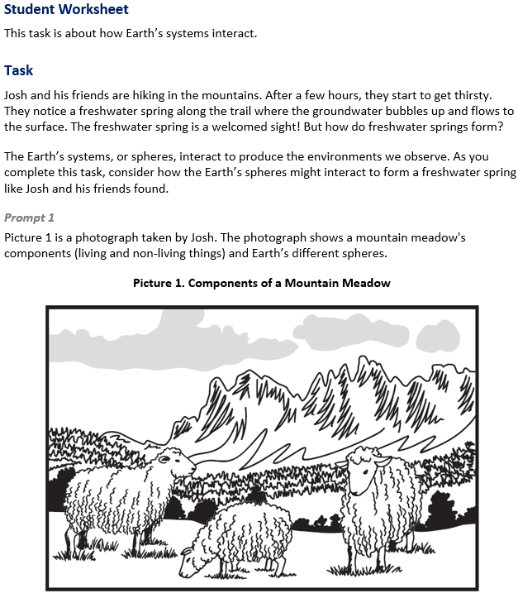

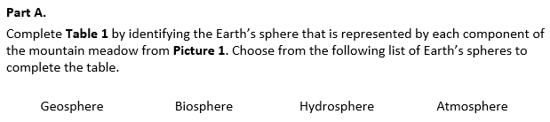  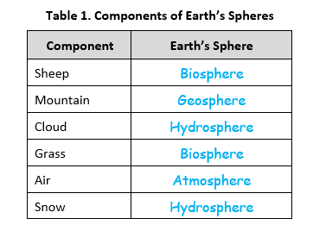  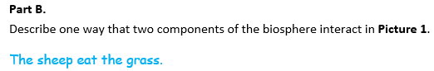  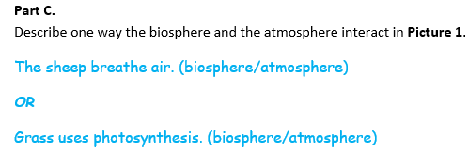
  Task 2 Prompt 1 Part A Complexity
  Degree and Nature of Sensemaking | Low | This task…  - Requires one or two dimensions
  Complexity of the Presentation | Low | - The amount and type of information provided in the scenario supports limited simple connections among ideas or concepts  - Provides few, simple graphics/data/models
  Cognitive Demand of Response Development | Moderate | - Requires application of ideas and practices given cues and guidance  - Requires drawing relationships and connecting ideas and practices
  Cognitive Demand of Response Production | Low | - Responses include selection from a small set of options presented as text (e.g., word, short phrase) or other formats (e.g., or a simple graphic or process)
  Task 2 Prompt 1 Parts B and C Complexity
  Degree and Nature of Sensemaking | Moderate | This prompt…  - Requires integration of two dimensions in the service of sensemaking  - Requires a combination of previously learned ideas or concepts and newly presented information
  Complexity of the Presentation | Low | - The amount and type of information provided in the scenario supports limited simple connections among ideas or concepts  - Phenomenon or problem presented in a concrete way with high level of certainty
  Cognitive Demand of Response Development | Moderate | - Requires drawing relationships and connecting ideas and practices  - Requires a moderate level of sophistication with typical and relatively complex representation of ideas and application of skills
  Cognitive Demand of Response Production | Moderate | - Response includes one or more sentences or a paragraph, a moderately complex graphic, or multiple steps in a simple or moderately complex process
  Task 2 Prompt 1 Parts A-C
  Connections to the Instructional Framework, Continued
  Formative Assessments | Opportunities to Learn
  Segment 4, pp. 21-22  Informal Assessment: Earth’s Spheres: We Are All Connected! (A9, A10*, A12, A19)  - Students identify information from one or more sources that relate to elements of four major systems of the Earth.  - Students describe how a model represents the four major systems of the Earth.  - Students identify and describe relationships (interactions) within and between the parts of the Earth systems identified in the model that are relevant to the example. | Segment 4, pp. 40-41  Nature Walk: Observations of the Earth’s Spheres (A9, A10*, A11*, A19)  - Students investigate Earth spheres/systems by making observations in nature. They go on a nature walk in a neighboring preserve, collecting water samples or other objects such as leaves, twigs, and rocks.  - During the nature walk, students observe and record their observations. Students then classify the material they collected from their nature walks as well as their observations.  Segment 4, p. 41  Explaining our Classifications (A9, A11*)  - Students note similarities in classifications such as plants, trees, flowers, water, air, rocks, soil, and the sun. After students explain their classifications, they watch a video about the Earth’s spheres. Students then reclassify their observations into the “Four Earth Spheres” and create a chart based on the information from the videos.
  Task 2 Prompt 1 Parts A-C
  Connections to the Instructional Framework
  Integration of Knowledge and Skills for Response Development
  Part A
  - Students review the provided informational text and picture about Earth’s systems and an example of the interaction of Earth’s spheres along a hiking trail and the phenomenon of the formation of a freshwater spring.
  - Students combine the text and information provided in the picture to identify components of Earth systems (hydrosphere, biosphere, geosphere, and atmosphere) in the scenario.
  - Students complete Table 1 by matching aspects with a corresponding sphere.
  Parts B and C
  - Students review the provided informational text and picture about Earth’s systems and an example of the interaction of Earth’s spheres along a hiking trail and the phenomenon of the formation of a freshwater spring.
  - Students use the provided information to identify and describe interactions and components in a single system in the scenario.
  - In Part B, students identify an interaction of two components of the biosphere.
  - In Part C, students identify an interaction of the biosphere and atmosphere.
  Task 2 Prompt 1 Parts A-C
  Connections to the Instructional Framework, Continued
  Formative Assessments | Opportunities to Learn
  Segment 4, pp. 22-23  Formal Assessment: Where in the Bottle are the Earth’s Spheres (A9, A12, A19)  - Students identify information from one or more sources that relate to elements of four major systems of Earth.  - Students identify and describe relationships (interactions) within and between the parts of the Earth systems identified in the model that are relevant to the example.  - Students describe how a model shows changes in one or more systems.  - Students describe relationships and/or interactions between elements of the four major systems of the Earth as found in different sources. | Segment 4, pp. 41-42  Earth’s Spheres in a Terrarium (A9, A10*, A11*, A12, A19)  - Students design and construct a bottle terrarium to observe a system and identify the parts of the terrarium’s four spheres. After constructing the terrarium, students develop a visual model of the terrarium that also labels/includes the four Earth spheres.  - Students then record what they see in the terrarium and classify their observations into the four spheres that they have included in their model.  Segment 4, pp. 43-44  Modeling Earth’s Systems (A19)  - Students use a model of the Earth systems and spheres and add to the model to represent how human activity can affect the Earth systems. Students obtain information to be used in their model from multiple sources. After modifying the model, students explain how the activities impact an Earth system (or systems).
Task 2 Prompt 2  Performance Category: Model Relationships to Communicate Information about Earth’s Surface Materials and Processes  Acquisition Goals  - A9: Obtain information from multiple sources to communicate information about the elements of the four major systems of the Earth.  - A10: Develop a model to describe the relationship between two Earth's systems under study.*  - A11: Construct an explanation on the cause-and-effect relationship between two interacting systems to address how changes in one system can cause changes in another interacting system.  - A12: Use a model to describe the four major systems of the Earth.  - A19: Develop a model using an example to describe ways the geosphere, biosphere, hydrosphere, and/or atmosphere interact. [5-ESS2-1]*  Prompt 2 measures students’ ability to:  - Develop or use models to support descriptions and predictions of relationships about interactions among components of various Earth systems in a stream environment. |  | 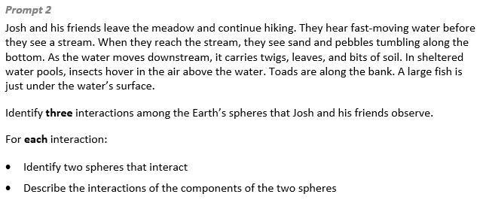  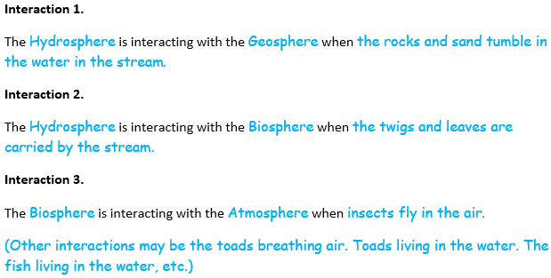
Task 2 Prompt 3 – Parts A and B  Performance Categories: Analyze Data to Describe the Availability of Needed Natural Resources  Acquisition Goals:  - A1: Use mathematics to describe and graph quantities about the distribution of water on Earth.  - A3: Obtain information from multiple sources to communicate information about the sources and distribution of fresh water on Earth to illustrate that nearly all of Earth's available freshwater reserves are glaciers and groundwater.  - A4: Construct an explanation using evidence on what are the largest sources of fresh water on Earth.  Prompt 3 Parts A and B measure students’ ability to:  - Analyze and interpret data and graphs to support conclusions about the distribution of saltwater and freshwater reservoirs on Earth and the importance of maintaining supplies of fresh water.  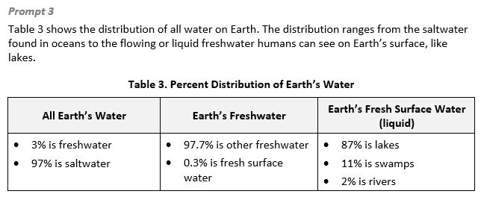 |  | 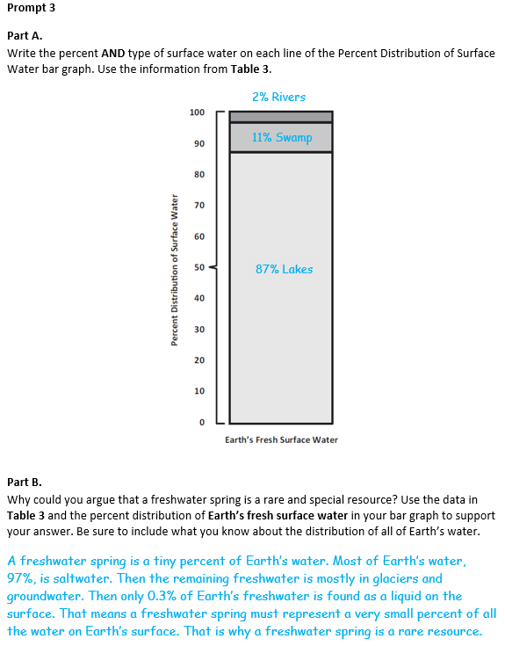
  Task 2 Prompt 2 Complexity
  Degree and Nature of Sensemaking | Low | This prompt…  - Requires one or two dimensions  - One dimension may have a greater degree of emphasis than another
  Complexity of the Presentation | Low | - The amount and type of information provided in the scenario supports limited simple connections among ideas or concepts  - Phenomenon or problem presented in a concrete way with high level of certainty
  Cognitive Demand of Response Development | Moderate | - Requires drawing relationships and connecting ideas and practices  - Requires a moderate level of sophistication with typical and relatively complex representation of ideas and application of skills
  Cognitive Demand of Response Production | Moderate | - Response includes one or more sentences or a paragraph, a moderately complex graphic, or multiple steps in a simple or moderately complex process
  Task 2 Prompt 2
  Connections to the Instructional Framework, Continued
  Formative Assessments | Opportunities to Learn
  Segment 4, pp. 22-23  Formal Assessment: Where in the Bottle are the Earth’s Spheres (A9, A12, A19)  - Students identify information from one or more sources that relate to elements of four major systems of Earth.  - Students describe aspects of the elements of the four major systems of Earth as found in different sources.  - Students identify and describe relationships (interactions) within and between the parts of the Earth systems identified in the model that are relevant to the example.  Segment 4, pp. 23-24  Formal Assessment: Protecting Earth’s Environment (A11)  - Students describe how changes in one system can cause changes in another system.  - Students identify information that shows the cause/and effect relationship between two interacting systems. | Segment 4, p. 41  Explaining our Classifications (A9, A11)  - Students note similarities in classifications such as plants, trees, flowers, water, air, rocks, soil, and the sun. After students explain their classifications, they watch a video about the Earth’s spheres. Students then reclassify their observations into the “Four Earth Spheres” and create a chart based on the information from the videos.  Segment 4, pp. 41-42  Earth’s Spheres in a Terrarium (A9, A10*, A11, A12, A19*)  - Students design and construct a bottle terrarium, record their observations of the resulting system, and identify parts of the terrarium’s four spheres. Students then develop a visual model of the terrarium that also labels/includes the four Earth spheres.  - Students record what they see in the terrarium and classify their observations into the four spheres that they have included in their model.
  Task 2 Prompt 2
  Connections to the Instructional Framework
  Integration of Knowledge and Skills for Response Development
  - Students review the provided informational text about Earth’s systems and an example of the interaction of Earth’s spheres along a hiking trail and the phenomenon of the formation of a freshwater spring.
  - Students use the provided information to identify and describe interactions and components between two systems using a description of a stream environment.
  - Students respond with three distinct interactions between two different spheres, including identification of the components related to each sphere in the interaction and a description of how one component interacts with the other.
  Formative Assessments | Opportunities to Learn
  Segment 4, pp. 21-22  Informal Assessment: Earth’s Spheres: We Are All Connected! (A9, A10*, A12, A19)  - Students predict how changes in one system will impact another system based on what is shown in a model.  - Students identify information that shows how the cause in one system can cause changes in another interacting system.  - Students identify and describe relationships (interactions) within and between the parts of the Earth systems identified in the model that are relevant to the example. | Segment 4, pp. 40-41  Nature Walk: Observations of the Earth’s Spheres (A9, A10*, A11*, A19)  - Students investigate Earth spheres/systems by making observations in nature. They go on a nature walk in a neighboring preserve.  - Students may collect water samples or other objects such as leaves, twigs, and rocks.  - During the nature walk, students observe and record their observations. Students then classify the material they collected from their nature walks as well as their observations.
  Task 2 Prompt 3 Parts A and B Complexity
  Degree and Nature of Sensemaking | Moderate | This prompt…  - Requires integration of two dimensions in the service of sense-making
  Complexity of the Presentation | Moderate | - The amount and type of information provided in the scenario supports multiple evident connections among ideas or concepts  - Provides graphics/data/models
  Cognitive Demand of Response Development | High | - Requires selection and application of multiple complex ideas and practices  - Requires high degree of sense- making, reasoning, and/or transfer
  Cognitive Demand of Response Production | Moderate | - Response includes one or more sentences or a paragraph, a moderately complex graphic, or multiple steps in a simple or moderately complex process
  Task 2 Prompt 3 Parts A and B
  Connections to the Instructional Framework
  Integration of Knowledge and Skills for Response Development
  - Students analyze and interpret Table 3, which indicates the percent distribution of Earth’s water.
  - In Part A, students use Table 3 to graph information to describe the proportions and distributions of fresh surface water on Earth.
  - In Part B, students use evidence from Table 3 to communicate information of water on Earth and to explain why a freshwater spring is a rare and special resource.
  Formative Assessments | Opportunities to Learn
  Segment 1, pp. 9-10  Informal Assessment: A Globe Full of Water (A1)  - Students use mathematics to describe the distribution of water on Earth.  - Students generate a graph that shows the distribution of water on Earth. | Segment 1, pp. 31-32  A Globe Full of Water (A1, A3)  - Students use small paper squares to cover the Earth in different colored papers and then use those papers to estimate the percentages of surface area of water on Earth. Then, students hypothesize and investigate the small-scale model of global water as a liter bottle distribution activity.  - Students continue with additional research of the volumes and percentages of salt and fresh water to develop graphs. Then, they observe and interpret other types of data infographics that show distributions, and/or create and share their own versions in infographics to illustrate the global water distribution data.
Task 2 Prompt 4 – Parts A-C  Performance Categories: Model Relationships to Communicate Information about Earth’s Surface Materials and Processes  Acquisition Goals:  - A10: Develop a model to describe the relationship between two Earth systems under study.  - A11: Construct an explanation on the cause-and-effect relationship between two interacting systems to address how changes in one system can cause changes in another interacting system.  - A12: Use a model to describe the four major systems of the Earth.  - A19: Develop a model using an example to describe ways the geosphere, biosphere, hydrosphere, and/or atmosphere interact. [5-ESS2-1]  Prompt 4 Parts A, B, and C measure students’ ability to:  - Develop or use models to support descriptions and predictions of relationships about the interaction of Earth’s spheres which result in the formation of a freshwater spring. |  | 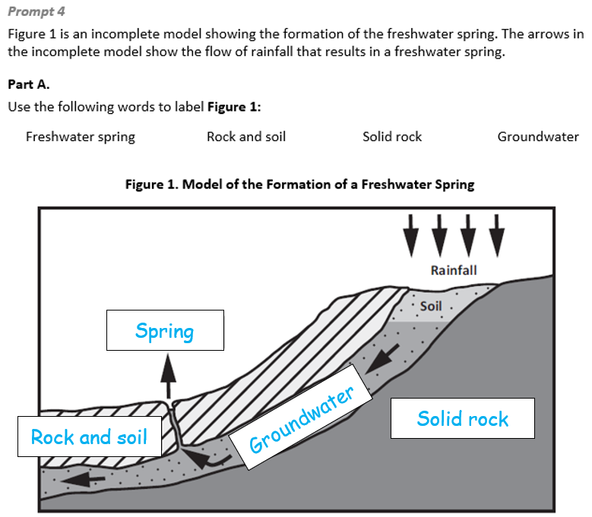  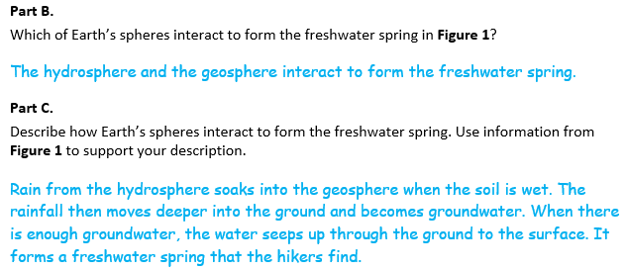
  Task 2 Prompt 3 Parts A and B
  Connections to the Instructional Framework, Continued
  Formative Assessments | Opportunities to Learn
  Segment 1, pp. 10-11  Formal Assessment: Where’s the Water (A1, A3)  - Students obtain information that supports the statement that most of Earth's available freshwater reserves are in glaciers and groundwater.  - Students use mathematics to describe the distribution of water on Earth.  - Students generate a graph that shows the distribution of water on Earth.  Segment 1, p. 11  Formal Assessment: Fresh Water by the Numbers (A1, A3)  - Students obtain information that supports a model that most of Earth's available freshwater reserves are in glaciers and groundwater.  - Students generate representations that show the sources of Earth’s fresh water.  - Students use mathematics to describe the distribution of water on Earth. | Segment 1, pp. 33-34  Water in the Snow, Glaciers, and Underground (A3, A4)  - Students investigate how much water is in snow and ice with simple melting and measuring experiments, which can be extended with various types of snow and/or how long the melting takes.  - Students read about groundwater and water tables, and then design models of groundwater aquifers to educate younger students about groundwater.  Segment 1, p. 34  Our Glass of Water (A3, A4)  - Students work to finalize their explanatory models about where a glass of water in their school comes from and where the water used in the school goes. Students give feedback to peers to help improve their explanatory models and then share their final models with the class.
  Task 2 Prompt 4 Part A Complexity
  Degree and Nature of Sensemaking | Moderate | This prompt…  - Requires integration of two dimensions in the service of sense-making
  Complexity of the Presentation | Low | - The amount and type of information provided in the scenario supports limited simple connections among ideas or concepts  - Provides few, simple graphics/data/models
  Cognitive Demand of Response Development | Moderate | - Requires application of ideas and practices given cues and guidance  - Requires drawing relationships and connecting ideas and practices
  Cognitive Demand of Response Production | Low | - Responses include selection from a small set of options presented as text (e.g., word, short phrase) or other formats (e.g., or a simple graphic or process)
  Task 2 Prompt 4 Parts A-C
  Connections to the Instructional Framework
  Integration of Knowledge and Skills for Response Development
  Part A
  - Students review Figure 1, an incomplete model showing the formation of a freshwater spring which includes arrows indicating the flow of rainfall.
  - Students use the provided words to label Figure 1, identifying components of a model to show the interaction of two of Earth’s systems related to the formation of a freshwater spring.
  Parts B and C
  - Students refer to their completed Figure 1, a model showing the formation of a freshwater spring which includes arrows indicating the flow of rainfall.
  - In Part B, students describe components of a model to show the interaction of two of Earth’s systems related to the formation of a freshwater spring.
  - In Part C, students use the model to support a description of how Earth’s spheres interact which lead to the formation of the freshwater spring.
  Formative Assessments | Opportunities to Learn
  Segment 4, pp. 21-22  Informal Assessment: Earth’s Spheres: We Are All Connected! (A10, A12*, A19*)  - Students develop a model, using a specific given example of a phenomenon, to describe ways that the geosphere, biosphere, hydrosphere, and/or atmosphere interact. | Segment 4, pp. 41-42  Earth’s Spheres in a Terrarium (A10, A11*, A12*, A19*)  - Students design and construct a bottle terrarium to observe a system and identify the parts of the terrarium’s four spheres. Then, students develop a visual model of the terrarium that also labels/includes the four Earth spheres.
  Task 2 Prompt 4 Parts A-C
  Connections to the Instructional Framework, Continued
  Formative Assessments | Opportunities to Learn
  Segment 4, pp. 23-24
  Formal Assessment: Protecting Earth’s Environment (A11)
  - Students describe how changes in one system can cause changes in another system.
  - Students identify information that shows the cause/and effect relationship between two interacting systems.
  - Students create an explanation for how changes in one system can cause changes in another interacting system.
  - Students describe how two of Earth's systems interact based on data.
  Task 2 Prompt 4 Parts B and C Complexity
  Degree and Nature of Sensemaking | Moderate | This prompt…  - Requires integration of two dimensions in the service of sense-making
  Complexity of the Presentation | Low | - The amount and type of information provided in the scenario supports limited simple connections among ideas or concepts  - Provides few, simple graphics/data/models
  Cognitive Demand of Response Development | High | - Requires selection and application of multiple complex ideas and practices  - Requires high degree of sense-making, reasoning, and/or transfer
  Cognitive Demand of Response Production | Moderate | - Responses include one or more sentences or a paragraph, a moderately complex graphic, or multiple steps in a simple or moderately complex process
  Task 2 Prompt 4 Parts A-C
  Connections to the Instructional Framework, Continued
  Formative Assessments | Opportunities to Learn
  Segment 4, pp. 22-23  Formal Assessment: Where in the Bottle are the Earth’s Spheres (A12*, A19)  - Students identify information from one or more sources that relate to elements of four major systems of Earth.  - Students develop a model, using a specific given example of a phenomenon, to describe ways that the geosphere, biosphere, hydrosphere, and/or atmosphere interact.  - Students identify and describe relationships (interactions) within and between the parts of the Earth systems identified in the model that are relevant to the example. | - Students then record what they see in the terrarium and classify their observations into the four spheres that they have included in their model.  Segment 4, pp. 42-43  Interaction of Earth’s Spheres (A11*)  - Students observe pictures to identify and describe the Earth’s four spheres and explain their interactions.  - Students create a slideshow to communicate the interactions between two spheres in each photo.  Segment 4, pp. 43-44  Modeling Earth’s Systems (A19)  - Students use a model of the Earth systems and spheres and add to the model to represent how human activity can affect the Earth systems. Students obtain information for their model from multiple sources. After modifying the model, students explain how the activities impact an Earth system (or systems).

Future Learning Connected to evidence elicited in Task 2
Crosscutting Concepts
- In Unit 3, students focus on systems and system models in terms of their components and interactions. Their experience with these concepts will help them as they apply these concepts in Unit 4 to learn about gravitational force, the distance between different stars, and how it impacts their apparent brightness from the Earth. In Unit 4, Acquisition Goal 11 requires students to use a model to describe that Earth's gravitational force pulls objects down to the Earth's surface. Students are asked to engage with data analysis, modeling, and supporting explanations to address concepts around how gravitational force acts on different objects and how it pulls objects down to the Earth’s surface. (Informal Assessment: Why Don’t We Fly Up Off the Earth’s Surface into the Sky? What’s Holding Us Down?, pp. 13-14)
Disciplinary Core Ideas
- In Unit 3, students demonstrate an understanding of the ways the geosphere, biosphere, hydrosphere and/or atmosphere interact. These ideas, especially understanding Earth’s major systems, prepare students for Unit 4 in which they will consider how Earth’s gravitational force pulls objects towards the planet’s center. In Unit 4, Acquisition Goal 12 requires students to analyze and interpret data to demonstrate that Earth's gravitational force pulls objects down to the Earth's surface. Students explore content that includes several pieces of evidence to support the claim that the Earth’s gravitational forces pull objects down to the Earth’s surface. (Formal Assessment: Which Way is Down?, pp. 14-15)
Science and Engineering Practices
- Over the course of this unit, students develop and use models. Their experience with these concepts will help them as they apply these concepts in Unit 4 to learn about gravitational force, the distance between different stars, and how it impacts their apparent brightness from the Earth. In Unit 4, Acquisition Goal 11 requires students to use a model to describe that Earth's gravitational force pulls objects down to the Earth's surface. Students are asked to engage with data analysis, modeling, and supporting explanations to address concepts around how gravitational force acts on different objects and how it pulls objects down to the Earth’s surface. (Informal Assessment: Why Don’t We Fly Up Off the Earth’s Surface into the Sky? What’s Holding Us Down?, pp. 13-14)

SIPS Grade 5 Unit 3 EOU Assessment Task 3: Protecting Earth’s Soil  Task 3 Prompt 1 Parts A and B  Performance Category: Model Relationships to Communicate Information about Earth’s Surface Materials and Processes  Acquisition Goals:  - A10: Develop a model to describe the relationship between two Earth's systems under study.  - A11: Construct an explanation on the cause-and-effect relationship between two interacting systems to address how changes in one system can cause changes in another interacting system.  - A12: Use a model to describe the four major systems of the Earth. *  - A19: Develop a model using an example to describe ways the geosphere, biosphere, hydrosphere, and/or atmosphere interact. [5-ESS2-1]  Prompt 1 Parts A and B measure students’ ability to:  - Develop or use models to support descriptions and predictions of relationships about how Earth’s hydrosphere is involved in an event related to soil erosion with and without vegetation. |  | 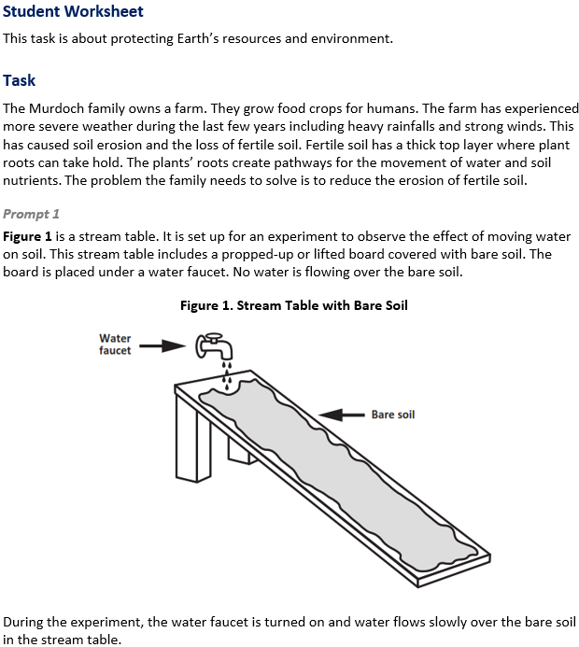
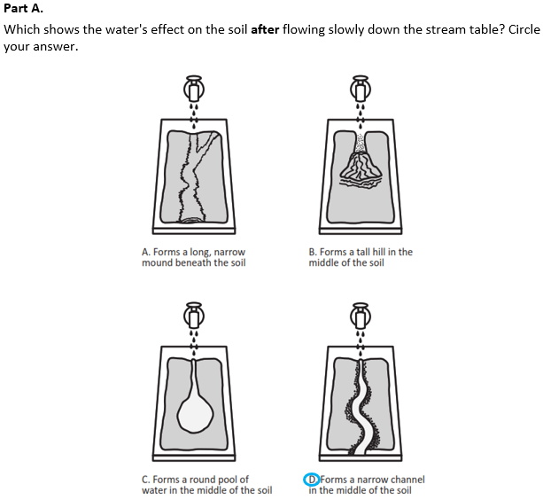 |  | 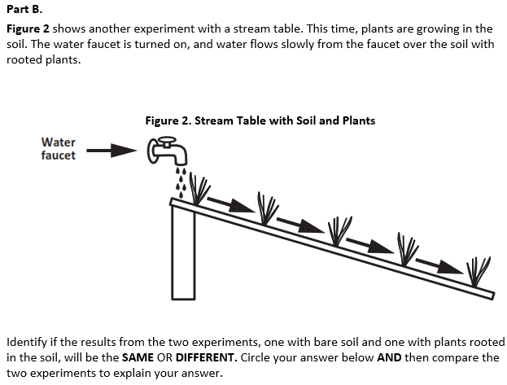  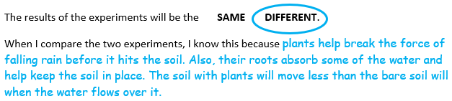

Task 3 Prompt 2 Parts A and B  Performance Category: Model Relationships to Communicate Information about Earth’s Surface Materials and Processes  Acquisition Goals:  - A10: Develop a model to describe the relationship between two Earth's systems under study.*  - A11: Construct an explanation on the cause-and-effect relationship between two interacting systems to address how changes in one system can cause changes in another interacting system.  - A12: Use a model to describe the four major systems of the Earth*  - A19: Develop a model using an example to describe ways the geosphere, biosphere, hydrosphere, and/or atmosphere interact. [5-ESS2-1]  Prompt 2 Parts A and B measures students’ ability to:  - Develop or use models to support descriptions and predictions of relationships about how Earth’s atmosphere is involved in an event related to wind erosion.  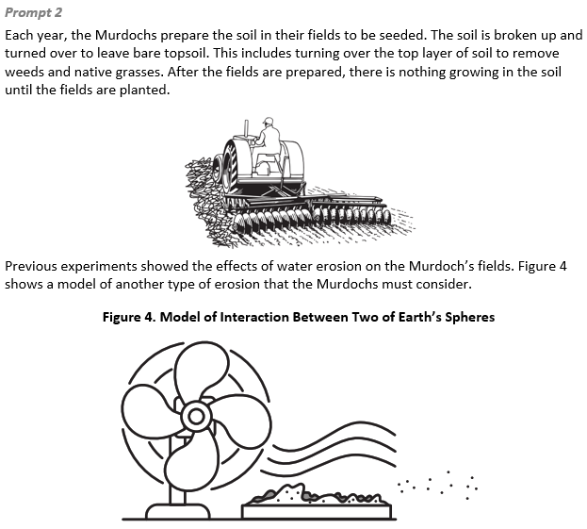 |  | 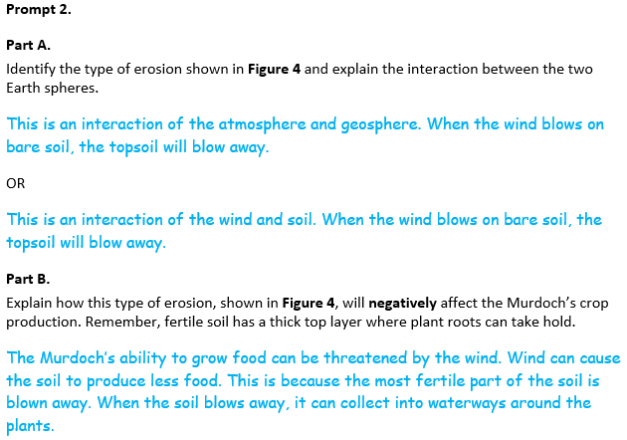
  Task 3 Prompt 1 Part A Complexity
  Degree and Nature of Sensemaking | Low | This prompt…  - Requires one or two dimensions  - One dimension may have a greater degree of emphasis than another
  Complexity of the Presentation | Low | - The amount and type of information provided in the scenario supports limited simple connections among ideas or concepts  - Provides few, simple graphics/data/models
  Cognitive Demand of Response Development | Moderate | - Requires drawing relationships and connecting ideas and practices  - Requires a moderate level of sophistication with typical and relatively complex representation of ideas and application of skills
  Cognitive Demand of Response Production | Low | - Responses include selection from a small set of options presented as text (e.g., word, short phrase) or other formats (e.g., or a simple graphic or process)
  Task 3 Prompt 1 Parts A and B
  Connections to the Instructional Framework
  Integration of Knowledge and Skills for Response Development
  Part A
  - Students review the task background and Figure 1, which presents a scenario and an initial model of a farm that has been experiencing more severe weather in recent years. The problem the farm needs to solve is to reduce soil erosion.
  - Students identify a final model showing how two of Earth’s systems are involved in an event related to the effects of soil erosion on the farm.
  Part B
  - Students refer to Figure 2, a model showing a stream table with soil and plants.
  - Students compare the components of Earth systems interacting in two models of a stream table, one with vegetation and the other without vegetation.
  - Students use the models to explain that the plant roots help keep the soil in place and the soil with plants does not wash away.
  Formative Assessments | Opportunities to Learn
  Segment 4, pp. 21-22
  Informal Assessment: Earth’s Spheres: We Are All Connected! (A10, A12*, A19)
  - Students develop a model that shows the relationships between two of Earth's systems.
  - Students develop a model, using a specific given example of a phenomenon, to describe ways that the geosphere, biosphere, hydrosphere, and/or atmosphere interact.
  Task 3 Prompt 1 Parts A and B
  Connections to the Instructional Framework, Continued
  Formative Assessments | Opportunities to Learn
  Segment 4, pp. 41-42
  Earth’s Spheres in a Terrarium (A10, A11*, A12*, A19)
  - Students design and construct a bottle terrarium to observe a system and identify the parts of the terrarium’s four spheres. After constructing the terrarium, students develop a visual model of the terrarium that also labels/includes the four Earth spheres.
  - Students then record what they see in the terrarium and classify their observations into the four spheres that they have included in their model.
  Segment 4, pp. 43-44
  Modeling Earth’s Systems (A19)
  - Students use a model of the Earth systems and spheres and add to the model to represent how human activity can affect the Earth systems. Students obtain information for their model from multiple sources. After modifying the model, students explain how the activities impact an Earth system (or systems).
  Task 3 Prompt 1 Part B Complexity
  Degree and Nature of Sensemaking | Moderate | This prompt…  - Requires integration of two dimensions in the service of sensemaking  - Requires a combination of previously learned ideas or concepts and newly presented information
  Complexity of the Presentation | Moderate | - The amount and type of information provided in the scenario supports multiple evident connections among ideas or concepts
  Cognitive Demand of Response Development | Moderate | - Requires drawing relationships and connecting ideas and practices  - Requires a moderate level of sophistication with typical and relatively complex representation of ideas and application of skills
  Cognitive Demand of Response Production | Moderate | - Responses include one or more sentences or a paragraph, a moderately complex graphic, or multiple steps in a simple or moderately complex process
  Task 3 Prompt 1 Parts A and B
  Connections to the Instructional Framework, Continued
  Formative Assessments | Opportunities to Learn
  Segment 4, pp. 22-23  Formal Assessment: Where in the Bottle are the Earth’s Spheres (A12*, A19)  - Students identify information from one or more sources that relate to elements of four major systems of Earth.  - Students develop a model, using a specific given example of a phenomenon, to describe ways that the geosphere, biosphere, hydrosphere, and/or atmosphere interact.  - Students identify and describe relationships (interactions) within and between the parts of the Earth systems identified in the model that are relevant to the example.  Segment 4, pp. 24-25  Formal Assessment: Earth’s Four Spheres Interaction Challenge (A19*)  - Students identify data and/or information about the interaction of two of Earth's systems under study related to a problem or challenge. | Segment 4, pp. 22-23  Evaluating Design and Preparing Presentations (A19)  - Students prepare a presentation that explains the problem their design solution is solving: to lessen the impact of human activity on depleting water resources.  - Students’ presentations should show how the criteria and constraints (e.g., how many people will be using the water, funds, materials, resources) are addressed through their design solution, which brings about water conservation.  Segment 4, pp. 23  Presentation Day (A19)  - Students compare various solutions, using information from available tests, to determine which solution is optimal.  - Finally, students draw conclusions based on the presentations and the design process about how different conditions affect the outcomes of a design solution.
  Task 3 Prompt 2 Parts A and B Complexity
  Degree and Nature of Sensemaking | Moderate | This prompt…  - Requires integration of two dimensions in the service of sensemaking  - Requires a combination of previously learned ideas or concepts and newly presented information
  Complexity of the Presentation | Low | - The amount and type of information provided in the scenario supports limited simple connections among ideas or concepts  - Provides few, simple graphics/data/models
  Cognitive Demand of Response Development | Moderate | - Requires drawing relationships and connecting ideas and practices  - Requires a moderate level of sophistication with typical and relatively complex representation of ideas and application of skills
  Cognitive Demand of Response Production | Moderate | - Responses include one or more sentences or a paragraph, a moderately complex graphic, or multiple steps in a simple or moderately complex process
  Task 3 Prompt 2 Parts A and B
  Connections to the Instructional Framework
  Integration of Knowledge and Skills for Response Development
  - Students read Prompt 2 and refer to Figure 4, which is a model of the interaction between two of Earth’s spheres.
  - Students identify and describe interactions and components between two systems using a model of wind erosion.
  - In Part A, students describe the interaction between the atmosphere (or wind) and the geosphere (or soil).
  - In Part B, students include a description of how the interaction of the atmosphere (or wind) and the geosphere (or soil) will result in a loss of topsoil or a reduction in crop production.
  Formative Assessments | Opportunities to Learn
  Segment 4, pp. 21-22  Informal Assessment: Earth’s Spheres: We Are All Connected! (A10*, A12*, A19)  - Students develop a model that shows the relationships between two of Earth's systems.  - Students develop a model, using a specific given example of a phenomenon, to describe ways that the geosphere, biosphere, hydrosphere, and/or atmosphere interact. | Segment 4, pp. 22-23  Evaluating Design and Preparing Presentations(A19)  - Students prepare a presentation that explains the problem their design solution is solving whose goal is to lessen the impact of human activity on depleting water resources.  - Students’ presentations should clearly show how the criteria and constraints (e.g., how many people will be using the water, funds, materials, resources) are addressed through their design solution, which in the long run brings about water conservation.
Task 3 Prompt 3 Parts A-C  Performance Category: Design the Best Solution to a Problem Involving Human Impacts on Earth Systems  Acquisition Goals:  - A14: Obtain and evaluate information from a variety of sources as the basis for claims about the positive or negative impact of human activities on Earth’s systems.*  - A15: Design and carry out an investigation to characterize the impact of human activities on a particular design solution.*  - A17: Design investigations where different conditions are considered relative to the outcomes that are important for a design solution.*  - A21: Generate and compare multiple solutions to a problem based on how well they meet the criteria and constraints of the design problem. [3-5-ETS1-2]  Prompt 3 Parts A, B, and C measure students’ ability to:  - Design a solution to a problem involving human impacts on Earth systems by explaining information to affect positive changes through protection of fertile soil by reducing the effects of wind erosion.  Task 3 Prompt 4 Parts A and B  Performance Category: Design the Best Solution to a Problem Involving Human Impacts on Earth Systems  Acquisition Goals:  - A15: Design and carry out an investigation to characterize the impact of human activities on a particular design solution.  - A16: Modify a design solution using information on the impact of human activities on the outcome of the solution, including specifying the way that the human activities can be reversed or addressed.*  - A18: Use information from available tests as the basis for deciding how a particular solution meets constraints and success criteria and how this can be used to choose an optimal solution.  - A21: Generate and compare multiple solutions to a problem based on how well they meet the criteria and constraints of the design problem. [3-5-ETS1-2]  Prompt 4 Parts A and B measure students’ ability to:  - Design a solution to a problem involving human impacts on Earth systems by identifying the criteria that can be used to draw conclusions about the solution’s effectiveness. |  | 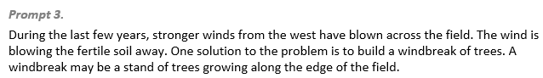  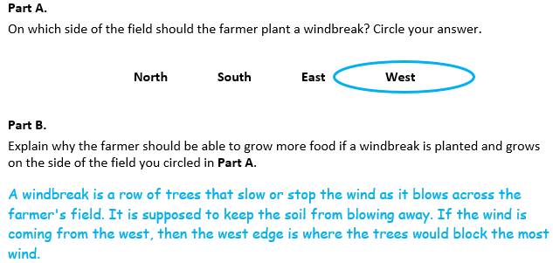  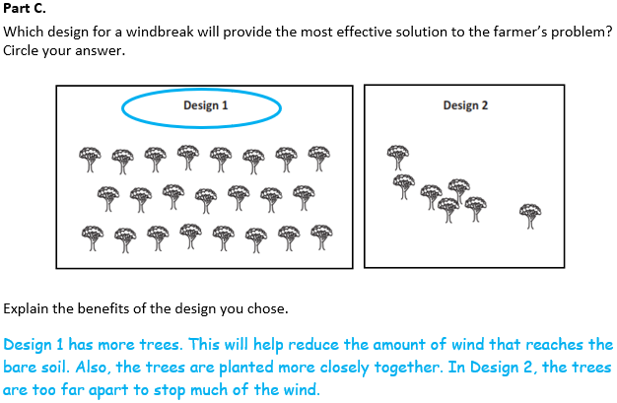  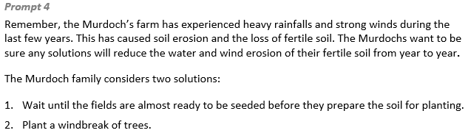  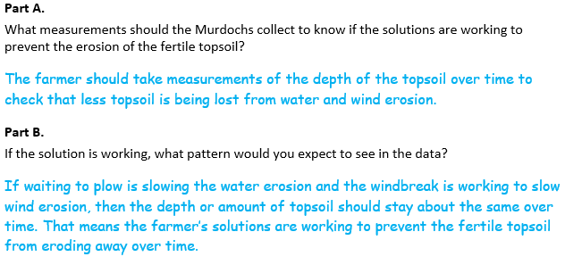
  Task 3 Prompt 2 Parts A and B
  Connections to the Instructional Framework, Continued
  Formative Assessments | Opportunities to Learn
  Segment 4, pp. 22-23  Formal Assessment: Where in the Bottle are the Earth’s Spheres (A12, A19)  - Students identify information from one or more sources that relate to elements of four major systems of Earth.  - Students develop a model, using a specific given example of a phenomenon, to describe ways that the geosphere, biosphere, hydrosphere, and/or atmosphere interact.  - Students identify and describe relationships (interactions) within and between the parts of the Earth systems identified in the model that are relevant to the example. | Segment 4, pp. 23  Presentation Day (A19)  - Students compare various solutions, using information from available tests, to determine which solution is optimal.  - Finally, students draw conclusions based on the presentations and the design process about how different conditions affect the design solution.  Segment 4, pp. 41-42  Earth’s Spheres in a Terrarium (A10*, A11*, A19)  - Students design and construct a bottle terrarium to observe a system and identify the parts of the terrarium’s four spheres. After constructing the terrarium, students develop a visual model of the terrarium that also labels/includes the four Earth spheres.  - Students then record what they see in the terrarium and classify their observations into the four spheres that they have included in their model.
  Task 3 Prompt 3 Parts A and B Complexity
  Degree and Nature of Sensemaking | Moderate | This prompt…  - Requires integration of two dimensions in the service of sensemaking  - Requires a combination of previously learned ideas or concepts and newly presented information
  Complexity of the Presentation | Low | - The amount and type of information provided in the scenario supports limited simple connections among ideas or concepts  - Provides few, simple graphics/data/models
  Cognitive Demand of Response Development | High | - Requires selection and application of multiple complex ideas and practices  - Requires high degree of sense-making, reasoning, and/or transfer
  Cognitive Demand of Response Production | Moderate | - Responses include one or more sentences or a paragraph, a moderately complex graphic, or multiple steps in a simple or moderately complex process
  Task 3 Prompt 3 Parts A-C
  Connections to the Instructional Framework
  Integration of Knowledge and Skills for Response Development
  Parts A and B
  - Students read the provided background information, which introduces a problem the farm needs to solve as reducing soil erosion.
  - Students evaluate a list of options and identify the best location for a windbreak.
  - Students provide an explanation that takes into consideration the criteria and constraints presented by soil erosion.
  Part C
  - Students evaluate the two options provided as a solution for the problem of soil erosion.
  - Students identify the best design solution (i.e., windbreak) helps humans to affect positive change based on ongoing processes (i.e., changing weather).
  - Students select “Design 1” and explain and why it meets the criteria and constraints better than design 2.
  Formative Assessments | Opportunities to Learn
  Segment 2, pp. 15-16  Formal Assessment: Explaining Impacts of Human Activity (A14*, A15*, A21)  - Students identify information from one or more sources that relate to how human activities affect the Earth system.  - Students evaluate information to determine whether or not the information supports claims for how human | Segment 2, pp. 34-35  Water, Water, Everywhere and Not a Drop to Drink (A21)  - The teacher shares with students the challenge of the Ogallala Aquifer, and how the level of water is dropping faster than it can be recharged.  - Students brainstorm ideas for their solution with the understanding that they will learn more about the topic in
  Task 3 Prompt 3 Parts A-C
  Connections to the Instructional Framework, Continued
  Formative Assessments | Opportunities to Learn
  Segment 3, pp. 18-19  Wrench in the Plans (A17*, A21)  - Students use scientific knowledge to generate design solutions.  - Students evaluate potential solutions to the design problem. | Segment 2, pp. 38-39  Nature Impact (A14*, A15*, A17, A21)  - Students review news articles and resources on the positive and negative impact of dams.  - Students share their thinking about dams and their usage for water reservoirs, flood control, energy, and the impact that has on the local fish, wildlife, and people in those areas.
  Task 3 Prompt 4 Parts A and B Complexity
  Degree and Nature of Sensemaking | Moderate | This prompt…  - Requires integration of two dimensions in the service of sensemaking  - Requires a combination of previously learned ideas or concepts and newly presented information
  Complexity of the Presentation | Low | - The amount and type of information provided in the scenario supports limited simple connections among ideas or concepts  - Provides few, simple graphics/data/models
  Cognitive Demand of Response Development | High | - Requires selection and application of multiple complex ideas and practices  - Requires high degree of sense-making, reasoning, and/or transfer
  Cognitive Demand of Response Production | Moderate | - Responses include one or more sentences or a paragraph, a moderately complex graphic, or multiple steps in a simple or moderately complex process
  Task 3 Prompt 4 Parts A and B
  Connections to the Instructional Framework, Continued
  Formative Assessments | Opportunities to Learn
  Segment 3, pp. 16-17  Informal Assessment: Class Discussions (A15*, A16*, A21)  - Students modify a design solution to reduce the negative effects of human activities on a solution.  - Students describe how a design activity can help address or reverse negative effects of human activities.  - Students use scientific knowledge to generate design solutions.  - Students evaluate potential solutions. | Segment 2, pp. 36-37  You Are What You Drink (A15, A21)  - Students explore the problem of water pollution/purification.  - Students investigate the process and consequences of water contamination on the land, groundwater, and plants. Students review articles and media about pollution events and risks.  - Students consider these negative impacts and potential concerns for their own water reduction process and refine their solutions to the engineering problem to minimize negative impacts.  Segment 2, pp. 38-39  Nature Impact (A21)  - Students review news articles, videos, and resources on the positive and negative impact of dams.  - Students share their thinking about dams and their usage for water reservoirs, flood control, energy, and the impact that has on the local fish, wildlife, and people in those areas.
  Task 3 Prompt 2 Parts A and B
  Connections to the Instructional Framework, Continued
  Formative Assessments | Opportunities to Learn
  Segment 4, pp. 43-44
  Modeling Earth’s Systems (A19)
  - Students use a model of the Earth systems and spheres and add to the model to represent how human activity can affect the Earth systems. Students obtain information for their model from multiple sources. After modifying the model, students explain how the activities impact an Earth system (or systems).
  Task 3 Prompt 3 Part C Complexity
  Degree and Nature of Sensemaking | Moderate | This prompt…  - Requires integration of two dimensions in the service of sensemaking  - Requires a combination of previously learned ideas or concepts and newly presented information
  Complexity of the Presentation | Moderate | - The amount and type of information provided in the scenario supports multiple evident connections among ideas or concepts
  Cognitive Demand of Response Development | Moderate | - Requires drawing relationships and connecting ideas and practices  - Requires a moderate level of sophistication with typical and relatively complex representation of ideas and application of skills
  Cognitive Demand of Response Production | Moderate | - Responses include one or more sentences or a paragraph, a moderately complex graphic, or multiple steps in a simple or moderately complex process
  Task 3 Prompt 3 Parts A-C
  Connections to the Instructional Framework, Continued
  Formative Assessments | Opportunities to Learn
  activities impact the Earth system.  - Students describe how human activities impact Earth system(s) based on information found from a variety of resources.  Segment 3, pp. 16-17  Informal Assessment: Class Discussions (A14*, A15*,A21)  - Students identify information from one or more sources that relate to how human activities affect the Earth system.  - Students evaluate information to determine whether or not the information supports claims for how human activities impact the Earth system.  - Students describe how human activities impact Earth system(s) based on information found from a variety of resources.  - Students use scientific knowledge to generate design solutions. | heterogenous groups and refine their solution as they proceed through the unit.  Segment 2, pp. 36-37  You Are What You Drink (A14*, A15*, A17*, A21)  - Students explore the problem of water pollution/purification.  - Students investigate the process and consequences of water contamination on the land, groundwater, and plants. Students review articles and media about pollution events and risks.  - Students consider these negative impacts and potential concerns for their own water reduction process and refine their solutions to the engineering problem to minimize negative impacts.
  Task 3 Prompt 4 Parts A and B
  Connections to the Instructional Framework
  Integration of Knowledge and Skills for Response Development
  - Students read the prompt and consider the two solutions that the farm is considering to help reduce wind erosion.
  - Students describe an experimental procedure appropriate to draw conclusions about the functioning of the windbreak.
  - Students include the measurement of the depth of the fertile topsoil and description of how maintaining a similar or improved depth of fertile topsoil over time shows how well the solution functions over time in their explanation.
  Formative Assessments | Opportunities to Learn
  Segment 2, pp. 15-16  Formal Assessment: Explaining Impacts of Human Activity (A15, A16*, A21)  - Students modify a design solution to reduce the negative effect of human activities on a solution.  - Students describe how a design activity can help address or reverse negative effects of human activities.  - Students use scientific knowledge to generate design solutions.  - Students evaluate potential solutions. | Segment 2, pp. 34-35  Water, Water, Everywhere and Not a Drop to Drink (A21)  - The teacher shares with students the challenge of the Ogallala Aquifer, and how the level of water is dropping faster than it can be recharged.  - Students brainstorm ideas for their solution with the understanding that they will learn more about the topic in heterogenous groups and will refine their solution as they proceed through the unit.
  Task 3 Prompt 4 Parts A and B
  Connections to the Instructional Framework, Continued
  Formative Assessments | Opportunities to Learn
  Segment 3, pp. 18-19  Formal Assessment: Wrench in the Plans (A16*, A18, A21)  - Students draw a conclusion based on an investigation about how different conditions affect the outcomes of a design solution.  - Students determine how a solution meets the success criteria and/or constraints of a problem.  - Students generate and compare multiple design solutions, using information from available tests, to determine which solution is more optimal.  Segment 3, pp. 20-21  Formal Assessment: How Did Our Design Do? (A18)  - Students determine how a solution meets the success criteria and/or constraints of a problem.  - Students compare solutions, using information from available tests, to determine which solution is more optimal. | Segment 3, p. 39  Investigating Efficacy of Design Solutions (A16*, A18, A21)  - Students have been carrying out an engineering design challenge, iterating upon their prior design solution as they learn about additional factors related to the impact of human activities on the overuse of water drawn from the Ogallala Aquifer.  - Next, students determine how different conditions affect the impact/efficacy of their design solution. The students conduct an investigation to determine if their proposed solution to water conservation/protection may be effective using a prototype that they create. Following their investigation, students may again refine/revise their design.
Future Learning Connected to evidence elicited in Task 3
Crosscutting Concepts
- In Unit 3, students focus on systems and system models in terms of their components and interactions. Their experience with these concepts will help them as they apply these concepts in Unit 4 to learn about gravitational force, the distance between different stars, and how it impacts their apparent brightness from the Earth. In Unit 4, Acquisition Goal 11 requires students to use a model to describe that Earth's gravitational force pulls objects down to the Earth's surface. Students are asked to engage with data analysis, modeling, and supporting explanations to address concepts around how gravitational force acts on different objects and how it pulls objects down to the Earth’s surface. (Informal Assessment: Why Don’t We Fly Up Off the Earth’s Surface into the Sky? What’s Holding Us Down?, pp. 13-14)
Disciplinary Core Ideas
- In Unit 3, students demonstrate an understanding of the ways the geosphere, biosphere, hydrosphere and/or atmosphere interact. These ideas, especially understanding Earth’s major systems, prepare students for Unit 4 in which they will consider how Earth’s gravitational force pulls objects towards the planet’s center. In Unit 4, Acquisition Goal 12 requires students to analyze and interpret data to demonstrate that Earth's gravitational force pulls objects down to the Earth's surface. Students explore content that includes several pieces of evidence to support the claim that the Earth’s gravitational forces pull objects down to the Earth’s surface. (Formal Assessment: Which Way is Down?, pp. 14-15)
Science and Engineering Practices
- Over the course of this unit, students develop and use models. Their experience with these concepts will help them as they apply these concepts in Unit 4 to learn about gravitational force, the distance between different stars, and how it impacts their apparent brightness from the Earth. In Unit 4, Acquisition Goal 11 requires students to use a model to describe that Earth's gravitational force pulls objects down to the Earth's surface. Students are asked to engage with data analysis, modeling, and supporting explanations to address concepts around how gravitational force acts on different objects and how it pulls objects down to the Earth’s surface. (Informal Assessment: Why Don’t We Fly Up Off the Earth’s Surface into the Sky? What’s Holding Us Down?, pp. 13-14)

