Coherence and Alignment Among Science Curriculum, Instruction, and Assessment (CASCIA)  Grade 5 Unit 4  End-of-Unit Assessment  Task Interpretation Guide  April 2024  The Grade 5 Unit 4 End-of-Unit Assessment Task Interpretation Guide was developed with funding from the U.S. Department of Education under the Competitive Grants for State Assessments Program, CFDA 84.368A. The contents of this guide do not represent the policy of the U.S. Department of Education, and no assumption of endorsement by the Federal government should be made. |  |   All rights reserved. Any or all portions of this document may be reproduced and distributed without prior permission, provided the source is cited as: Coherence and Alignment Among Science Curriculum, Instruction, and Assessment (CASCIA) Project. (2024). Grade 5 Unit 4 End-of-Unit Assessment Task Interpretation Guide. Lincoln, NE: Nebraska Department of Education.

Table of Contents
Introduction 1
Purpose 1
Contents 2
SIPS Grade 5 Unit 4 EOU Assessment Task 1: Here Comes the Sun 3
Task 1 Prompt 1 – Part A 3
Task 1 Prompt 1 – Parts B and C 7
Task 1 Prompt 1 – Part D 11
Task 1 Prompt 2 15
SIPS Grade 5 Unit 4 EOU Assessment Task 2: Meet the Beetles! 20
Task 2 Prompt 1 20
Task 2 Prompt 2 – Parts A-C 24
Task 2 Prompt 3 29
SIPS Grade 5 Unit 4 EOU Assessment Task 3: Turn, Turn, Turn 33
Task 3 Prompt 1 33
Task 3 Prompt 2 – Parts A and B 36
Task 3 Prompt 2 – Part C 39
Task 3 Prompt 3 41

Introduction  The use of formative assessment practices, with informative and immediate feedback that leads to adjustments to instructional next steps, has been shown to be effective in helping students learn (Black & Wiliam, 1998; Wylie & Lyon, 2009; Heritage, 2010). Interim or large-scale summative assessments, such as those required under the Every Student Succeeds Act of 2015 (ESSA), cannot and are not meant to inform daily instruction because of how and when they are administered. These forms of assessment can bring value to an assessment system, but only if coordinated and meaningfully aligned within a comprehensive, coherent system.  The Coherence and Alignment Among Science Curriculum, Instruction, and Assessment (CASCIA) Project brings together three partner states—Nebraska, Alabama, and Alaska—with a team of researchers and experts to establish science assessment resources that are coordinated and aligned across all parts of the assessment system. With coherence as the guiding principle, these state-level educators and national science education and measurement experts have joined with hundreds of local educators to address states’ need for quality, standards-aligned science assessments that generate meaningful, interpretable, and actionable results, and to design a scoring and score reporting framework that builds educators’ capacity to track, interpret, and communicate students’ learning in science and to offer effective instruction for all students.  Purpose  The purpose of the Grade 5 Unit 4 End-of-Unit Assessment Task Interpretation Guide is to support educators’ understanding of the Grade 5 Unit 4 End-of-Unit assessment tasks and prompts, their features, and the evidence (i.e., knowledge and skills) they are designed to elicit about student learning, and how the assessment and the information it provides can be used to plan instruction and learning opportunities for students, whether it involves planning for instruction prior to teaching the instructional unit, reflecting on the quality and sufficiency of prior instruction and instructional materials or planning additional student learning opportunities or interventions in the subsequent unit. |  | The Grade 5 Unit 4 Science Assessment includes three science tasks, each including multiple scorable prompts. Task 1, Here Comes the Sun, includes two prompts and 12 possible score points with Prompt 1 having a Part A through D; Task 2, Meet the Beetles!, includes three prompts and 11 possible score points with Prompt 2 having a Part A, B, and C; Task 3, Turn, Turn, Turn, includes three prompts and 11 possible score points, with Prompt 2 having a Part A, B, and C.  Prompts from the three tasks that measure similar combinations of dimensions (i.e., Disciplinary Core Ideas, Science and Engineering Practices, and Crosscutting Concepts) from the Next Generation Science Standards (NGSS) are organized into three performance categories. The NGSS Performance Expectations (PEs) are addressed in one or more performance categories to provide multiple opportunities to demonstrate flexible thinking and competency in different situations and contexts.
  Performance Category | NGSS PEs | Prompts in Performance Category | Points Possible
  Support Arguments Related to Interactions Within the Earth, Sun, and Moon System | 5-PS2-1 5-ESS1-1 5-ESS1-2 | Task 1, Prompt 1A Task 1, Prompt 1D Task 1, Prompt 2 Task 3, Prompt 2C Task 3, Prompt 3 | 12 points
  Analyze Data to Describe Observable Patterns Related to the Earth, Sun, and Moon System | 5-ESS1-1 5-ESS1-2 | Task 1, Prompt 1BC Task 2, Prompt 1 Task 3, Prompt 1 Task 3, Prompt 2AB | 13 points
  Support Arguments Related to the Apparent Brightness of Stars | 5-ESS1-1 5-ESS1-2 | Task 2, Prompt 2A-C Task 2, Prompt 3 | 9 points
Contents  This document includes interpretive guidance to support educators’ understanding of each prompt on the Grade 5 Unit 4 EOU Assessment, its features, and the evidence it is designed to elicit about students’ learning, and offers important connections to the learning goals, formative assessment opportunities, and lesson descriptions within the SIPS Grade 5 Unit 4 Map / Instructional Framework as well as connections to future learning opportunities in the next unit.  For each prompt, the following information is provided:  - Performance Category – A classification of prompts within the EOU based on similarities in knowledge, skills, and abilities for which the prompts were designed to measure.  - Acquisition Goals – Specific goals that describe what students should understand, know, and be able to do at the end of a unit or course of instruction. The acquisition goals are derived from Stage 1 of the unit map / instructional framework that the prompt is intended to measure.  - Prompt Knowledge and Skills for Measurement – The evidence of student learning the prompt is designed to elicit.  - Prompt and Exemplar Response – The prompt consists of one to three sentences that raises an issue or asks a question to which students need to respond. An exemplar response represents a high-quality response that provides evidence that students have demonstrated the knowledge, skills, and abilities assessed by the prompt. Student exemplars are intended to assist in understanding the nature and expectations of the prompt. However, students may respond with other relevant scientifically accurate responses, evidence, observations, and ideas.  In general, a full-point exemplar response meets expectations and is:  - scientifically accurate  - complete  - coherent |  | - consistent with the type of student evidence expected as described in the rubric  For examples of student responses for each prompt representative of the full range of score points possible based on the scoring rubric, access the Grade 5 Unit 4 EOU Assessment Scoring Guide.  - Prompt Complexity – The sophistication of students’ ability to demonstrate sense-making is characterized by their ability to (a) use disciplinary core ideas (DCIs), scientific and engineering practices (SEPs), and crosscutting concepts (CCCs) together in the service of sense-making about a phenomenon or problem, and (b) engage with and respond to items and tasks designed using variable features representing combinations of Low, Moderate, and High complexity designations. These combinations of features are based on the SIPS Complexity Framework.  Adapted from the Cambridge Alignment Methodology (Forte, 2021) and informed by aspects of Achieve’s Framework to Evaluate Cognitive Complexity in Science Assessments (Achieve, 2019), the SIPS Complexity Framework is grounded in sense-making and students’ ability to flexibly apply knowledge through the integration of the same and new/different combinations of dimensions within the PEs from a unit bundle, in the context of a phenomenon or phenomenon-rooted design problem based on the focal DCIs.  - Prompt Connections to the Unit Map / Instructional Framework – A high-level overview of the evidence elicited by the prompt related to the acquisition goals, connections to the instructionally-embedded formative assessment opportunities within Stage 2 of the unit map, and connections to opportunities to learn based on the lesson descriptions within stage 3 of the unit map.  For each of the three tasks, the following information is provided:  - Connections to Future Learning Opportunities – The knowledge, skills, and abilities elicited by the prompt that can be leveraged and extended in future learning. Unit connections highlight where and how an educator can emphasize connections for students in the next unit.
SIPS Grade 5 Unit 4 EOU Assessment Task 1: Here Comes the Sun  Task 1 Prompt 1 – Part A  Performance Category: Support Arguments Related to Interactions Within the Earth, Sun, and Moon System  Acquisition Goals  - A8: Use evidence to support an argument that Earth’s rotation about its axis causes differences in the amount of sunlight that reaches a given location on Earth over the course of 24 hours (e.g., darkness at night, dim light at sunrise that increases to daylight, decreasing light at sunset). *  - A9: Represent data in graphical displays to reveal differences in length and direction of shadow over a 24-hour period. *  - A10: Organize simple data sets to reveal patterns of change in length and direction of a shadow over a 24-hour period.  Prompt 1 Part A measures the students’ ability to:  - Support an argument with evidence, data, or a model to explain how the length and direction of shadows relate to the time of day. |  | 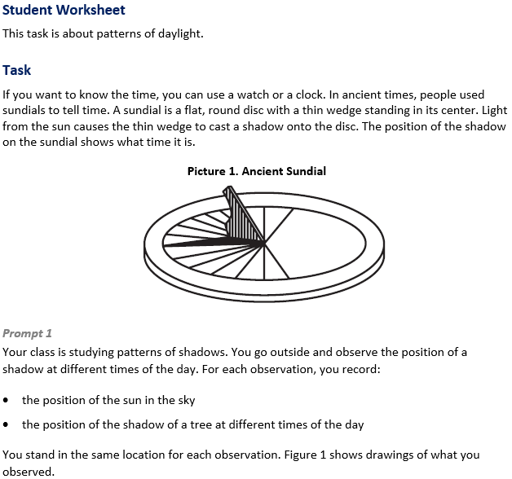
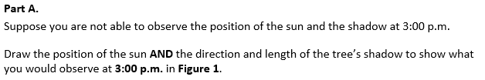  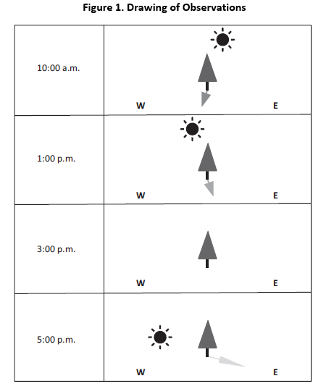
  Task 1 Prompt 1 Part A Complexity
  Degree and Nature of Sensemaking | Moderate | This task…  - Requires integration of two dimensions in the service of sense-making
  Complexity of the Presentation | Moderate | - The amount and type of information provided in the scenario supports multiple evident connections among ideas or concepts.  - Provides graphics/data/models
  Cognitive Demand of Response Development | Low | - Requires well-defined set of actions or procedures  - Requires a connection or retrieval of factual information
  Cognitive Demand of Response Production | Moderate | - Response includes multiple steps in a simple or moderately complex process
  Task 1 Prompt 1 Part A
  Connections to the Instructional Framework
  Integration of Knowledge and Skills for Response Development
  - Students read the provided background information and Picture 1, which introduces a topic related to ancient people developing and using sundials to record time.
  - Students interpret a visual representation of a tree and the shadow it casts due to the position of the sun at different times of day to predict a missing data recording.
  - Students identify a pattern from their interpretation and use it to add to the model, indicating that the sun is further down than at 1:00 PM and that the shadow moves to the right. The shadow length at 3:00 PM is longer than 1:00 PM and shorter than 5:00 PM.
  Formative Assessments | Opportunities to Learn
  Segment 3, pp. 16-17  Informal Assessment: Sun-Earth Model (A10)  - Students describe patterns in data related to the change in length and direction of a shadow over a 24-hour period.  - Students generate mathematical representations of data that show patterns of change in the length and direction of a shadow over a 24-hour period.  - Students describe how mathematical representations support conclusions about how the length and direction of a shadow change over a 24-hour period. | Segment 3, pp. 36-37  Why are Shadows Always Changing? (A9, A10)  - Students investigate shadows in which they observe changes in shadows and the sun’s position throughout the day. As students collect data, they begin to recognize the cause-and-effect relationship between the changing position of the sun, causing the shadows to change.
  Task 1 Prompt 1 Part A
  Connections to the Instructional Framework, Continued
  Formative Assessments | Opportunities to Learn
  Segment 3, pp. 17-18  Informal Assessment: Movements of the Earth (A8)  - Students describe patterns in generated data related to the change in the amount of sunlight over 24 hours as the Earth rotates.  - Students use data to support conclusions about patterns of change in the amount of sunlight over 24 hours as the Earth rotates.  Segment 3, pp. 18-19  Formal Assessment: Sunrise and Sunset, how do the Earth and Sun Repeat that? (A8)  - Students describe patterns in generated data related to the change in the amount of sunlight over 24 hours as the Earth rotates.  - Students use data to support conclusions about patterns of change in the amount of sunlight over 24 hours as the Earth rotates. | Segment 3, pp. 37  Why do we have Time Zones? (A8)  - The teacher displays a map of the world, which shows students the time zones. The teacher displays a flat projection of a map of the world and a globe.  - Students use Stellarium to observe the sky at different points around the world, making sure they look at the current time. Eventually, students have enough observation points represented on the maps that when the sun is high in the sky on one side of the world, it is dark on the other, with dawn and dusk occurring in between.  Segment 3, pp. 37-38  I’m Spinning Around (A8)  - Students use a model of a rotating chair to simulate the rotation of Earth and investigate the connections between the Earth’s rotation on its axis, the appearance of stars in the sky, and the patterns in day and night around the world.
Task 1 Prompt 1 Part A
Connections to the Instructional Framework, Continued
Formative Assessments | Opportunities to Learn
Segment 3, pp. 20-21  Formal Assessment: Shadow Puppets are Changing (A9, A10)  - Students generate representations of data that show patterns of change in the amount of sunlight over 24 hours as the Earth rotates.  - Students use data to support conclusions about patterns of change in the amount of sunlight over 24 hours as the Earth rotates.  Segment 3, pp. 21-22  Formal Assessment: Sun-Earth Model Revisions 1 (A8)  - Students describe patterns in generated data related to the change in the amount of sunlight over 24 hours as the Earth rotates.  - Students use data to support conclusions about patterns of change in the amount of sunlight over 24 hours as the Earth rotates. | Segment 3, p. 38  Time by the Ancient Sundial (A9, A10)  - Students create a sundial to investigate shadows, observe the movement of the sun, make quantitative observations, collect data, and recognize the patterns.  - Students design and construct sundials using the engineering design process.

Task 1 Prompt 1 – Parts B and C  Performance Category: Analyze Data to Describe Observable Patterns Related to the Earth, Sun, and Moon System  Acquisition Goals  - A7: Represent data in graphical displays to reveal patterns of change in the amount of sunlight over 24 hours as the Earth rotates. *  - A9: Represent data in graphical displays to reveal differences in length and direction of shadow over a 24-hour period.  - A10: Organize simple data sets to reveal patterns of change in length and direction of a shadow over a 24-hour period. *  Prompt 1 Parts B and C measure students’ ability to:  - Analyze and interpret data and graphs to reveal patterns or relationships about predicting shadow length during regular intervals over the course of a day. |  | 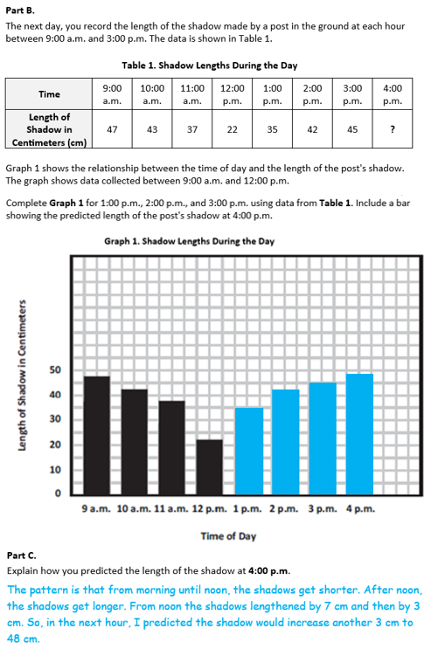
  Task 1 Prompt 1 Part B Complexity
  Degree and Nature of Sensemaking | Moderate | This task…  - Requires integration of two dimensions in the service of sense-making
  Complexity of the Presentation | Moderate | - The amount and type of information provided in the scenario supports multiple evident connections among ideas or concepts  - Provides graphics/data/models
  Cognitive Demand of Response Development | Low | - Requires well-defined set of actions or procedures  - Requires a connection or retrieval of factual information
  Cognitive Demand of Response Production | Moderate | - Response includes multiple steps in a simple or moderately complex process
  Task 1 Prompt 1 Part C Complexity
  Degree and Nature of Sensemaking | Low | This task…  - Requires one or two dimensions  - One dimension may have a greater degree of emphasis than another
  Complexity of the Presentation | Low | - The amount and type of information provided in the scenario supports limited simple connections among ideas or concepts  - Provides few, simple graphics/data/models
  Cognitive Demand of Response Development | Low | - Requires well-defined set of actions or procedures  - Requires a connection or retrieval of factual information
  Cognitive Demand of Response Production | Low | - Responses include selection from a small set of options presented as text (e.g., word, short phrase) or other formats (e.g., or a simple graphic or process)
  Task 1 Prompt 1 Parts B and C
  Connections to the Instructional Framework
  Integration of Knowledge and Skills for Response Development
  Part B
  - Students refer to Table 1 and Graph 1 to identify patterns and reference the length and direction of shadows over the course of a day.
  - Students construct a graph comparing the length of shadows over the course of a day.
  - Students complete Graph 1 with an accurate representation of recorded observations at 1:00 PM., 2:00 PM, and 3:00 PM and an accurate representation of the predicted observation at 4:00 PM.
  Part C
  - Students refer to Table 1 and Graph 1 that provide students with information from multiple sources in order to address questions.
  - Students analyze their graph to answer a question about an unknown shadow length.
  - Students construct an explanation that shows a relationship between the length of the shadow and the time of day.
  - Students use their analysis to make a reasonable prediction within 46 to 52 cm based on an observed pattern in the data.
  Formative Assessments | Opportunities to Learn
  Segment 3, pp. 16-17  Informal Assessment: Sun-Earth Model (A7, A10)  - Students describe patterns in data related to the change in length and direction of a shadow over a 24-hour period.  - Students generate mathematical representations of data that show patterns of change in the length and direction of a shadow over a 24-hour period. | Segment 3, pp. 36-37  Why are Shadows Always Changing? (A9, A10*)  - Students investigate shadows in which they observe changes in shadows and the sun’s position over the day. As students collect data, they begin to recognize the cause-and-effect relationship between the changing position of the sun and the shadows changing.
  Task 1 Prompt 1 Parts B and C
  Connections to the Instructional Framework, Continued
  Formative Assessments | Opportunities to Learn
  - Students describe how mathematical representations support conclusions about how the length and direction of a shadow change over a 24-hour period.  Segment 3, pp. 17-18  Informal Assessment: Movements of the Earth (A7)  - Students describe patterns in generated data related to the change in the amount of sunlight over 24 hours as Earth rotates.  - Students use data to support conclusions about patterns of change in the amount of sunlight over 24 hours as Earth rotates.  Segment 3, pp. 18-19  Formal Assessment: Sunrise and Sunset, how do the Earth and Sun Repeat that? (A7)  - Students describe patterns in generated data related to the change in the amount of sunlight over 24 hours as Earth rotates.  - Students use data to support conclusions about patterns of change in the amount of sunlight over 24 hours as Earth rotates. | Segment 3, pp. 37  Why do we have Time Zones? (A7)  - The teacher displays a map of the world, which shows students the time zones. The teacher displays a flat projection of a map of the world and a globe. Students use Stellarium to observe the sky at different points around the world, making sure they look at the current time. Eventually, students have enough observation points represented on the maps that when the sun is high in the sky on one side of the world, it is dark on the other, with dawn and dusk occurring in between.  Segment 3, p. 38  Time by the Ancient Sundial (A9, A10)  - Students create a sundial to investigate shadows, observe the movement of the sun, make quantitative observations, collect data, and recognize the patterns. Students design and construct sundials using the engineering design process.
Task 1 Prompt 1 Parts B and C
Connections to the Instructional Framework, Continued
Formative Assessments | Opportunities to Learn
Segment 3, pp. 20-21
Formal Assessment: Shadow Puppets are Changing (A9, A10)
- Students generate representations of data that show patterns of change in the amount of sunlight over 24 hours as Earth rotates.
- Students use data to support conclusions about patterns of change in the amount of sunlight over 24 hours as Earth rotates.
Segment 3, pp. 21-22
Formal Assessment: Sun-Earth Model Revisions 1 (A8)
- Students describe patterns in generated data related to the change in the amount of sunlight over 24 hours as Earth rotates.
- Students use data to support conclusions about patterns of change in the amount of sunlight over 24 hours as Earth rotates.

Task 1 Prompt 1 – Part D  Performance Category: Support Arguments Related to Interactions Within the Earth, Sun, and Moon System  Acquisition Goals  - A6: Use evidence (models, observations, or data patterns) to construct or support an explanation that Earth rotates about an axis and takes approximately 24 hours for a complete rotation.  - A7: Represent data in graphical displays to reveal patterns of change in the amount of sunlight over 24 hours as the Earth rotates. *  - A8: Use evidence to support an argument that Earth’s rotation about its axis causes differences in the amount of sunlight that reaches a given location on Earth over the course of 24 hours (e.g., darkness at night, dim light at sunrise that increases to daylight, decreasing light at sunset).*  - A9: Represent data in graphical displays to reveal differences in length and direction of shadow over a 24-hour period. *  - A10: Organize simple data sets to reveal patterns of change in length and direction of a shadow over a 24-hour period. *  Prompt 1 Part D measures students’ ability to:  - Support an argument with evidence, data, or a model to explain how the position and motion of objects in the Earth-sun system relate to the length and direction of shadows during the day. |  | 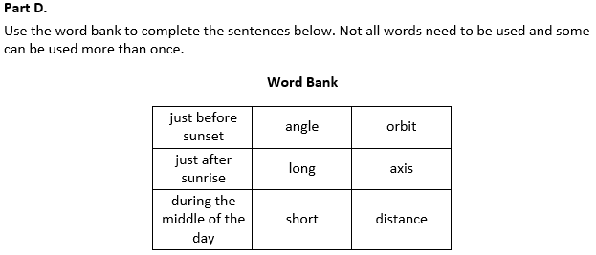  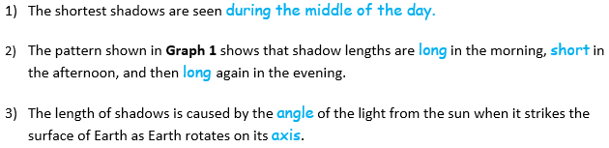
  Task 1 Prompt 1 Part D Complexity
  Degree and Nature of Sensemaking | Moderate | This prompt…  - Requires integration of two dimensions in the service of sense-making
  Complexity of the Presentation | Low | - The amount and type of information provided in the scenario supports limited simple connections among ideas or concepts.  - Provides few, simple graphics/data/models
  Cognitive Demand of Response Development | Moderate | - Requires application of ideas and practices given cues and guidance  - Requires drawing relationships and connecting ideas and practices
  Cognitive Demand of Response Production | Low | - Responses include selection from a small set of options presented as text (e.g., word, short phrase) or other formats (e.g., or a simple graphic or process)
  Task 1 Prompt 1 Part D
  Connections to the Instructional Framework
  Integration of Knowledge and Skills for Response Development
  - Students are given a word bank to complete the sentences in Part D.
  - Students organize and analyze data to interpret how the position and motion of objects in the Earth-sun system relate to the length and direction of shadows during the day.
  - Students use evidence from Graph 1 to answer Part D by indicating that the shortest shadows are seen during the middle of the day. That evidence from Graph 1 shows shadows start long in the morning, get short in the afternoon, and then get long again in the evening. Students recognize the length of shadows is caused by the angle of the sun’s light striking Earth’s surface as Earth rotates on its axis.
  Formative Assessments | Opportunities to Learn
  Segment 3, pp. 17-18  Informal Assessment: Movements of the Earth (A6, A7, A8)  - Students describe patterns in generated data related to the change in the amount of sunlight over 24 hours as the Earth rotates.  - Students use data to support conclusions about patterns of change in the amount of sunlight over 24 hours as the Earth rotates. | Segment 3, p. 36  What Have We Seen So Far? (A6, A8)  - The teacher opens class with a display of an image of the sky during the daytime with the sun and moon in the sky and visible in the picture. The class discusses what students observe about the sun at different times of the day.  - Students create a table and an annotated drawing of what they have observed about the sun’s position at different times of day. Students’ annotated drawings show that the sun moves across the sky as the day advances.
  Task 1 Prompt 1 Part D
  Connections to the Instructional Framework, Continued
  Formative Assessments | Opportunities to Learn
  Segment 3, pp. 18-19  Formal Assessment: Sunrise and Sunset, how do the Earth and Sun Repeat that? (A6, A7, A8)  - Students describe patterns in generated data related to the change in the amount of sunlight over 24 hours as the Earth rotates.  - Students use data to support conclusions about patterns of change in the amount of sunlight over 24 hours as the Earth rotates.  - Students describe, use, and/or develop a model to show that Earth rotates about an axis and takes approximately 24 hours for a complete rotation.  Segment 3, pp. 19-20  Formal Assessment: Where are you Right Now in the Earth’s Rotation? (A7, A8)  - Students describe patterns in generated data related to the change in the amount of sunlight over 24 hours as the Earth rotates. | Segment 3, pp. 36-37  Why Are Shadows Always Changing? (A9, A10)  - Students investigate shadows in which they observe changes in shadows and the sun’s position throughout the day. As students collect data, they begin to recognize the cause-and-effect relationship between the sun's changing position, causing the shadows to change.  Segment 3, pp. 37-38  I’m Spinning Around (A6, A8)  - The teacher places a chair that can rotate, like an office desk chair, directly under the stars hung from the ceiling. A student sits in the chair and asks them to move without standing in such a way that the stars on the ceiling turn like they saw in the video. The other students observe their movements.
  Task 1 Prompt 1 Part D
  Connections to the Instructional Framework, Continued
  Formative Assessments | Formative Assessments
  - Students identify and use evidence that supports an argument that Earth’s spin about its axis causes differences in the amount of sunlight that reaches a given location on Earth over the course of 24 hours.  Segment 3, pp. 20-21  Formal Assessment: Shadow Puppets are Changing (A9, A10)  - Students generate representations of data that show patterns of change in the amount of sunlight over 24 hours as the Earth rotates.  - Students use data to support conclusions about patterns of change in the amount of sunlight over 24 hours as the Earth rotates.  Segment 3, pp. 21-22  Formal Assessment: Sun-Earth Model Revisions 1 (A6, A7, A8)  - Students identify evidence that supports an explanation that the Earth rotates about an axis and takes approximately 24 hours for a complete rotation. | - At this point, students have enough evidence and experience to understand that the Earth rotates, like the person in the chair. The teacher facilitates a class discussion where students discuss the meaning of the person rotating, the rotating sky, and the differences in sunlight around the world.  Segment 3, p. 38  Time by the Ancient Sundial (A9, A10)  - Students create a sundial to investigate shadows, observe the movement of the sun, make quantitative observations, collect data, and recognize the patterns.  - Students design and construct sundials using the engineering design process.
Task 1 Prompt 1 Part D
Connections to the Instructional Framework, Continued
Formative Assessments | Formative Assessments
- Students construct an explanation that the Earth rotates about an axis and takes approximately 24 hours for a complete rotation.
- Students develop and use a model to show that Earth rotates about an axis and takes approximately 24 hours for a complete rotation.

Task 1 Prompt 2  Performance Category: Support Arguments Related to Interactions Within the Earth, Sun, and Moon System  Acquisition Goals  - A7: Represent data in graphical displays to reveal patterns of change in the amount of sunlight over 24 hours as the Earth rotates. *  - A8: Use evidence to support an argument that Earth’s rotation about its axis causes differences in the amount of sunlight that reaches a given location on Earth over the course of 24 hours (e.g., darkness at night, dim light at sunrise that increases to daylight, decreasing light at sunset).*  - A9: Represent data in graphical displays to reveal differences in length and direction of shadow over a 24-hour period. *  - A10: Organize simple data sets to reveal patterns of change in length and direction of a shadow over a 24-hour period. *  - A16: Analyze and interpret data on the length of the days at a location to determine how the length of the day changes throughout the year.  Prompt 2 measures students’ ability to:  - Support an argument with evidence, data, or a model to explain how the length of shadows changes from summer to winter. |  | 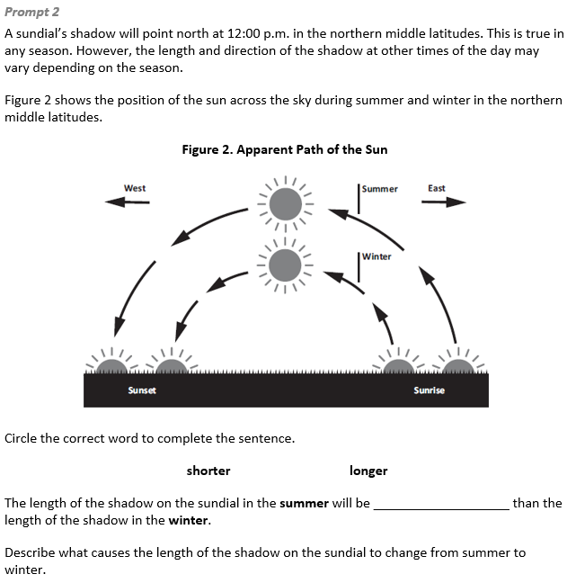  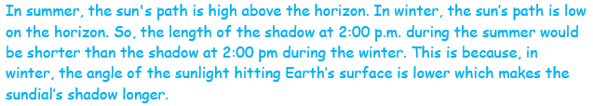
  Task 1 Prompt 2 Complexity
  Degree and Nature of Sensemaking | High | This task…  - Requires integration of three dimensions in the service of sense-making
  Complexity of the Presentation | Moderate | - The amount and type of information provided in the scenario supports multiple evident connections among ideas or concepts  - Provides graphics/data/models
  Cognitive Demand of Response Development | High | - Requires selection and application of multiple complex ideas and practices
  Cognitive Demand of Response Production | Moderate | - Responses include one or more sentences or a paragraph
  Task 1 Prompt 2
  Connections to the Instructional Framework
  Integration of Knowledge and Skills for Response Development
  - Students are presented with a scenario that introduces the effect of different seasons when using a sundial.
  - Students relate the apparent path of the sun across the sky in winter and summer to its effect on reading a sundial.
  - Students answer Prompt 2 using evidence from Figure 2 to explain that the length of the shadow in the summer will be shorter than the length of the shadow in the winter and relate the angle of the sun’s light when it hits Earth’s surface is different in the summer and winter which affects the length of the shadow.
  Formative Assessments | Opportunities to Learn
  Segment 1, pp. 8-9  Informal Assessment: Schoolyear Sky Journal (A16)  - Students describe patterns in data related to how the length of the day changes throughout the year.  - Students represent data about the length of the day at a location to show how the length of the day changes through the year.  - Students use data to support conclusions about how the length of the day changes throughout the year. | Segment 3, pp. 36-37  Why Are Shadows Always Changing? (A9, A10)  - Students investigate shadows in which they observe changes in shadows and the sun’s position throughout the day. As students collect data, they begin to recognize the cause-and-effect relationship between the sun's changing position causing the shadows to change.
  Task 1 Prompt 2
  Connections to the Instructional Framework, Continued
  Formative Assessments | Opportunities to Learn
  Segment 3, pp. 16-17  Informal Assessment: Sun-Earth Model (A7*, A10)  - Students describe patterns in data related to the change in length and direction of a shadow over a 24-hour period.  - Students generate mathematical representations of data that show patterns of change in the length and direction of a shadow over a 24-hour period.  - Students describe how mathematical representations support conclusions about how the length and direction of a shadow change over a 24-hour period.  Segment 3, pp. 18-19  Formal Assessment: Sunrise and Sunset, how do the Earth and Sun Repeat that? (A7, A8)  - Students describe patterns in generated data related to the change in the amount of sunlight over 24 hours as the Earth rotates.  - Students use data to support conclusions about patterns of change in the amount of sunlight over 24 hours as the Earth rotates. | Segment 3, p. 37  Why do we have Time Zones? (A7, A8)  - Students use Stellarium to observe the sky at different points around the world, making sure they look at the current time. As students make observations, they mark on a globe or map if it is day, night, or somewhere in between.  - Students create an annotated drawing of the globe or map with labels that indicate where it is day, night, and in between.  - Students then answer the question, “Why do we have time zones?” to check their understanding.  Segment 3, p. 38  Time by the Ancient Sundial (A9, A10)  - Students create a sundial to investigate shadows, observe the movement of the sun, make quantitative observations, collect data, and recognize the patterns.  - Students design and construct sundials using the engineering design process.
  Task 1 Prompt 2
  Connections to the Instructional Framework, Continued
  Formative Assessments | Opportunities to Learn
  Segment 3, pp. 19-20  Formal Assessment: Where are you Right Now in the Earth’s Rotation? (A7, A8)  - Students describe patterns in generated data related to the change in the amount of sunlight over 24 hours as the Earth rotates.  - Students use data to support conclusions about patterns of change in the amount of sunlight over 24 hours as the Earth rotates.  - Students identify and use evidence to support an argument that Earth’s spin about its axis causes differences in the amount of sunlight that reaches a given location on Earth over 24 hours.  Segment 3, pp. 20-21  Formal Assessment: Shadow Puppets are Changing (A9, A10)  - Students generate representations of data that show patterns of change in the amount of sunlight over 24 hours as the Earth rotates. | Segment 4, pp. 39-40  Daytime, Nighttime, Playtime, Bedtime! (A16)  - The teacher starts the lesson by reminding students that we can see our constellations rotate in the sky with it repeating every 24 hours, but it also moves from month to month. Students research, analyze, and graph data sets of times of sunrise, sunset, daylight, and dark to recognize patterns of these events and changing conditions.  - To emphasize the contrast around the Earth, students examine a globe to identify multiple locations around the Earth. After their data analysis, students create a visual display to show how sunrise and sunset change over a year for their location.
Task 1 Prompt 2
Connections to the Instructional Framework, Continued
Formative Assessments | Opportunities to Learn
- Students use data to support conclusions about patterns of change in the amount of sunlight over 24 hours as the Earth rotates.
Segment 3, pp. 21-22
Informal Assessment: Sun-Earth Model Revisions 1 (A7, A8)
- Students describe patterns in generated data related to the change in the amount of sunlight over 24 hours as the Earth rotates.
- Students use data to support conclusions about patterns of change in the amount of sunlight over 24 hours as the Earth rotates.
Segment 4, pp. 23-24
Formal Assessment: Daytime, Nighttime, Playtime, Bedtime! (A16)
- Students Describe patterns in data related to how the length of the day changes throughout the year.
- Students represent data about the length of the day at a location to show how the length of the day changes through the year.
- Students use data to support conclusions about how the length of the day changes throughout the year.

Future Learning Connected to evidence elicited in Task 1
Crosscutting Concepts
- Unit 4 CCCs focus on using Cause and Effect, Patterns, and Systems and System Models to describe how Earth’s spin causes day and night and understand how its gravitational force is always directed downwards. In future middle school learning experiences related to Earth’s gravitational force and motion, students will continue to understand how models can be used to represent systems and their interactions—such as inputs, processes, and outputs—and energy and matter flows within systems (MS-PS4-1).
Disciplinary Core Ideas
- Unit 4 focuses extensively on understanding the direction of Earth’s gravitational force, how the distance of the Earth from the sun and stars influences their brightness, and Earth’s spin day-to-day patterns. Students’ learning and understanding increase in sophistication beyond grade 5, where students extend their knowledge to understand that there is a gravitational force between any two masses, but it is very small except when one or both objects have large masses—for example, Earth and the sun. The knowledge they obtain about the brightness of stars in relation to Earth’s distance is developed further after grade 5, when they are introduced to observing patterns of the apparent motion of the sun, the moon, and stars in the sky. Also, learning about Earth’s spins prepares them to learn more about other solar system components and how they are held in orbit around the sun by its gravitational pull on them.
Science and Engineering Practices
- Unit 4 SEPs focus predominantly on engaging in arguments from evidence and analyzing and interpreting data. Additional SEPs are using mathematical and computational thinking, developing and using models, and constructing explanations and designing solutions. Students visit these practices in their future learning experiences related to Earth’s gravitational force and motion by developing and using models to describe phenomena (MS-ESS2-1). They analyze and interpret data to determine similarities and differences in findings (MS-ESS1-3). They also construct and present oral and written arguments supported by empirical evidence and scientific reasoning to support or refute an explanation or a model for a phenomenon or a solution to a problem (MS-PS2-4).
SIPS Grade 5 Unit 4 EOU Assessment Task 2: Meet the Beetles!  Task 2 Prompt 1  Performance Category: Analyze Data to Describe Observable Patterns Related to the Earth, Sun, and Moon System  Acquisition Goals  - A17. Analyze and interpret data on the visible constellations at a location to determine if some constellations are visible throughout the year. *  - A18. Engage in argument from evidence on why some constellations are visible at a location only at some parts of the year.  Prompt 1 measures students’ ability to:  - Analyze and interpret data and graphs to reveal patterns or relationships about predicting the position and movement of the Big Dipper in the night sky. |  | 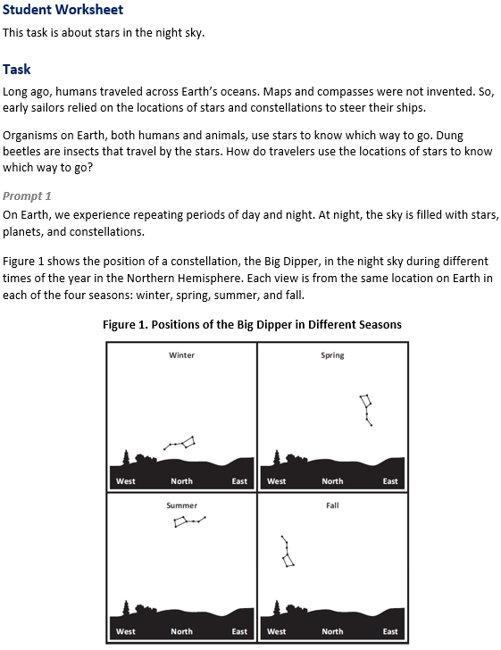

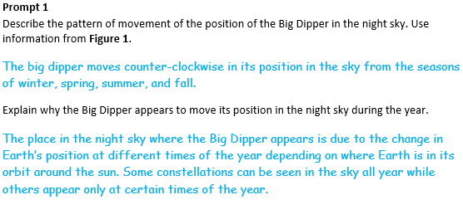
  Task 2 Prompt 1 Complexity
  Degree and Nature of Sensemaking | Moderate | This task…  - Requires integration of two dimensions in the service of sense-making
  Complexity of the Presentation | Moderate | - The amount and type of information provided in the scenario supports multiple evident connections among ideas or concepts  - Provides graphics/data/models
  Cognitive Demand of Response Development | Low | - Requires well-defined set of actions or procedures  - Requires a connection or retrieval of factual information
  Cognitive Demand of Response Production | Moderate | - Responses include one or more sentences or a paragraph, a moderately complex graphic, or multiple steps in a simple or moderately complex process

  Task 2 Prompt 1
  Connections to the Instructional Framework
  Integration of Knowledge and Skills for Response Development
  - Students are presented with a scenario that introduces a topic related to ancient people using the stars and constellations as a navigation tool.
  - Students analyze and interpret a visual representation of the position of the Big Dipper in the night sky at different times of the year to explain the pattern of movement.
  - Students describe the pattern of movement as counter-clockwise during the year and explain how constellations can change positions and/or appear only at certain times of the year due to the Earth’s orbit around the sun.
  Formative Assessments | Opportunities to Learn
  Segment 4, p. 23  Informal Assessment: Questioning Our Sun-Earth Model (A17, A18)  - Students engage in argument from evidence on why some constellations are visible at a location only at some part of the year.  Segment 4, pp. 24-25  Formal Assessment: How Does My Constellation Move? (A17, A18)  - Students use data to support conclusions about whether or not some constellations are visible throughout the year.  - Students identify evidence that supports an explanation that some constellations are visible throughout the year. | Segment 1, pp. 30-31  Stories in the Sky (A17, A18)  - The teacher begins by asking students to share what they know about constellations and if they know of any. The teacher shares some examples of star maps from different cultures to help students better picture the different ways of looking at the sky.  - Students generate questions about the sky and the different ways that cultures see it. They then complete a sky observation, paying close attention to movement.
  Task 2 Prompt 1
  Connections to the Instructional Framework, Continued
  Formative Assessments | Opportunities to Learn
  Segment 4, p. 26  Formal Assessment: Teaching About the Sun, Stars, and Earth (A18)  - Students engage in argument from evidence on why some constellations are visible at a location only at some part of the year. | Segment 4, pp. 39-40  Daytime, Nighttime, Playtime, Bedtime! (A18)  - The teacher starts the lesson by reminding students that we can see our constellations rotate in the sky with it repeating every 24 hours, but it also moves from month to month. Students research, analyze, and graph data sets of times of sunrise, sunset, daylight, and dark to recognize patterns of these events and changing conditions.  - Students examine a globe to identify multiple locations around the Earth. After their data analysis, students create a visual display to show how sunrise and sunset change over a year for their location.
  Task 2 Prompt 1
  Connections to the Instructional Framework, Continued
  Formative Assessments | Opportunities to Learn
  Segment 4, p. 25  Formal Assessment: My Sun-Earth Model (A18)  - Students identify evidence that supports an explanation that some constellations are visible throughout the year. | Segment 4, p. 39  Does Spinning Explain Why My Constellation Moves? (A17, A18)  - The teacher asks the students, “Can you explain the movement of your constellation by the spinning of the Earth?” The teacher encourages students to turn and talk about the evidence and information they learned about the Earth’s rotation and return to Stellarium to watch the constellation’s movement over a day and over several months to a year.  - Students see that the constellation may rotate in the sky over a day, but it doesn’t explain the movement over the entire year, with constellations rising and falling below the horizon.
  Task 2 Prompt 1
  Connections to the Instructional Framework, Continued
  Formative Assessments | Opportunities to Learn
  Segment 4, pp. 40-41
  How Does My Constellation Move? (A17, A18)
  - Students chart how their constellations move. They analyze the data they have collected and answer discussion questions that help them see that the constellations return to the same place every year.
  Segment 4, p. 41
  My Sun-Earth Model (A17*, A18)
  - Students return to their model of the sun and Earth and modify their model and explanation to incorporate the evidence that the Earth revolves around the sun while rotating. Students make changes and share their thinking with peers, who give them feedback before finalizing their model.
Task 2 Prompt 2 – Parts A-C  Performance Category: Support Arguments Related to the Apparent Brightness of Stars  Acquisition Goals  - A1. Develop and/or use a model to describe that light from stars reaches Earth even when those stars’ distances vary greatly.  - A2. Support an argument that stars range greatly in their distance from Earth and they emit light that can reach Earth, using evidence, data, or a model.  - A3. Represent data in graphical displays to reveal that the sun is closer than other stars and that the sun appears larger and brighter than other stars.  - A4. Construct an explanation of the observed relationship between distance and apparent size/brightness of the sun versus all other stars. *  - A20. Support an argument that the apparent brightness of the sun and stars is due to their relative distances from the Earth.  Prompt 2 Parts A-C measure students’ ability to:  - Support an argument with evidence, data, or a model to explain how the effect of distance on the apparent brightness of the sun compared to that of other stars can be used to support or refute a claim related to the brightness of stars. |  | 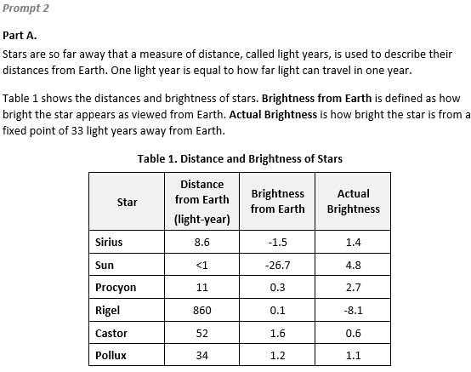  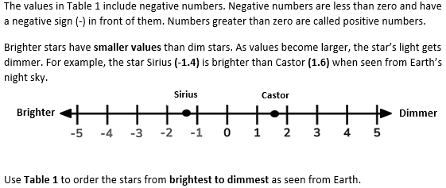
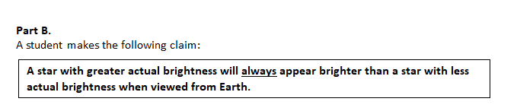  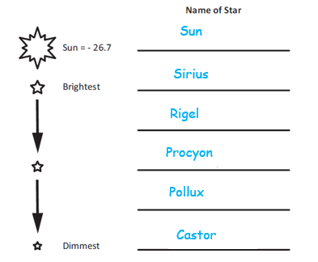  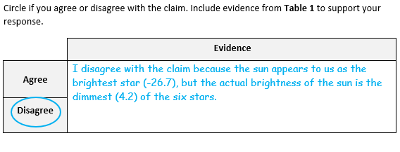 |  | 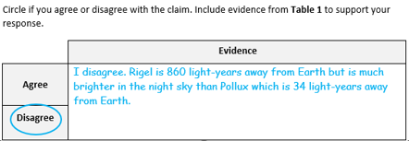
  Task 2 Prompt 2 Part A Complexity
  Degree and Nature of Sensemaking | Low | This prompt…  - Requires one or two dimensions  - One dimension may have a greater degree of emphasis than another
  Complexity of the Presentation | Low | - The amount and type of information provided in the scenario supports limited simple connections among ideas or concepts  - Phenomenon or problem presented in a concrete way with high level of certainty
  Cognitive Demand of Response Development | Moderate | - Requires drawing relationships and connecting ideas and practices  - Requires a moderate level of sophistication with typical and relatively complex representation of ideas and application of skills
  Cognitive Demand of Response Production | Low | - Responses include selection from a small set of options presented as text (e.g., word, short phrase) or other formats (e.g., or a simple graphic or process)
  Task 2 Prompt 2 Parts B & C Complexity
  Degree and Nature of Sensemaking | Moderate | This prompt…  - Requires integration of two dimensions in the service of sense-making
  Complexity of the Presentation | Low | - The amount and type of information provided in the scenario supports limited simple connections among ideas or concepts  - Phenomenon or problem presented in a concrete way with high level of certainty
  Cognitive Demand of Response Development | High | - Requires selection and application of multiple complex ideas and practices
  Cognitive Demand of Response Production | Moderate | - Response includes one or more sentences or a paragraph, a moderately complex graphic, or multiple steps in a simple or moderately complex process
Task 2 Prompt 3  Performance Categories: Support Arguments Related to the Apparent Brightness of Stars  Acquisition Goals:  - A1. Develop and/or use a model to describe that light from stars reaches Earth even when those stars' distances vary greatly. *  - A2. Support an argument that stars range greatly in their distance from Earth and they emit light that can reach Earth, using evidence, data, or a model.*  Prompt 3 measures students’ ability to:  - Support an argument with evidence, data, or a model to explain how living organisms rely on the predictable patterns of the position and motion of objects in the sky. |  | 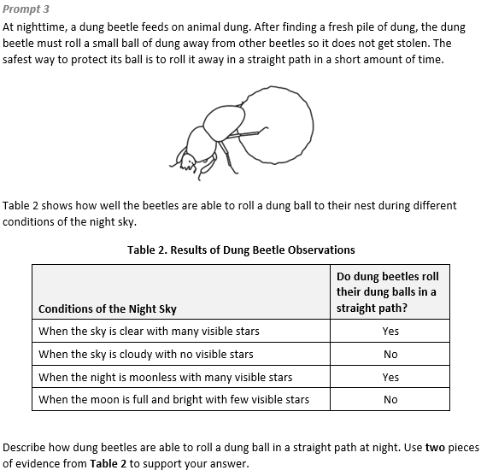  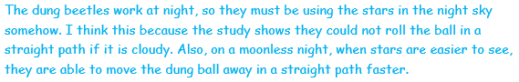
  Task 2 Prompt 2
  Connections to the Instructional Framework
  Integration of Knowledge and Skills for Response Development
  Part A
  - Students review Table 1 and the model, which provides students with information from multiple sources in order to address questions.
  - Students use data to compare the brightness of the sun and other stars.
  - Students place the apparent brightness of stars in the correct order.
  Parts B & C
  - Students review Table 1 and the model, which provides students with information from multiple sources in order to address questions.
  - Students use evidence from Table 1 to disagree with the claim in Part B and Part C, explaining the effect of distance on the apparent brightness of stars as compared to the actual brightness of stars.
  Formative Assessments | Opportunities to Learn
  Segment 1, pp. 8-9  Informal Assessment: Schoolyear Sky Journal (A1, A2, A4*)  - Students develop and/or use a model to describe that light from stars reaches Earth even when those stars’ distances vary greatly.  - Students identify evidence to support an argument that stars range greatly in their distance from Earth and they emit light that can reach Earth using evidence, data, or a model. | Segment 1, p. 31-32  The Sun and Stars (A1, A2, A3, A4*)  - Students explore a variety of resources to learn about stars and the sun.  - Students gather information and record their learning in their science notebook or other organizer.  - Next, students prepare a presentation that includes an explanation and their understanding of the distance of the sun from Earth relative to other stars.
  Task 2 Prompt 2
  Connections to the Instructional Framework, Continued
  Formative Assessments | Opportunities to Learn
  - Students identify what evidence or data supports an argument that stars range greatly in their distance from Earth and/or that stars emit light that can reach Earth.  - Students describe how data shows that the sun is closer than other stars and/or that the sun appears larger and brighter than other stars.  Segment 1, pp. 10-11  Formal Assessment: Where do the Stars go During the Day? (A1, A2, A3)  - Students identify what evidence or data supports an argument that stars range greatly in their distance from Earth and/or that stars emit light that can reach Earth.  - Students support an argument that stars range greatly in their distance from Earth and they emit light that can reach Earth using evidence, data, or a model.  - Students construct an explanation of the observed relationship between distance and apparent size/brightness of the sun versus all other stars. | - Students also collect data using a light meter and measure the change in brightness at different distances from a light source.  Segment 1, p. 33  Where do the Stars go During the Day? (A1, A2, A20)  - The teacher sets up lights to be bright so that they overpower string lights. Before turning on the string lights, students consider what they think happens if there is one very bright object and many smaller, less bright objects.  - Students draw a modified version of this model that will better model what they have learned about the night sky and create a scientific explanation for why the sun is bigger and brighter than other stars.
  Task 2 Prompt 3 Complexity
  Degree and Nature of Sensemaking | Moderate | This prompt…  - Requires integration of two dimensions in the service of sense-making
  Complexity of the Presentation | High | - The amount and type of information provided in the scenario supports multiple and varied complex connections among ideas or concepts
  Cognitive Demand of Response Development | Moderate | - Requires application of ideas and practices given cues and guidance
  Cognitive Demand of Response Production | Moderate | - Response includes one or more sentences or a paragraph, a moderately complex graphic, or multiple steps in a simple or moderately complex process
  Task 2 Prompt 3
  Connections to the Instructional Framework, Continued
  Formative Assessments | Opportunities to Learn
  Segment 1, pp. 9-10  Formal Assessment: Star Light, Star Bright (A1, A2)  - Students identify what evidence or data supports an argument that stars range greatly in their distance from Earth and/or that stars emit light that can reach Earth.  Segment 1, pp. 10-11  Formal Assessment: Where do the Stars go During the Day? (A1, A2)  - Students identify what evidence or data supports an argument that stars range greatly in their distance from Earth and/or that stars emit light that can reach Earth.  - Students support an argument that stars range greatly in their distance from Earth and they emit light that can reach Earth using evidence, data, or a model. | - Students meet with other groups to share and collaborate on what they found and why they think their information is important.  Segment 1, p. 33  Where do the Stars go During the Day? (A1, A2)  - The teacher sets up lights to be bright so that they overpower string lights. Before turning on the string lights, students consider what they think happens if there is one very bright object and many smaller, less bright objects.  - Students draw a modified version of this model that will better model what they have learned about the night sky and create a scientific explanation for why the sun is bigger and brighter than other stars.
  Task 2 Prompt 2
  Connections to the Instructional Framework, Continued
  Formative Assessments | Opportunities to Learn
  - Students identify evidence to support an explanation of the observed relationship between distance and apparent size/brightness of the sun versus all other stars.  Segment 1, p. 9  Formal Assessment: Twinkle, Twinkle Little Star (A3, A4*)  - Students describe how data shows that the sun is closer than other stars and/or that the sun appears larger and brighter than other stars.  - Students identify evidence that supports an explanation about the relationship between distance and apparent size and/or brightness of the sun versus all other stars.  Segment 1, pp. 9-10  Formal Assessment: Star Light, Star Bright (A3, A4*)  - Students identify evidence that supports an explanation about the relationship between distance and apparent size and/or brightness of the sun versus all other stars. | - Students meet with other groups to share and collaborate on what they found and why they think their information is important.  Segment 1, p. 32-33  Big, Small, it is all Relative (A2 ,A3, A4*)  - Students gather data that includes graphical displays about the apparent size of a basketball, a baseball, or some other objects.  - After placing the students in small groups, the teacher provides them with a ruler and a measuring tape.  - The teacher places the two balls next to each other and students stand at different distances away from the balls and record measurements of how large the ball appears to be using the ruler.  - Students examine their data to see what patterns they notice, noticing that the closer they are to the objects the larger they appear to be.
  Task 2 Prompt 2
  Connections to the Instructional Framework, Continued
  Formative Assessments | Opportunities to Learn
  - Students describe how data shows that the sun is closer than other stars and/or that the sun appears larger and brighter than other stars.  Segment 1, pp. 11-12  Informal Assessment: The Sun and Stars (A1, A2, A4)  - Students develop and/or use a model to describe that light from stars reaches Earth even when those stars’ distances vary greatly.  - Students identify evidence to support an argument that stars range greatly in their distance from Earth and they emit light that can reach Earth using evidence, data, or a model.  - Students identify evidence to support an explanation of the observed relationship between distance and apparent size/ brightness of the sun versus all other stars.  Segment 4, p. 26  Formal Assessment: Teaching About the Sun, Stars, and Earth (A1, A20)  - Support an argument that the apparent brightness of the sun and stars is due to their relative distances from the Earth. | Segment 4, p.41  Universe In a Box (A20)  - Students create their own universe in a box. Students draw their own constellations on the inside of the box and build a box in a similar manner. After completing their simple model of the sky, students write an explanation where they explain the strengths and weaknesses of their model.
  Task 2 Prompt 3
  Connections to the Instructional Framework
  Integration of Knowledge and Skills for Response Development
  - Students are presented with a question about how dung beetles use the night sky as a navigation tool.
  - Students support an argument with different justifications for a claim about how the dung beetles use the stars to navigate.
  - Students answer by indicating that the beetles use positions of the stars in the night sky to roll a dung ball in a straight path at night OR beetles use constellations to track their own movements at night.
  - Students include evidence of cloudy conditions when the effectiveness of dung rolling is decreased and moonless conditions when the effectiveness of dung rolling is increased.
  Formative Assessments | Opportunities to Learn
  Segment 1, pp. 8-9  Informal Assessment: Schoolyear Sky Journal (A1, A2)  - Students develop and or use a model to describe that light from stars reaches Earth even when those stars’ distances vary greatly.  - Students identify evidence to support an argument that stars range greatly in their distance from Earth and they emit light that can reach Earth using evidence, data, or a model. | Segment 1, p. 31-32  The Sun and Stars (A1, A2)  - Students explore a variety of resources to learn about stars and the sun.  - Students gather information and record their learning in their science notebook or other organizer.  - Next, students prepare a presentation that includes an explanation and their understanding of the distance of the sun from Earth relative to other stars.
  Task 2 Prompt 3
  Connections to the Instructional Framework, Continued
  Formative Assessments | Opportunities to Learn
  Segment 1, pp. 11-12
  Informal Assessment: The Sun and Stars (A1, A2)
  - Students develop and or use a model to describe that light from stars reaches Earth even when those stars’ distances vary greatly.
  - Students identify evidence to support an argument that stars range greatly in their distance from Earth and they emit light that can reach Earth using evidence, data, or a model.

Future Learning Connected to evidence elicited in Task 2
Crosscutting Concepts
- Unit 4 CCCs focus on using Cause and Effect, Patterns, and Systems and System Models to describe how Earth’s spin causes day and night and understand how its gravitational force is always directed downwards. In future middle school learning experiences related to Earth’s gravitational force and motion, students will continue to understand how models can be used to represent systems and their interactions—such as inputs, processes, and outputs—and energy and matter flows within systems (MS-PS4-1).
Disciplinary Core Ideas
- Unit 4 focuses extensively on understanding the direction of Earth’s gravitational force, how the distance of the Earth from the sun and stars influences their brightness, and Earth’s spin day-to-day patterns. Students’ learning and understanding increase in sophistication beyond grade 5 where students extend their knowledge to understand that there is a gravitational force between any two masses, but it is very small except when one or both objects have large masses—for example, Earth and the sun. The knowledge they obtain about the brightness of stars in relation to Earth’s distance is developed further after grade 5 where they are introduced to observing patterns of the apparent motion of the sun, the moon, and stars in the sky. Also, learning about Earth’s spins prepares them to learn more about other solar system components and how they are held in orbit around the sun by its gravitational pull on them.
Science and Engineering Practices
- Unit 4 SEPs focus predominantly on engaging in arguments from evidence and analyzing and interpreting data. Additional SEPs are using mathematical and computational thinking, developing and using models, and constructing explanations and designing solutions. Students visit these practices in their future learning experiences related to Earth’s gravitational force and motion by developing and using models to describe phenomena (MS-ESS2-1). They analyze and interpret data to determine similarities and differences in findings (MS-ESS1-3). They also construct and present oral and written arguments supported by empirical evidence and scientific reasoning to support or refute an explanation or a model for a phenomenon or a solution to a problem (MS-PS2-4).

SIPS Grade 5 Unit 4 EOU Assessment Task 3: Turn, Turn, Turn  Task 3 Prompt 1  Performance Category: Analyze Data to Describe Observable Patterns Related to the Earth, Sun, and Moon System  Acquisition Goals:  - A16: Analyze and interpret data on the length of the days at a location to determine how the length of the day changes throughout the year.  Prompt 1 measures students’ ability to:  - Analyze and interpret data and graphs to reveal patterns or relationships about approximate sunrise and sunset times (e.g., length of daylight) during regular intervals over the course of a year. |  | 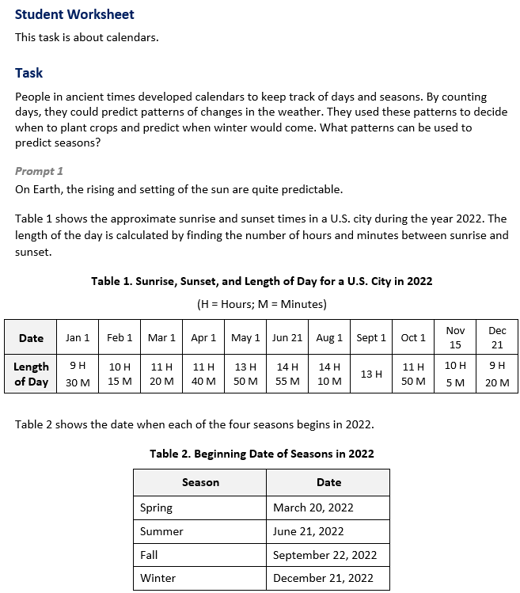
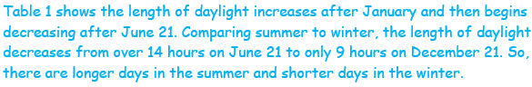
  Task 3 Prompt 1 Complexity
  Degree and Nature of Sensemaking | Moderate | This prompt…  - Requires integration of two dimensions in the service of sensemaking  - Requires a combination of previously learned ideas or concepts and newly presented information
  Complexity of the Presentation | Moderate | - The amount and type of information provided in the scenario supports multiple evident connections among ideas or concepts
  Cognitive Demand of Response Development | Low | - Requires well-defined set of actions or procedures  - Requires a connection or retrieval of factual information
  Cognitive Demand of Response Production | Moderate | - Responses include one or more sentences or a paragraph, a moderately complex graphic, or multiple steps in a simple or moderately complex process

Task 3 Prompt 2 – Parts A and B  Performance Category: Analyze Data to Describe Observable Patterns Related to the Earth, Sun, and Moon System  Acquisition Goals:  - A21: Analyze and interpret data on observed appearances of the moon to determine how the moon’s orbit around Earth explains the observed appearances of the moon.  - A22: Engage in argument from evidence on how the moon’s orbit around Earth explains the observed shapes/shadows of the moon.  Prompt 2 Parts A and B measures students’ ability to:  - Analyze and interpret data and graphs to reveal patterns or relationships about the appearance of the moon every four weeks (e.g., moon phases) during regular intervals over the course of four months. |  | 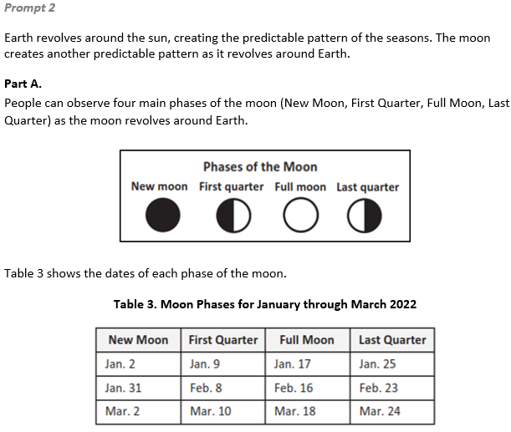
  Task 3 Prompt 1
  Connections to the Instructional Framework
  Integration of Knowledge and Skills for Response Development
  - Students review the task background and Tables 1 and 2, which present a scenario related to how ancient people used the patterns of constellations and the moon to develop the basis of the calendar we still use today.
  - Students analyze and interpret data provided in Table 1, which describes/lists the length of day for a U.S. city over the course of a year.
  - Students describe observable patterns in the length of day over a period of weeks or months that make predictions possible.
  Formative Assessments | Opportunities to Learn
  Segment 1, pp. 8-9  Informal Assessment: Schoolyear Sky Journal (A16)  - Students describe patterns related to how the length of day changes throughout the year.  - Students represent data about the length of the day at a location to show how the length of the day changes through the year.  - Students use data to support conclusions about how the length of the day changes throughout the year. | Segment 4, pp. 39-40  Daytime, Nighttime, Playtime, Bedtime! (A16)  - Students research, analyze, and graph data sets of times of sunrise, sunset, daylight, and dark to recognize patterns of these events and changing conditions.  - To emphasize the contrast around the Earth, students examine a globe to identify multiple locations around the Earth. After their data analysis, students create a visual display to show how sunrise and sunset change over a year for their location.
  Task 3 Prompt 1
  Connections to the Instructional Framework, Continued
  Formative Assessments | Opportunities to Learn
  Segment 4, pp. 23-24  Formal Assessment: Daytime, Nighttime, Playtime, Bedtime! (A16)  - Students describe patterns in data related to how the length of the day changes throughout the year.  - Students represent data about the length of the day at a location to show how the length of the day changes throughout the year.  - Students use data to support conclusions about how the length of the day changes throughout the year. | Segment 4, p. 41  My Sun-Earth Model (A16*)  - Students return to their model of the sun and Earth and modify their model and explanation to incorporate the evidence that the Earth revolves around the sun while rotating. Students make changes and share their thinking with peers who give them feedback before finalizing their model.
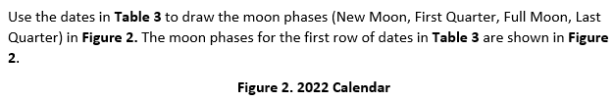  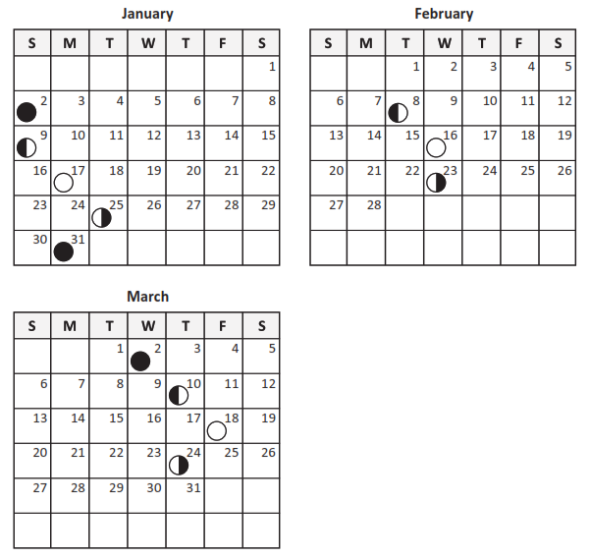  Task 3 Prompt 2 – Part C  Performance Category: Support Arguments Related to Interactions Within the Earth, Sun, and Moon System  Acquisition Goals:  - A21: Analyze and interpret data on observed appearances of the moon to determine how the moon’s orbit around Earth explains the observed appearances of the moon.  - A22: Engage in argument from evidence on how the moon’s orbit around Earth explains the observed shapes/shadows of the moon.  Prompt 2 Part C measures students’ ability to:  - Support an argument with evidence, data, or a model to explain how observable patterns can be used to predict dates of various moon phases.  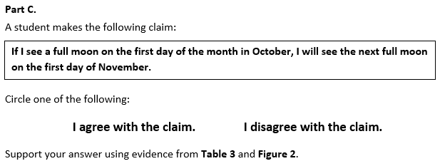  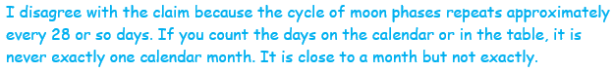 |  | 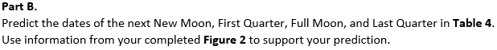  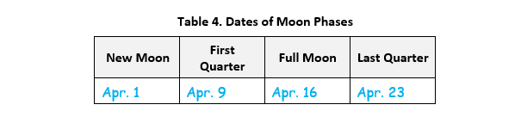
  Task 3 Prompt 2 Parts A and B Complexity
  Degree and Nature of Sensemaking | Moderate | This prompt…  - Requires integration of two dimensions in the service of sensemaking  - Requires a combination of previously learned ideas or concepts and newly presented information
  Complexity of the Presentation | Moderate | - The amount and type of information provided in the scenario supports multiple evident connections among ideas or concepts
  Cognitive Demand of Response Development | High | - Requires selection and application of multiple complex ideas and practices  - Requires high degree of sensemaking, reasoning, and/or transfer
  Cognitive Demand of Response Production | High | - Responses include multiple paragraphs, multiple graphics of at least moderate complexity, or multiple steps in a complex process
  Task 3 Prompt 2 Parts A and B
  Connections to the Instructional Framework
  Integration of Knowledge and Skills for Response Development
  - Students read Prompt 2 and refer to Table 3, which provides a description/list of lunar phases over a period of months.
  - Students analyze and interpret data that can be displayed graphically (pictures in a calendar, for example), which will allow them to describe the pattern of change that occurs in the appearance of the moon every four weeks.
  - In Part A, students develop a model and correctly place moon phases on the calendar for eight dates.
  - In Part B, students use their model to correctly predict the dates of the moon phases for four dates.
  Formative Assessments | Opportunities to Learn
  Segment 4, p. 22  Informal Assessment: Interactive Moon Model (A21, A22)  - Students describe patterns in data to determine how the moon's orbit around the Earth explains the observed phases of the moon.  - Students represent data about the phases of the moon to determine how the moon's orbit around the Earth explains the observed phases of the moon.  - Students use data to support conclusions about how the moon's orbit around the Earth explains the observed phases of the moon. | Segment 4, pp. 38-39  Moon Model (A21, A22)  - Students use a physical model to observe and discuss the different phases of the moon. Students engage in a class discussion to evaluate their understanding of what shapes of the moon are observable at night and why the moon looks different throughout the month.  Segment 4, p. 39  Phases of the Moon (A21, A22)  - Students watch a video and work in groups to create a model of the phases of the moon in the Earth-sun-moon system.
  Task 3 Prompt 2 Part C Complexity
  Degree and Nature of Sensemaking | Moderate | This prompt…  - Requires integration of two dimensions in the service of sensemaking  - Requires a combination of previously learned ideas or concepts and newly presented information
  Complexity of the Presentation | Low | - The amount and type of information provided in the scenario supports limited simple connections among ideas or concepts  - Provides few, simple graphics/data/models
  Cognitive Demand of Response Development | Moderate | - Requires application of ideas and practices given cues and guidance
  Cognitive Demand of Response Production | Moderate | - Responses include one or more sentences or a paragraph, a moderately complex graphic, or multiple steps in a simple or moderately complex process
Task 3 Prompt 3  Performance Category: Support Arguments Related to Interactions Within the Earth, Sun, and Moon System  Acquisition Goals:  - A11. Use a model to describe that Earth's gravitational force pulls objects down to the Earth's surface. *  - A13. Use evidence (models, observations, or data patterns) to construct or support an explanation that the Earth’s shape is spherical.  - A14. Analyze and interpret qualitative data to show that gravitational force acting on two objects is always a pull. *  - A19. Support an argument that the gravitational force exerted by Earth on objects is directed down. *  Prompt 3 measures students’ ability to:  - Support an argument with evidence, data, or a model to explain how gravity is the force that maintains Earth’s spherical shape.  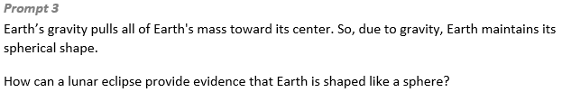  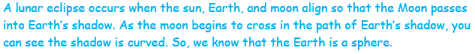
  Task 3 Prompt 2 Part C
  Connections to the Instructional Framework
  Integration of Knowledge and Skills for Response Development
  - Students evaluate the provided graphs, charts, and tables.
  - Students support or refute a claim related to observable patterns of lunar phases.
  - Students support their answers using evidence from the provided information.
  Formative Assessments | Opportunities to Learn
  Segment 4, p. 22  Informal Assessment: Interactive Moon Model (A21, A22)  - Students describe patterns in data to determine how the moon's orbit around the Earth explains the observed phases of the moon.  - Students represent data about the phases of the moon to determine how the moon's orbit around the Earth explains the observed phases of the moon.  - Students use data to support conclusions about how the moon's orbit around the Earth explains the observed phases of the moon. | Segment 4, pp. 38-39  Moon Model (A21, A22)  - Students use a physical model to observe and discuss the different phases of the moon. Students engage in a class discussion to evaluate their understanding of what shapes of the moon are observable at night and why the moon looks different throughout the month.  Segment 4, p. 39  Phases of the Moon (A21, A22)  - Students watch a video and work in groups to create a model of the phases of the moon in the Earth-sun-moon system.
  Task 3 Prompt 3
  Connections to the Instructional Framework
  Integration of Knowledge and Skills for Response Development
  - Students read the prompt and consider Earth’s gravity and its spherical shape relating to a lunar eclipse.
  - Students support an argument related to the gravitational force maintaining the moon’s orbit around Earth.
  - Students construct an explanation about the arrangement of the sun, Earth, and moon during a lunar eclipse and how the curved shape of Earth’s shadow on the moon is evidence that the Earth is a sphere.
  Formative Assessments | Opportunities to Learn
  Segment 2, pp. 13-14  Informal Assessment: Why Don’t We Fly Up Off the Earth’s Surface into the Sky? What’s Holding Us Down? (A11, A13, A14, A19)  - Students identify what evidence or data supports an argument that the Earth’s shape is spherical.  - Students identify what evidence or data supports an argument that the gravitational force exerted by Earth on objects is directed down.  - Students use evidence and/or data to support an argument that the gravitational force exerted by Earth on objects is directed down. | Segment 2, p. 35  Round and Down, but How? (A11, A13)  - The class comes together to discuss how everything falling toward the Earth is related to why the Earth is round. Using core curricular materials, core text, and instructional resources from the end of this instructional framework, the teacher facilitates learning about the concept of “gravity” an attractive force that pulls everything together. As students watch, read, and explore resources, they record information about gravity in their scientific notebooks, graphic organizers, or concept maps.
  Task 3 Prompt 3
  Connections to the Instructional Framework, Continued
  Formative Assessments | Opportunities to Learn
  - Students use evidence and/or data to support an argument that the gravitational force exerted by Earth on objects is directed down.
  Segment 2, pp. 15-16
  Formal Assessment: Is the Earth Round? (A11, A13, A19)
  - Identify scientific evidence, data, or models for evidence that the Earth’s shape is spherical.
  - Identify what evidence or data supports an argument that the gravitational force exerted by Earth on objects is directed down.
  - Use evidence and/or data to support an argument that the gravitational force exerted by Earth on objects is directed down.
  Task 3 Prompt 3 Complexity
  Degree and Nature of Sensemaking | Moderate | This prompt…  - Requires integration of two dimensions in the service of sensemaking  - Requires a combination of previously learned ideas or concepts and newly presented information
  Complexity of the Presentation | Low | - The amount and type of information provided in the scenario supports limited simple connections among ideas or concepts  - Provides few, simple graphics/data/models
  Cognitive Demand of Response Development | High | - Requires selection and application of multiple complex ideas and practices  - Requires high degree of sense-making, reasoning, and/or transfer
  Cognitive Demand of Response Production | High | - Responses include multiple paragraphs, multiple graphics of at least moderate complexity, or multiple steps in a complex process
  Task 3 Prompt 3
  Connections to the Instructional Framework, Continued
  Formative Assessments | Opportunities to Learn
  Segment 2, p. 14
  Informal Assessment: The Earth is Round (A13, A19)
  - Students identify scientific evidence, data, or models for evidence that the Earth’s shape is spherical.
  - Students identify what evidence or data supports an argument that the gravitational force exerted by Earth on objects is directed down.
  - Students use evidence and/or data to support an argument that the gravitational force exerted by Earth on objects is directed down.
  Segment 2, p. 15
  Formal Assessment: Which Way is Down? (A11, A13, A19)
  - Students identify scientific evidence, data, or models for evidence that the Earth’s shape is spherical.
  - Students identify what evidence or data supports an argument that the gravitational force exerted by Earth on objects is directed down.
Future Learning Connected to evidence elicited in Task 3
Crosscutting Concepts
- Unit 4 CCCs focus on using Cause and Effect, Patterns, and Systems and System Models to describe how Earth’s spin causes day and night and understand how its gravitational force is always directed downwards. In future middle school learning experiences related to Earth’s gravitational force and motion, students will continue to understand how models can be used to represent systems and their interactions—such as inputs, processes, and outputs—and energy and matter flows within systems (MS-PS4-1).
Disciplinary Core Ideas
- Unit 4 focuses extensively on understanding the direction of Earth’s gravitational force, how the distance of the Earth from the sun and stars influences their brightness, and Earth’s spin day-to-day patterns. Students’ learning and understanding increase in sophistication beyond grade 5 where students extend their knowledge to understand that there is a gravitational force between any two masses, but it is very small except when one or both objects have large masses—for example, Earth and the sun. The knowledge they obtain about the brightness of stars in relation to Earth’s distance is developed further after grade 5, when they are introduced to observing patterns of the apparent motion of the sun, the moon, and stars in the sky. Also, learning about Earth’s spins prepares them to learn more about other solar system components and how they are held in orbit around the sun by its gravitational pull on them.
Science and Engineering Practices
- Unit 4 SEPs focus predominantly on engaging in arguments from evidence and analyzing and interpreting data. Additional SEPs are using mathematical and computational thinking, developing and using models, and constructing explanations and designing solutions. Students visit these practices in their future learning experiences related to Earth’s gravitational force and motion by developing and using models to describe phenomena (MS-ESS2-1). They analyze and interpret data to determine similarities and differences in findings (MS-ESS1-3). They also construct and present oral and written arguments supported by empirical evidence and scientific reasoning to support or refute an explanation or a model for a phenomenon or a solution to a problem (MS-PS2-4).

