
Coherence and Alignment Among Science Curriculum, Instruction, and Assessment (CASCIA) Project

Grade 8 Unit 1: Forces and Energy

Family Guidance and Learning Resources for Performance Category 4

October 2023

Grade 8 Unit 1: Forces and Energy, Family Guidance and Learning Resources for Performance Category 4 was developed with funding from the U.S. Department of Education under the Competitive Grants for State Assessments Program CFDA 84.368A. The contents of this paper do not represent the policy of the U.S. Department of Education, and no assumption of endorsement by the Federal government should be made.
All rights reserved. Any or all portions of this document may be reproduced and distributed without prior permission, provided the source is cited as: Coherence and Alignment Among Science Curriculum, Instruction, and Assessment (CASCIA) Project. (2023). Grade 8 Unit 1: Forces and Energy, Family Guidance and Learning Resources for Performance Category 4. Lincoln, NE: Nebraska Department of Education.
Purpose
The purpose of this document is to help families understand their student’s performance on the Grade 8 Unit 1 Science Assessment and to provide resources and recommendations for engaging their student in science learning at home.
Unit Overview
By engaging in this unit, students deepen their knowledge of forces, including gravitational forces, motion, and energy related to mass, and how these concepts can be used to explain phenomena including collisions, the changes in motion that result, and the effect of collisions on objects. Students develop their experience and skills in planning and carrying out investigations and constructing and interpreting graphical displays of data in support of arguments to explain interactions between energy, forces, and motion in a system.
Performance Category 4: Support Arguments About Interactions Between Objects, Forces, and Energy
Prompts for this performance category require students to support an argument with evidence, data, or a model to explain a scenario related to:
- The application of Newton’s First and Third Law to a problem involving the motion of two colliding objects
- The relationship of mass to the magnitude of gravitational force
- The mathematical relationship between kinetic energy and mass
- Gravitational interactions between and the relative mass of the objects to what is observed

Grade 8 Unit 1: Forces and Energy

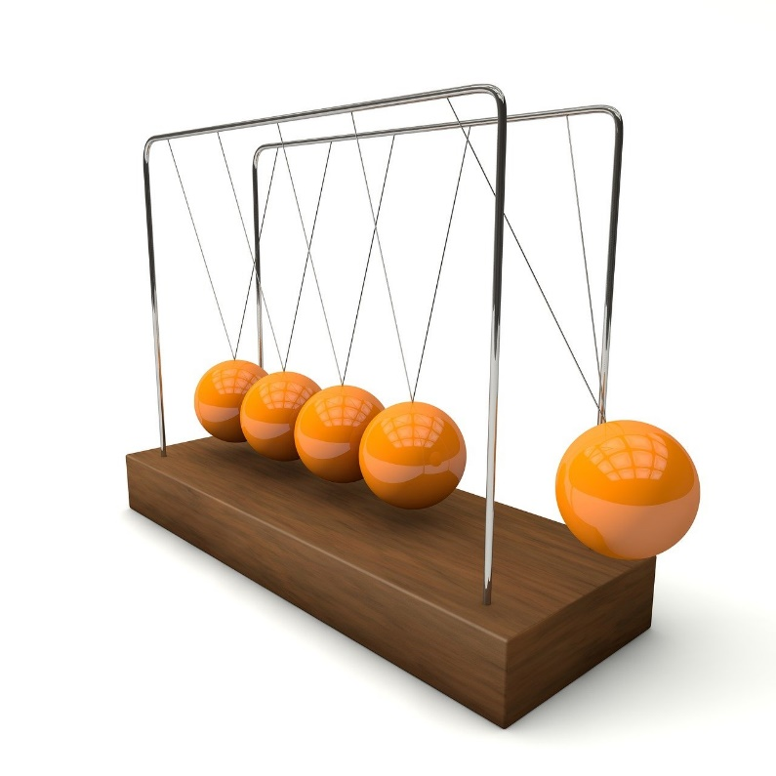

Instructions for Parents/Guardians
- Refer to your student’s score report to determine their instructional needs level—red, yellow, or green—for this performance category.
- Use the Interpretive Guidance (see page 2) to understand what your student likely knows and is able to do based on their instructional needs level.
- Use the Family Resources and Recommendations (see page 3) to engage with and support your student’s science learning at home.

Interpretive Guidance for Performance Category 4:
Support Arguments About Interactions Between Objects, Forces, and Energy
Red (0-6 score points earned)  - Extensive additional instruction and reteaching of these skills is recommended.  - The student needs significant opportunities to reinforce and apply these skills in future learning. | Yellow (7-10 score points earned)  - Moderate additional instruction on these skills is recommended.  - The student needs additional opportunities to strengthen these skills in future learning. | Green (11-13 score points earned)  - Minimal to no additional instruction on these skills is recommended.  - The student is ready to extend these skills in future learning.
What These Results Mean
This student is likely able to:  - Make an attempt to represent provided information in a model, utilizing a vague and inaccurate explanation of Newton’s First and Third Law.  - Provide an attempt to support an argument with a partial and inaccurate explanation of the relationship between variables in the system.  - Provide a partial and inaccurate explanation of invisible gravitational interactions between objects with major conceptual errors related to the relationship between mass and gravity. | This student is likely able to:  - Accurately represent provided information in a model, utilizing a vague but accurate explanation of Newton’s First and Third Law.  - Provide reasoning that attempts to link the argument with evidence with a partial and mostly accurate explanation of the relationship between mass and gravitational force, as well as the mathematical relationship between kinetic energy, mass, and velocity, depending on the system.  - Provide a partial explanation of invisible gravitational interactions between objects, comparing to observed motion, using the relationship between mass and gravity with minor conceptual errors. | This student is likely able to:  - Accurately and clearly represent provided information in a model, utilizing a clear and explicit explanation of Newton’s First and Third Law.  - Provide reasoning that accurately and clearly links the argument with evidence by explaining the relationship between mass and gravitational force, as well as the mathematical relationship between kinetic energy, mass, and velocity, depending on the system.  - Provide a complete and accurate explanation of invisible gravitational interactions between objects, comparing them to observed motion, using the relationship between mass and gravity.

Family Resources and Recommendations for Performance Category 4:
Support Arguments About Interactions Between Objects, Forces, and Energy
Resources and Recommendations to Support Science Learning at Home
Engage in the Topic  Why do objects fall? | Newton’s laws of motion help us understand what happens to objects when they are not moving, moving, or exposed to forces. They describe the relationships between forces acting on objects and the motion of the objects.  Ask your student what they think would happen to phones if dropped from the 10th floor of a building. Would they break or still function? Watch this video with your student and get their reactions.  Engage your student in a discussion:  - What if you dropped your phone and it goes crashing to the floor? What do you think would happen to your phone?  - Do you think the force of impact for the smaller phone and larger phone will be the same when dropped from the same height?  - What forces might be involved when the phone is falling toward the floor or ground?
Explore the Topic  What is a gravitational force?  What role does gravity play in the interactions of objects? | Gravity is an attractive force between any two objects. Gravitational forces are always attractive.  Watch this video with your student and discuss these key points:  - The force of gravity, or gravitational force, pulls objects with mass toward each other.  - Any object with mass exerts a gravitational force on all other objects with mass.  - More massive objects attract each other with greater gravitational force.  - Think about the force of gravity from Earth. This force keeps your body on the ground.  - Gravity is actually a weak force. The gravitational force on each of us is weaker than what we exert every day—like picking up a glass of water.  If your student is curious about mass, gravity, and weight, show this short video to identify differences, similarities, and relationships between all three.
Explain with Evidence  What is gravitational potential energy?  How can we compare the gravitational potential energy of different systems? | Potential energy is the stored energy an object has because of its position or state. Some examples of potential energy include a raised object such as a book, a stretch or compressed spring, or an object on top of a hill. Ask your student to give other examples of potential energy. (Examples: a stretched rubber band, water at the top of a waterfall, a yo-yo before it is released, a child on the top of a slide, ripe fruit before it falls)  Watch this video which presents examples of gravitational potential energy for your student to evaluate. After each of the following questions is presented, pause the video and repeat the question for your student. After your student answers, resume the video.  - Which ball will come down with more energy? (The blue ball has more energy due to more height.)  - Which weight has more energy? (The weight on the right has more potential energy. The heavier the weight, the more potential energy it will have.)  - Why does the water released from a dam have huge energy to produce electricity? (It is because the water is stored at a great height and has so much weight.)
Evaluate the Topic  How can Newton’s laws of motion be observed and used in everyday life? | Now ask your student:  - TRUE or FALSE: The phone with greater mass has less potential energy at the top of the drop than the phone with less mass. (FALSE)  - TRUE or FALSE: If the mass of the two phones is equal, then the phone that is higher off the ground will have greater potential energy. (TRUE)  - TRUE or FALSE: As height decreases, potential energy decreases. (TRUE)  - TRUE or FALSE: Mass is the force that causes the phone to fall towards the ground. (FALSE. Gravity is the force.)  - TRUE or FALSE: The phone with greater mass will hit the ground with more kinetic energy than the phone with less mass. (TRUE)

Resources
- Experiment: Dropping iPhone from the 10th FLOOR, video by Superkot
[https://www.youtube.com/watch?v=IxWRPXcbYqM&t=15s]
- Gravitational Forces, video developed by Khan Academy
[https://www.khanacademy.org/science/ms-physics/x1baed5db7c1bb50b:forces-at-a-distance/x1baed5db7c1bb50b:gravitational-forces/v/gravitational-forces-ms]
- Mass, Gravity, and Weight, video by Likeable Science
[https://www.youtube.com/watch?v=J0Y-VM7NTZ8]
- Potential Energy \ Potential Energy Concepts, Examples | Potential and Kinetic, video by TutWay
[https://www.youtube.com/watch?v=BfHa1LPtEMs]

