
Coherence and Alignment Among Science Curriculum, Instruction, and Assessment (CASCIA) Project

Grade 8 Unit 2: Gravity and Motion of Objects in the Solar System

Family Guidance and Learning Resources for Performance Category 2

October 2023

Grade 8 Unit 2: Gravity and Motion of Objects in the Solar System, Family Guidance and Learning Resources for Performance Category 2 was developed with funding from the U.S. Department of Education under the Competitive Grants for State Assessments Program CFDA 84.368A. The contents of this paper do not represent the policy of the U.S. Department of Education, and no assumption of endorsement by the Federal government should be made.
All rights reserved. Any or all portions of this document may be reproduced and distributed without prior permission, provided the source is cited as: Coherence and Alignment Among Science Curriculum, Instruction, and Assessment (CASCIA) Project. (2023). Grade 8 Unit 2: Gravity and Motion of Objects in the Solar System, Family Guidance and Learning Resources for Performance Category 2. Lincoln, NE: Nebraska Department of Education.
Purpose
The purpose of this document is to help families understand their student’s performance on the Grade 8 Unit 2 Science Assessment and to provide resources and recommendations for engaging their student in science learning at home.
Unit Overview
By engaging in this unit, students deepen their knowledge of Earth’s place in the universe, the force of gravity between objects with mass, and the role of gravitational force in keeping planetary objects in orbit. Students develop their experience and skills in developing and using models and analyzing and interpreting data to investigate the characteristics of objects in the solar system, explain patterns of the apparent motion of the sun, moon, and stars, and construct and support evidence-based arguments about the connections between gravitational forces and orbital motion.
Performance Category 2: Support Arguments About Earth’s Place in the Solar System and Universe
Prompts for this performance category require students to support an argument with evidence, data, or a model to explain:
- the relationship between asteroid diameters and frequency
- the role of Earth’s axial tilt in causing seasons
- lunar phases in terms of the relative positions of the sun, Earth, and moon
- the pattern regarding the surface temperatures of planets and their location in a solar system
- the role of gravity in the sequence of events leading to the formation of Earth’s solar system

Grade 8 Unit 2: Gravity and Motion of Objects in the Solar System

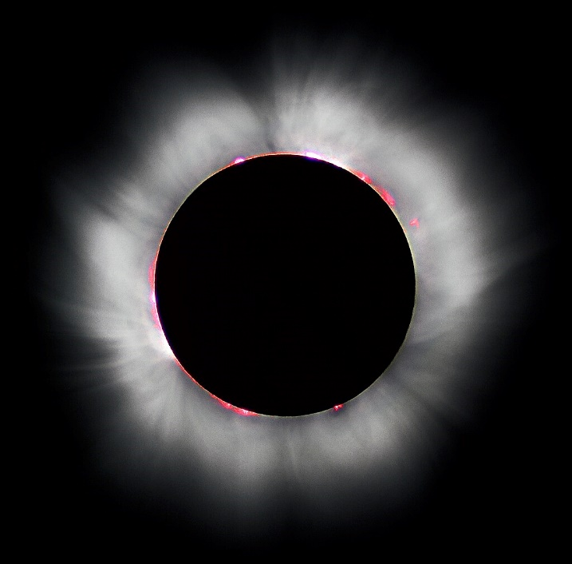
Credit: “Total solar eclipse” by Luc Viatour
Source: https://Lucnix.be
License: CC BY-SA 3.0

Instructions for Parents/Guardians
- Refer to your student’s score report to determine their instructional needs level—red, yellow, or green—for this performance category.
- Use the Interpretive Guidance (see pages 2-3) to understand what your student likely knows and is able to do based on their instructional needs level.
- Use the Family Resources and Recommendations (see pages 4-6) to engage with and support your student’s science learning at home.

Interpretive Guidance for Performance Category 2:
Support Arguments About Earth’s Place in the Solar System and Universe
Red (0-7 score points earned)  - Extensive additional instruction and reteaching of these skills is recommended.  - The student needs significant opportunities to reinforce and apply these skills in future learning. | Yellow (8-13 score points earned)  - Moderate additional instruction on these skills is recommended.  - The student needs additional opportunities to strengthen these skills in future learning. | Green (14-16 score points earned)  - Minimal to no additional instruction on these skills is recommended.  - The student is ready to extend these skills in future learning.
What These Results Mean
This student is likely able to:  - Attempt to interpret provided data in a graph.  - Provide some evidence to support an incomplete or inaccurate explanation of the spatial and temporal relationships in the Earth-sun-moon system, including seasonal patterns of Earth and the cyclic pattern of the lunar phases.  - Attempt to describe a relationship or pattern in the data when making inferences based on properties of objects within a solar system.  - Attempt to develop an explanation of the formation of Earth’s solar system with major conceptual errors.  - Demonstrate limited understanding of similarities and differences among solar system objects (e.g., using patterns of features when using a model to compare the inner planets to the outer planets). | This student is likely able to:  - Accurately interpret some provided data in a graph, using simple mathematical thinking, as necessary.  - Provide adequate evidence to support a reasonable explanation of the spatial and temporal relationships in the Earth-sun-moon system, including seasonal patterns of Earth and the cyclic pattern of the lunar phases.  - Describe the relationship between variables and identify patterns (qualitative or quantitative) among variables represented in the data, but analyses include some minor errors.  - Describe some aspects of the events leading to the formation of Earth’s solar system with some conceptual errors.  - Demonstrate partial understanding of similarities and differences among solar system objects and apply some of these concepts to compare conditions (e.g., surface temperature) of inner planets to outer planets. | This student is likely able to:  - Accurately interpret provided data in a graph and demonstrate mathematical thinking in their explanation.  - Provide complete and accurate evidence of the spatial and temporal relationships in the Earth-sun-moon system.  - Describe the relationship between variables and identify patterns (qualitative or quantitative) among variables represented in the data with minimal errors.  - Describe the events leading to the formation of Earth’s solar system with few conceptual errors.  - Demonstrate complete and accurate understanding of similarities and differences among solar system objects and accurately explain the pattern found regarding the comparison of surface temperatures of planets and their location in a solar system.

Family Resources and Recommendations for Performance Category 2:
Support Arguments About Earth’s Place in the Solar System and Universe
Resources and Recommendations to Support Science Learning at Home
Engage in the Topic  Why does Earth have seasons? | Present the following arguments to your student:  - Veronica says that we have seasons because Earth’s orbit is not a perfect circle. Sometimes, Earth is closer to the sun than other times.  - Nia says that we have seasons because the Earth is tilted on its axis. Sometimes, the Northern Hemisphere is tilted towards the sun, and sometimes, the Southern Hemisphere is tilted towards the sun.  Ask your student which argument they support.
Explore the Topic  What relationships among the Earth-Moon-Sun system describe the cause of Earth’s seasons? | Present the source of evidence used by Veronica and Nia to support their arguments:  - Veronica relies on a diagram of Earth’s actual orbital path around the sun.  - Point out the differences in the distance between the sun and Earth at different seasons during a year.  - Nia presents a diagram showing the angle of sunlight during Earth’s winter and summer seasons.  - State that the tilt of Earth’s axis never changes.  - Point out the tilt of Earth on its axis during the Winter Solstice.  - Point out the differences in the angle of the sunlight as it hits Earth’s surface during different times of the year. Different parts of Earth receive the sun’s most direct rays.  - Describe the difference between direct (Southern latitude during summer) and indirect (Northern latitude during winter) rays of sunlight hitting Earth’s surface on December 21.
Explain using Evidence  What role does Earth’s tilt play in seasonal changes? | Ask your student again which argument they support, given the evidence used by Veronica and Nia. Restate Veronica and Nia’s explanations.  Watch and discuss this website from NASA to reinforce your student’s understanding that Earth’s tilted axis causes the seasons.  - Seasons are caused by the Earth’s tilted axis. As the Earth orbits the sun, when the Northern Hemisphere is tilted towards the sun, the surface of Earth receives the most direct rays from the sun. The direct rays from the sun cause Earth to heat up, causing summer temperatures.  Watch this video [up to 1:59] explaining why Earth has seasons to highlight how Earth’s tilted axis causes seasons.  - Ask your student if the video gives them more evidence to support Veronica or Nia’s argument. Ask your student to explain their response. Your student may speak, write, or draw their response.
Elaborate with New Evidence  What other predictions can be made related to Earth’s tilt? | Work with your student to gather a light source (e.g., flashlight, cell phone light, etc.) and a round object (e.g., basketball, balloon, tennis ball). Using a pen, rubber band, or other means, identify a band around the center of the round object that represents Earth’s equator.  - Ask your student to use the light source and round object to model summer in the Northern latitude. (The ‘top’ half of the object is tilted towards the light source.)  - Ask your student to manipulate the model to correctly depict an explanation of winter in the Northern Hemisphere. (The ‘top’ half of the object is tilted away from the light source.)  - Ask your student to manipulate the model to correctly depict an explanation of the effect on temperatures in the Northern and Southern latitudes if Earth’s axis had NO tilt. (Neither the top nor bottom half of the object is tilted.)  Extension: Ask your student, “What would Earth be like with no tilt?” (e.g., The length of day and night would be exactly equal.; There would be no seasons, just an average of the current four seasons.; The types of living organisms on Earth would likely be quite different. Etc.)

Resources
- Earth’s orbit around the Sun, Diagram by Quora
[https://qph.cf2.quoracdn.net/main-qimg-632b0986e406299f88f120d9f6b07fb3.webp]
- Earth at Winter Solstice, Diagram by Weebly
[https://taylorsciencegeeks.weebly.com/uploads/5/9/2/0/59201005/449811051.png]
- What Causes the Seasons, Webpage by NASA Space Place
[https://spaceplace.nasa.gov/seasons/en/]
- Why Do We Have Different Seasons?, Video by California Academy of Sciences
[https://youtu.be/WgHmqv_-UbQ]

