
Coherence and Alignment Among Science Curriculum, Instruction, and Assessment (CASCIA) Project

Grade 8 Unit 4: Providing Solutions to Problems Using Simple Wave Properties

Family Guidance and Learning Resources for Performance Category 3

April 2024

Grade 8 Unit 4: Providing Solutions to Problems Using Simple Wave Properties, Family Guidance and Learning Resources for Performance Category 3 was developed with funding from the U.S. Department of Education under the Competitive Grants for State Assessments Program CFDA 84.368A. The contents of this paper do not represent the policy of the U.S. Department of Education, and no assumption of endorsement by the Federal government should be made.
All rights reserved. Any or all portions of this document may be reproduced and distributed without prior permission, provided the source is cited as: Coherence and Alignment Among Science Curriculum, Instruction, and Assessment (CASCIA) Project. (2023). Grade 8 Unit 4: Providing Solutions to Problems Using Simple Wave Properties, Family Guidance and Learning Resources for Performance Category 3. Lincoln, NE: Nebraska Department of Education.
Purpose
The purpose of this document is to help families understand their student’s performance on the Grade 8 Unit 4 Science Assessment and to provide resources and recommendations for engaging their student in science learning at home.
Unit Overview
By engaging in this unit, students deepen their knowledge of properties and types of simple waves and provide design solutions to problems that involve these properties. Students ask questions and define problems, develop and use models, plan and carry out investigations, construct explanations and design solutions, and use mathematical and computational thinking to build an understanding of sound waves and how properties of matter affect light.
Performance Category 3: Design the Best Solution to a Problem Involving Properties of Sound Waves and Materials
Prompts for this performance category require students to design a solution to a problem involving sound using properties of waves by:
- describing the relationship among different materials and the transmission of sound waves
Image: Sine waves different frequences
Credit: LucasVB
Source: https://en.wikipedia.org/wiki/Sound#/media/File:Sine_waves_different_frequencies.svg
License: Public Domain
- identifying the aspects of a solution to a problem related to properties of sound waves and providing justification for the importance of considering each when developing the solution
- identifying considerations for testing the solution that can be used to evaluate the solution’s effectiveness

Grade 8 Unit 4: Providing Solutions to Problems Using Simple Wave Properties
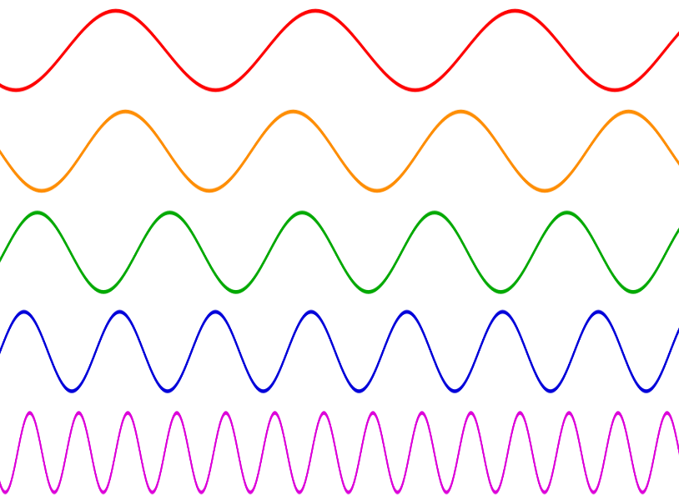

Instructions for Parents/Guardians
- Refer to your student’s score report to determine their instructional needs level—green, yellow, or red—for this performance category.
- Use the Interpretive Guidance (see page 2) to understand what your student likely knows and is able to do based on their instructional needs level.
- Use the Family Resources and Recommendations (see page 3) to engage with and support your student’s science learning at home.

Interpretive Guidance for Performance Category 3:
Design the Best Solution to a Problem Involving Properties of Sound Waves and Materials
Red (0-3 score points earned)  - Extensive additional instruction and reteaching of these skills is recommended.  - The student needs significant opportunities to reinforce and apply these skills in future learning. | Yellow (4-5 score points earned)  - Moderate additional instruction on these skills is recommended.  - The student needs additional opportunities to strengthen these skills in future learning. | Green (6-8 score points earned)  - Minimal to no additional instruction on these skills is recommended.  - The student is ready to extend these skills in future learning.

What These Results Mean
This student is likely able to:  - Use insufficient information to evaluate the aspects of a design problem involving sound waves, supported by limited or unrelated evidence regarding the behavior of sound waves with different media.  - Address one or no aspects of a design solution with little to no relevance to properties of sound waves.  - Attempt to describe a method or data needed to test the functioning of a design solution with limited connection to relevant criteria or constraints of the problem. | This student is likely able to:  - Evaluate and articulate the aspects of a design solution with minor errors or omissions involving sound waves by clearly describing their behavior with different media and the impact on the sound.  - Accurately describe at least two aspects of a solution and provide information to support the importance of considering each when developing a design solution related to properties of sound waves.  - Describe an appropriate method for testing a design solution and the necessary data to draw conclusions about its functioning. | This student is likely able to:  - Accurately evaluate and clearly articulate the components and interactions that result in a design problem involving sound waves by effectively describing their behavior with different media and the impact on sound.  - Accurately describe three aspects of a solution and provide relevant information to justify the importance of considering each when developing a design solution related to properties of sound waves.  - Describe an appropriate and systematic method for testing the functioning of a proposed solution and accurately describe the expected patterns or trends in data that reflect a successful solution.

Family Resources and Recommendations for Performance Category 3:
Design the Best Solution to a Problem Involving Properties of Sound Waves and Materials
Resources and Recommendations to Support Science Learning at Home
Engage in the Topic  - How does sound move? | Read the following to your student: A person stands across the room from a speaker on a shelf and wonders if it works. They walk closer to the speaker, and when they get about 2 feet from it, they hear music playing quietly. If they put their ear just a couple of inches from the speaker, they can hear the music playing more loudly.  Why would the music sound louder when the person stands closer to the speaker but quieter when they stand further from it? (Sound waves radiate outward as they travel away from a sound source, the speaker. As this happens, the wave's energy spreads out over a greater and greater space. This results in the amplitude of the wave decreasing. The lower the amplitude of the wave, the quieter it sounds. So, when the amplitude of the sound wave is higher, the person is closer to the speaker, which is why the sound is louder.)
Explore the Topic  - Why does acoustic engineering matter? | Watch this video with your student [1:54].  Noise can be described as an unwanted sound.  - What are some ways sound can affect people? (Sound affects people through safety, distraction, sleep interruption, concentration breaks, and stress.)  - What are some ways acoustic engineers can provide solutions to the harmful effects of sound? (Through sound-reducing materials, adding carpeting.)
Explore the Topic  - What is the relationship between different materials and how sound travels? | Read the following to your student: Acoustic engineers need to know how sound interacts with different materials to design solutions to sound problems.  Sound needs a medium to travel through. The medium can be solid, liquid, or gas.  - Scroll down to play the animation “The Speed in Sound of Other Materials.” What evidence does this provide about the speed of sound through materials? (Sound travels at different speeds in different materials. The sound travels faster in the solid pipes than in air. The friend yells and bangs the pipes at the same time, but the banging sound reaches you faster than the yelling sound.)  - Sound waves interact with materials in other ways, too. Read this information to learn about sound reflection, absorption, and transmission. Watch the Clap-Test video [1:02] with your student as you scroll down the page.
Explain the Topic  - How can the interactions between sound and different materials be explained? | With your student, look at the four diagram models in this article showing ways sound interacts with materials.  - Have your student name each interaction being modeled and, in their own words, describe what is happening to the sound waves for each model. (1. Sound Reflection: All of the sound waves from the person talking bounce off the walls, floors, and ceiling, so the sound waves are coming from multiple directions to the receiver. 2. Sound Absorption: Some of the sound that hits the walls and ceiling is being absorbed by materials that have been added. Only some of the sound reaches the receiver. 3. Sound Transmission: Sound waves are directly transmitted and reach the receiver. 4. Sound Blocking: Some of the sound is blocked and can’t be transmitted through the material to reach the receiver.)
Evaluate the Topic  - How would you test a design for different interactions of sound and materials? | Read to your student: Imagine you are investigating an acoustic problem. You create a prototype to test different materials that sound will interact with. There are four identical boxes to test. You have lined each box with a different type of material. A sound meter is placed at the same distance from each box to test each material. A cell phone playing music is placed in each box, one at a time. The sound level in decibels for each test is recorded.  - Look at the four diagram models. Which interaction are you testing for? (Sound transmission)  - How would you test the prototypes for which material has the greatest amount of sound absorption? (I would test each box with the music playing at different volumes to determine which has the lowest decibel reading when the music is loudest.)  - How could you demonstrate the ‘Clap Test’ in your investigation to demonstrate the effectiveness of your selected ‘best’ prototype? (Test a box without any added materials, then test the box with the best soundproofing to compare them.)
Elaborate on the Topic  - What do acoustic engineers look for when designing solutions to noise problems? | Read to your student: Acoustic engineers look at several aspects of materials when designing solutions to noise problems. One is the Sound Transmission Class (STC) rating. STC ratings measure the sound reduction capabilities of building materials, with ratings ranging from 0 to 100. High STC ratings help reduce noise transmission.  Suppose you were an acoustic engineer solving a problem of limiting the amount of sound transmitting through classroom walls. What other aspects besides an STC rating would you most likely consider when selecting a material for your design? (Possible answers include cost, ease of installation, availability, durability, and delivery time.)

Resources
- Interface FYI - Acoustics, YouTube
[https://www.youtube.com/watch?v=qzCAAQETx0o&t=21s]
- Sound, Iowa State University
[https://www.nde-ed.org/Physics/Sound/speedinair.xhtml]
- Reflection, Absorption, and Transmission of sound…what is the difference?, Aluglass Bautech
[https://aluglass.co.za/reflection-absorption-and-transmission-of-sound-what-is-the-difference/]
- Soundproofing vs Sound Absorption, Brennan
[https://brennancorp.com/blog/soundproofing-vs-sound-absorption/]

