Stackable Instructionally-embedded Portable Science (SIPS) Assessments Project



SIPS Grade 5 Unit 3 End-of-Unit Assessment Scoring Guide

May 2025

The SIPS Grade 5 Unit 3 End-of-Unit Assessment Scoring Guide was developed with funding from the U.S. Department of Education under the Competitive Grants for State Assessments Program, CFDA 84.368A. The contents of this paper do not represent the policy of the U.S. Department of Education, and no assumption of endorsement by the Federal government should be made.

All rights reserved. Any or all portions of this document may be reproduced and distributed without
prior permission, provided the source is cited as: Stackable Instructionally-embedded Portable Science
(SIPS) Assessments Project. (2025). SIPS Grade 5 Unit 3 End-of-Unit Assessment Scoring Guide. Lincoln,
NE: Nebraska Department of Education.
Table of Contents
SIPS Grade 5 Unit 3 EOU Assessment Task 1: Every Drop Counts ............................................................ 1
Task 1 Scoring Rubric ............................................................................................................................. 8
Task 1 Student Exemplars .................................................................................................................... 12
SIPS Grade 5 Unit 3 EOU Assessment Task 2: Searching for Freshwater ................................................ 16
Task 2 Scoring Rubric ........................................................................................................................... 22
Task 2 Student Exemplars .................................................................................................................... 26
SIPS Grade 5 Unit 3 EOU Assessment Task 3: Protecting Earth’s Soil ………............................................. 30
Task 3 Scoring Rubric ........................................................................................................................... 36
Task 3 Student Exemplars .................................................................................................................... 39


SIPS Grade 5 Unit 3 EOU Assessment Task 1: Every Drop Counts

Student Worksheet
This task is about Earth’s water.

Task
A new housing development is built to provide homes for new homeowners. After several months, the new homeowners discover that their toilets are often refilling between flushes. The toilets must be leaking!
The water used by the housing development is stored in an underground water source called an aquifer. Over time, the amount of water in the aquifer may get low.
The homeowners are concerned about how much water is being wasted.

Prompt 1
Figure 1 shows the percentage of household water use for different activities. It shows how the average household uses fresh, clean water in one year.
Figure 1. Household Water Uses
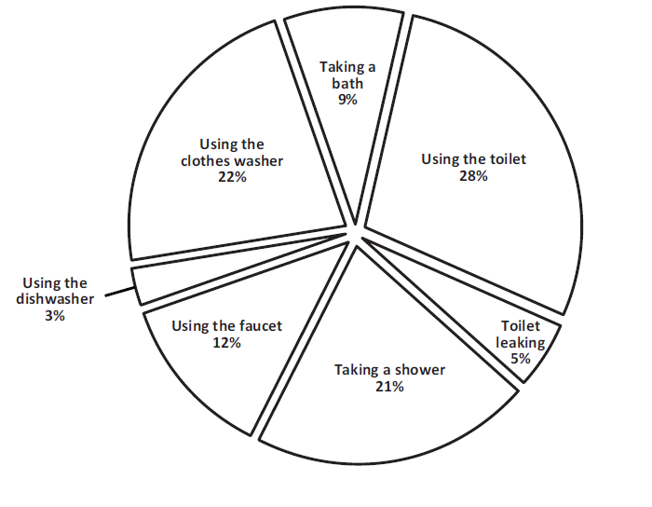
- Which activity uses the most water in Figure 1?

_____________________________

- Which activity uses the least water in Figure 1?

_____________________________
The average American family uses more than 300 gallons of water per day! Based on Figure 1, leaking standard toilets account for 15 gallons of water loss per day, or 5,475 gallons per year. That’s a lot of water loss!
Table 1 compares the water usage of two types of toilets.
Table 1. Toilet Water Usage
Type of Toilet | Gallons per Flush
Standard | 6.0
Low-flow | 1.5

- How much water would a homeowner save per flush by replacing a standard toilet with a low-flow toilet? ___________________________ gallons
- Per day, how many flushes of a low-flow toilet equal the amount of water lost by the leaking toilets in each household? _______________________flushes
- Write an argument to convince the homeowners to replace their leaking standard toilets to conserve the water in the aquifer. Use information from Figure 1 and Table 1.
___________________________________________________________________________
___________________________________________________________________________
___________________________________________________________________________
___________________________________________________________________________
___________________________________________________________________________

Prompt 2
Clean, fresh water is an important natural resource. Think about the ways you use fresh water each day. Of the water on Earth, only 3% is freshwater. Every drop counts because the rest of the water on Earth is saltwater. Table 2 shows four sources of fresh water and their approximate distribution on Earth.
Table 2. Distribution of Fresh Water Sources on Earth
Source | Percent (%)
Glaciers and ice caps | 76.0
Shallow groundwater | 12.0
Deep groundwater | 11.0
Lakes and rivers | 0.3

Part A.
Complete Figure 2 below using the information about Earth’s water sources and the information in Table 2. Be sure to include the name of each water source and its percent distribution to fill in the blanks to complete the figure.
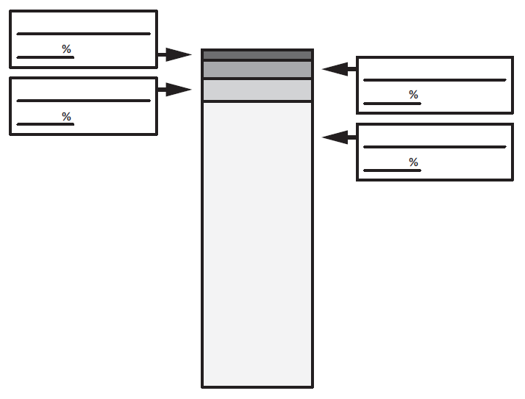
Figure 2. Distribution of Freshwater on Earth
Of the freshwater sources on Earth, only the water in lakes, rivers, and shallow groundwater is available for human use.
Part B.
What percent of the freshwater on Earth is available for human use? _____________%
Part C.
Explain to the homeowners why it is important to protect the aquifer by fixing the leaking standard toilets and implementing other ways to reduce freshwater waste. Use the data in Table 2 and Figure 2 to support your explanation.
______________________________________________________________________________
______________________________________________________________________________
______________________________________________________________________________
______________________________________________________________________________

Prompt 3
You want to show the homeowners how to design a solution to conserve water when using water to grow a vegetable garden. The garden is about 20 feet away from the house. To conserve water, a possible solution is to catch rainwater as it collects from the roof. The water runs through the gutter into the downspout.
Figure 3. Homeowner’s House and Garden
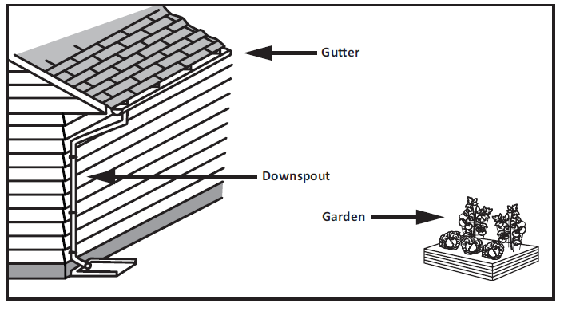
You have $75.00 to spend on a solution to conserve water, keep the plants in the garden alive, and provide the owners with a convenient way to reuse the rainwater. Table 3 shows garden supplies and their costs that could be used to solve the problem.
Table 3. Costs of Garden Supplies
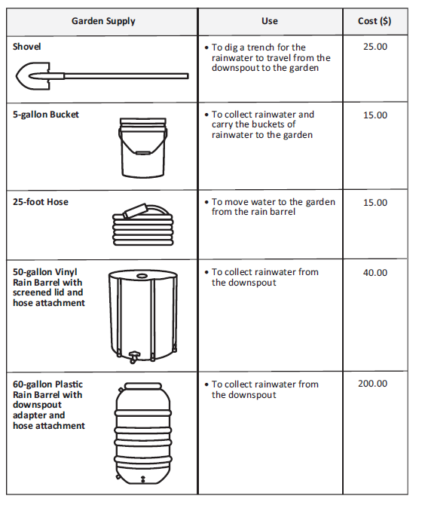

Part A.
Draw a solution for conserving water in Figure 4. In your drawing, be sure to label each garden supply you include and show how they work together to conserve water. Use information from Table 3 and the homeowner’s requirements to design your solution.
Figure 4. Design Solution to Conserve Water
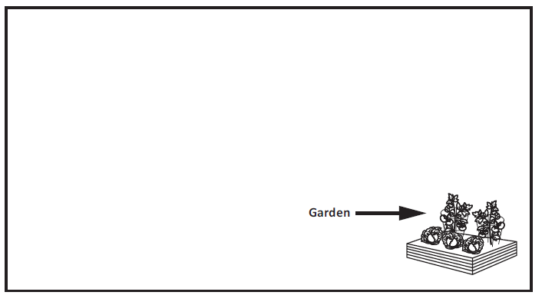
Part B.
Explain your design solution to conserve water.
______________________________________________________________________________
______________________________________________________________________________
______________________________________________________________________________
______________________________________________________________________________
______________________________________________________________________________

______________________________________________________________________________

______________________________________________________________________________

______________________________________________________________________________

Part C.
Compare how well your solution addresses the water conservation problem compared to other possible solutions. Consider the homeowner’s requirements that you:
- have $75.00 to spend on a solution to conserve water
- need to keep the plants in the garden alive
- need to provide the owners with a convenient way to reuse the rainwater
________________________________________________________________________
________________________________________________________________________
________________________________________________________________________
________________________________________________________________________

SIPS Grade 5 Unit 3 EOU Assessment Task 1 Rubric (5-ESS2-2, 5-ESS3-1, 5-ETS1-2)
Prompt | Score Point 0 | Score Point 1 | Score Point 2 | Score Point 3 | Score Point 4
Prompt 1  Parts A – D.  Scored Responses | No aspect of the response is correct | Response includes one (1) of the four (4) aspects | Response includes two (2) of the four (4) aspects | Response includes three (3) of the four (4) aspects | Response includes the following aspects:  - A. Using the toilet  - B. Using the dishwasher  - C. 4.5  - D. 10
Prompt 1  Part E.  Scored Responses | No aspect of the response is correct | Response includes one (1) of the three (3) aspects | Response includes two (2) of the three (3) aspects | Response includes the following aspects:  - Refers to Figure 1 by comparing water usage to another part of the pie chart OR indicates that leaking represents 5% of all water usage  - Indicates that the standard toilet uses a lot more water than the low-flow toilet using information from Table 1  - Indicates that saving water is important in support of the argument | NA
Prompt 2  Part A. & Part B.  Scored Responses | No aspect of the response is correct | Response includes the following aspects:  Part A  - Correctly labels at least one (1) water source or correctly indicates a percentage for at least one (1) water source  OR  Part B  - 12.3% or states “lakes and rivers and shallow groundwater” | Response includes the following aspects:  Part A  - Correctly labels at least two (2) water sources  - Correctly indicates a percentage for at least two (2) water sources  OR  Part B  - 12.3% or states “lakes and rivers and shallow groundwater” | Response includes the following aspects:  Part A:  - Correctly labels at least two (2) water sources  - Correctly indicates a percentage for at least two (2) water sources  AND  Part B  - 12.3% or states “lakes and rivers and shallow groundwater” | Response includes the following aspects:  Part A  - Correctly labels four (4) water sources  - Correctly indicates percentages for four (4) water sources  AND  Part B  - 12.3% or states “lakes and rivers and shallow groundwater”
Prompt 2 Part C.  Scored Responses | No aspect of the response is correct | Response includes one (1) of the three (3) aspects | Response includes two (2) of the three (3) aspects | Response includes the following aspects:  - The total amount of freshwater is only 3% of all Earth’s water  - The amount of water humans can use is a small percent of the amount of freshwater on Earth  - Saving water is important for the aquifer in support of the argument | NA
Prompt 3  Part A.  Scored Responses | No aspect of the response is correct | Response includes one (1) of the three (3) aspects | Response includes two (2) of the three (3) aspects | Response includes the following aspects:  - A means to collect rainwater  - A means to transport the rainwater to the garden  - Labels for all garden supplies included in the drawing | NA
Prompt 3  Part B.  Scored Responses | No aspect of the response is correct | Response includes one (1) of the two (2) aspects | Response includes the following aspects:  - A clear connection between the drawing and the explanation  - Description of a viable solution | NA | NA
Prompt 3  Part C.  Scored Responses | No aspect of the response is correct | Response includes one (1) of the two (2) aspects | Response includes the following aspects:  - Addresses the cost of their solution  - States another advantage of their solution and/or disadvantage of another | NA | NA

Student Exemplar(s)
Student exemplars represent high-quality responses that align to full-point rubric scores. The exemplar responses are intended to assist educators’ understanding of the nature and expectations of each prompt. Note the exemplars serve as examples of high-quality responses, and students may respond with equally relevant, scientifically accurate responses and ideas that meet the expectations of a full-point rubric score.

Prompt 1
- Which activity uses the most water in Figure 1? Using the toilet

- Which activity uses the least water in Figure 1? Using the dishwasher

- How much water would a homeowner save per flush by replacing a standard toilet with a low-flow toilet? 4.5 gallons

- Per day, how many flushes of a low-flow toilet equal the amount of water lost by the leaking toilets in each household? 10 flushes

- Write an argument to convince the homeowners to replace their leaking standard toilets to conserve the water in the aquifer. Use information from Figure 1 and Table 1.

The leaking toilet is the cause of 5% of the water loss. This is a lot of water as it is more than a dishwasher uses. Also, a standard toilet uses a lot more water per flush than a low-flow toilet. Water is important and we need to save as much as we can. There is a limited amount of water underground so the homeowners should replace their leaking standard toilets.

Prompt 2
Part A.
Complete Figure 2 below using the information about Earth’s water sources and the information in Table 2. Be sure to include the name of each water source and its percent distribution to fill in the blanks to complete the figure.

Figure 2. Distribution of Freshwater on Earth
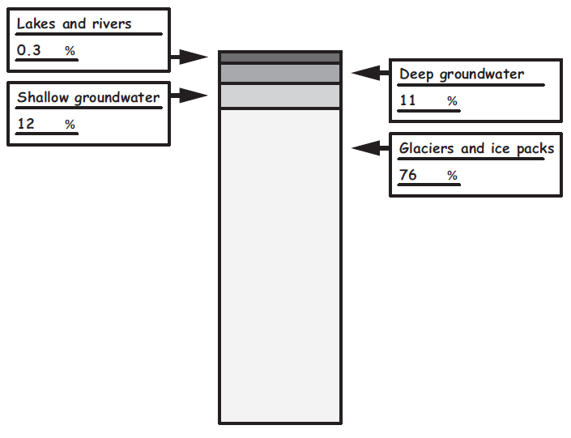

Part B.
What percent of the freshwater on Earth is available for human use? 12.3 %
Part C.
Explain to the homeowners why it is important to protect the aquifer by fixing the leaking standard toilets and implementing other ways to reduce freshwater waste. Use the data in Table 2 and Figure 2 to support your explanation.

Homeowners must fix toilet leaks and reduce freshwater waste. Most of Earth’s water, 97%, is salt water that humans do not use. Freshwater is only 3% of Earth’s water. Of that, humans can only use about 12% of that. So, that means we have a tiny drop of all Earth’s water to use and should not waste any of it. We need to keep the underground water level from getting too low. This will help protect the aquifer.

Prompt 3
Part A.
Draw a solution for conserving water in Figure 4. In your drawing, be sure to label each garden supply you include and show how they work together to conserve water. Use information from Table 3 and the homeowner’s requirements to design your solution.
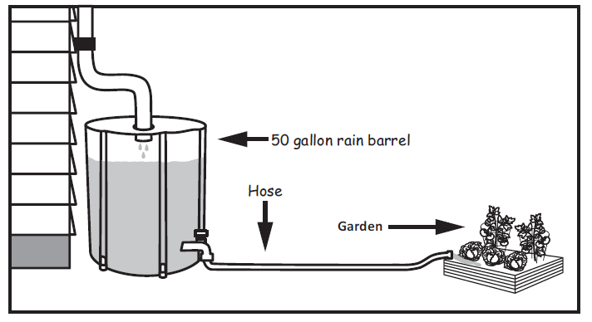
Figure 4. Design Solution to Conserve Water

Part B.
Explain your design solution to conserve water.
The best solution is to use the 50-gallon vinyl rain barrel and a hose. I would place the barrel below the downspout to collect the rainwater. Then I would connect the hose to the bottom of the barrel at the spigot. The hose can be used to move the water right to the garden. That way you can water the garden with the saved rainwater.

Part C.
Compare how well your solution addresses the water conservation problem compared to other possible solutions. Consider the homeowner’s requirements that you:
- have $75.00 to spend on a solution to conserve water
- need to keep the plants in the garden alive
- need to provide the owners with a convenient way to reuse the rainwater
The hose and the 50-gallon vinyl rain barrel will cost less than $75. Using a 50-gallon barrel with a lid on top will hold a lot of water and the lid keeps leaves and stuff out. Another solution is to use a 5-gallon bucket to collect water and it would be the cheapest. But, 5 gallons is a lot less than 50 gallons. If it rains a lot, the water will flow out of the bucket and the water can get full of leaves.

SIPS Grade 5 Unit 3 EOU Assessment Task 2: Searching for Freshwater
Student Worksheet
This task is about how Earth’s systems interact.

Task
Josh and his friends are hiking in the mountains. After a few hours, they start to get thirsty. They notice a freshwater spring along the trail where the groundwater bubbles up and flows to the surface. The freshwater spring is a welcomed sight! But how do freshwater springs form?
The Earth’s systems, or spheres, interact to produce the environments we observe. As you complete this task, consider how the Earth’s spheres might interact to form a freshwater spring like Josh and his friends found.

Prompt 1
Picture 1 is a photograph taken by Josh. The photograph shows a mountain meadow's components (living and non-living things) and Earth’s different spheres.
Picture 1. Components of a Mountain Meadow
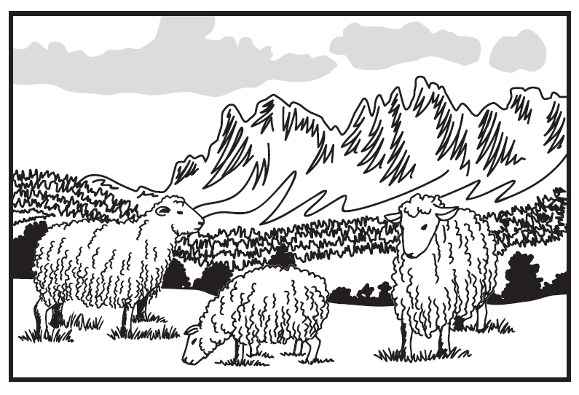
Part A.
Complete Table 1 by identifying the Earth’s sphere that is represented by each component of the mountain meadow from Picture 1. Choose from the following list of Earth’s spheres to complete the table.
Geosphere | Biosphere | Hydrosphere | Atmosphere

Table 1. Components of Earth’s Spheres
Component | Earth’s Sphere
Sheep | ______________
Mountain | ______________
Cloud | ______________
Grass | ______________
Air | ______________
Snow | ______________
Part B.
Describe one way that two components of the biosphere interact in Picture 1.
______________________________________________________________________________
______________________________________________________________________________
Part C.
Describe one way the biosphere and the atmosphere interact in Picture 1.
______________________________________________________________________________
______________________________________________________________________________

Prompt 2
Josh and his friends leave the meadow and continue hiking. They hear fast-moving water before they see a stream. When they reach the stream, they see sand and pebbles tumbling along the bottom. As the water moves downstream, it carries twigs, leaves, and bits of soil. In sheltered water pools, insects hover in the air above the water. Toads are along the bank. A large fish is just under the water’s surface.
Identify three interactions among the Earth’s spheres that Josh and his friends observe.
For each interaction:
- Identify two spheres that interact
- Describe the interactions of the components of the two spheres
Interaction 1.
The ___________________________ is interacting with the _____________________________
(sphere) (sphere)
when _________________________________________________________________________
_____________________________________________________________________________.
Interaction 2.
The ___________________________ is interacting with the _____________________________
(sphere) (sphere)

when _________________________________________________________________________
_____________________________________________________________________________.
Interaction 3.
The___________________________ is interacting with the _____________________________
(sphere) (sphere)
when _________________________________________________________________________
_____________________________________________________________________________.

Prompt 3
Table 3 shows the distribution of all water on Earth. The distribution ranges from the saltwater found in oceans to the flowing or liquid freshwater humans can see on Earth’s surface, like lakes.
Table 3. Percent Distribution of Earth’s Water
All Earth’s Water | Earth’s Freshwater | Earth’s Fresh Surface Water (liquid)
- 3% is freshwater  - 97% is saltwater | - 97.7% is other freshwater  - 0.3% is fresh surface water | - 87% is lakes  - 11% is swamps  - 2% is rivers

Part A.
Write the percent AND type of surface water on each line of the Percent Distribution of Surface Water bar graph. Use the information from Table 3.

Part B.
Why could you argue that a freshwater spring is a rare and special resource? Use the data in Table 3 and the percent distribution of Earth’s fresh surface water in your bar graph to support your answer. Be sure to include what you know about the distribution of all of Earth’s water.
______________________________________________________________________________
______________________________________________________________________________
______________________________________________________________________________
______________________________________________________________________________

______________________________________________________________________________

______________________________________________________________________________

Prompt 4
Figure 1 is an incomplete model showing the formation of the freshwater spring. The arrows in the incomplete model show the flow of rainfall that results in a freshwater spring.
Part A.
Use the following words to label Figure 1:
Freshwater spring | Rock and soil | Solid rock | Groundwater

Figure 1. Model of the Formation of a Freshwater Spring
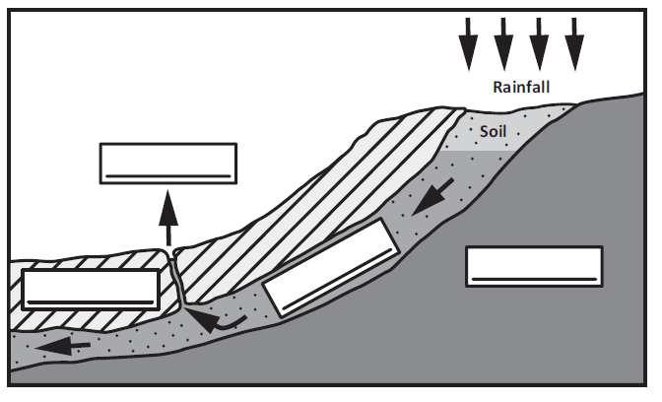
Part B.
Which of Earth’s spheres interact to form the freshwater spring in Figure 1?
_____________________________________________________________________________

____________________________________________________________________________________________

Part C.
Describe how the Earth's spheres interact to form the freshwater spring. Use information from Figure 1 to support your description.
______________________________________________________________________________
______________________________________________________________________________
______________________________________________________________________________

______________________________________________________________________________

______________________________________________________________________________

______________________________________________________________________________

SIPS Grade 5 Unit 3 EOU Assessment Task 2 Rubric (5-ESS2-1, 5-ESS2-2, and 5-ESS3-1)
Prompt | Score Point 0 | Score Point 1 | Score Point 2 | Score Point 3 | Score Point 4
Prompt 1 Part A.  Scored Responses | No aspect of the response is correct | Response includes one (1) or two (2) aspects matched with a corresponding sphere | Response includes three (3) or four (4) aspects matched with a corresponding sphere | Response includes five (5) or six (6) aspects matched with a corresponding sphere | NA
Prompt 1  Part B. & Part C.  Scored Responses | No aspect of the response is correct | Response includes one (1) of the two (2) aspects | Response includes the following aspects:  Part B  - Identifies an interaction of two components of the biosphere  Part C  - Identifies an interaction of the biosphere and atmosphere | NA | NA
Prompt 2  Scored Responses | No aspect of the response is correct | Response includes one (1) distinct interaction between two different spheres  AND  The distinct interaction includes both required aspects | Response includes two (2) distinct interactions between two different spheres  AND  At least one (1) of the two (2) distinct interactions includes both required aspects | Response includes three (3) distinct interactions between two different spheres  AND  At least two (2) of the three (3) distinct interactions include both required aspects | Response includes three (3) distinct interactions between two different spheres  AND  Each interaction includes the following aspects:  - Identification of the components related to each sphere in the interaction  AND  - Description of how one component interacts with the other
Prompt 3  Part A. & Part B.  Scored Responses | No aspect of the response is correct | Response includes one (1) of the four (4) aspects | Response includes two (2) of the four (4) aspects | Response includes three (3) of the four (4) aspects | Response includes the following aspects:  Part A  - Accurately indicates the percent distribution for each fresh surface water source and labels each fresh surface water source  Part B  - Description of the relative proportions between sources of water on Earth  - Data relates to the corresponding water sources  - Clear conclusion about the importance/rarity of freshwater springs in relation to Earth’s available water
Prompt 4 Part A.  Scored Responses | No aspect of the response is correct | Student correctly identifies one (1) aspect of the model | Student correctly identifies two (2) or three (3) aspects of the model | Student correctly identifies all four (4) aspects of the model | NA
Prompt 4 Part B. & Part C.  Scored Responses | No aspect of the response is correct | Response includes one (1) of the three (3) aspects | Response includes two (2) of the three (3) aspects | Response includes the following aspects:  Part B  - Identifies the hydrosphere and the geosphere as the two spheres that interact  Part C  - Indicates that water comes from the hydrosphere (i.e., rainfall) and moves into the geosphere (e.g., soaks into the soil)  - Describes how that water forms a spring | NA

Student Exemplar(s)
Student exemplars represent high-quality responses that align to full-point rubric scores. The exemplar responses are intended to assist educators’ understanding of the nature and expectations of each prompt. Note the exemplars serve as examples of high-quality responses, and students may respond with equally relevant, scientifically accurate responses and ideas that meet the expectations of a full-point rubric score.

Prompt 1
Part A.
Complete Table 1 by identifying the Earth’s sphere that is represented by each component of the mountain meadow from Picture 1. Choose from the following list of Earth’s spheres to complete the table.
Geosphere | Biosphere | Hydrosphere | Atmosphere
Table 1. Components of Earth’s Spheres
Component | Earth’s Sphere
Sheep | Biosphere
Mountain | Geosphere
Cloud | Hydrosphere
Grass | Biosphere
Air | Atmosphere
Snow | Hydrosphere

Part B.
Describe one way that two components of the biosphere interact in Picture 1.
The sheep eat the grass.
Part C.
Describe one way the biosphere and the atmosphere interact in Picture 1.
The sheep breathe air. (biosphere/atmosphere)
OR
Grass uses photosynthesis. (biosphere/atmosphere)

Prompt 2

Identify three interactions among the Earth’s spheres that Josh and his friends observe.
For each interaction:
- Identify two spheres that interact
- Describe the interactions of the components of the two spheres
Interaction 1.
The Hydrosphere is interacting with the Geosphere when the rocks and sand tumble in the water in the stream.
Interaction 2.
The Hydrosphere is interacting with the Biosphere when the twigs and leaves are carried by the stream.
Interaction 3.
The Biosphere is interacting with the Atmosphere when insects fly in the air.
(Other interactions may be the toads breathing air. Toads living in the water. The fish living in the water, etc.)

Prompt 3
Part A.
Write the percent AND type of surface water on each line of the Percent Distribution of Surface Water bar graph. Use the information from Table 3.
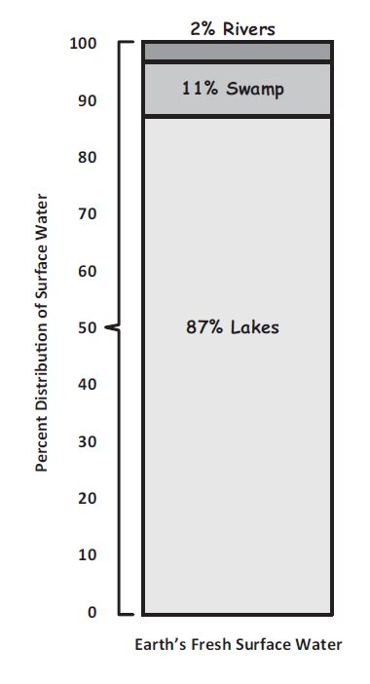
Part B.
Why could you argue that a freshwater spring is a rare and special resource? Use the data in Table 3 and the percent distribution of Earth’s fresh surface water in your bar graph to support your answer. Be sure to include what you know about the distribution of all of Earth’s water.
A freshwater spring is a tiny percent of Earth’s water. Most of Earth’s water, 97%, is saltwater. Then the remaining freshwater is mostly in glaciers and groundwater. Then only 0.3% of Earth’s freshwater is found as a liquid on the surface. That means a freshwater spring must represent a very small percent of all the water on Earth’s surface. That is why a freshwater spring is a rare resource.

Prompt 4
Part A.
Use the following words to label Figure 1.
Freshwater spring | Rock and soil | Solid rock | Groundwater
Figure 1. Model of the Formation of a Freshwater Spring
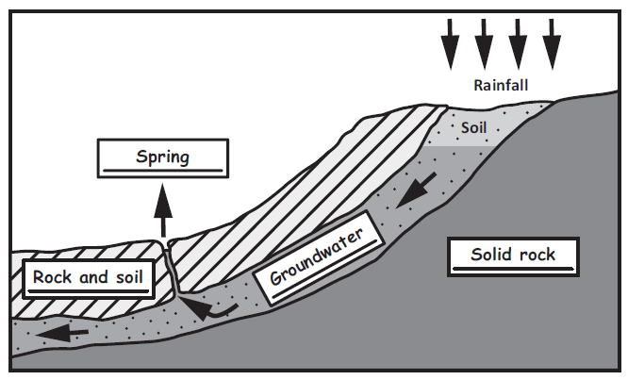
Part B.
Which of Earth’s spheres interact to form the freshwater spring in Figure 1?
The hydrosphere and the geosphere interact to form the freshwater spring.
Part C.
Describe how Earth’s spheres interact to form the freshwater spring. Use information from Figure 1 to support your description.
Rain from the hydrosphere soaks into the geosphere when the soil is wet. The rainfall then moves deeper into the ground and becomes groundwater. When there is enough groundwater, the water seeps up through the ground to the surface. It forms a freshwater spring that the hikers find.
SIPS Grade 5 Unit 3 EOU Assessment Task 3: Protecting Earth’s Soil

Student Worksheet
This task is about protecting Earth’s resources and environment.

Task
The Murdoch family owns a farm. They grow food crops for humans. The farm has experienced more severe weather during the last few years including heavy rainfalls and strong winds. This has caused soil erosion and the loss of fertile soil. Fertile soil has a thick top layer where plant roots can take hold. The plants’ roots create pathways for the movement of water and soil nutrients. The problem the family needs to solve is to reduce the erosion of fertile soil.

Prompt 1
Figure 1 is a stream table. It is set up for an experiment to observe the effect of moving water on soil. This stream table includes a propped-up or lifted board covered with bare soil. The board is placed under a water faucet. No water is flowing over the bare soil.
Figure 1. Stream Table with Bare Soil
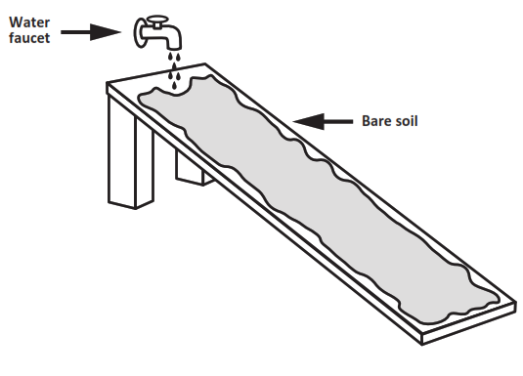
During the experiment, the water faucet is turned on and water flows slowly over the bare soil in the stream table.

Part A.
Which shows the water's effect on the soil after flowing slowly down the stream table? Circle your answer.
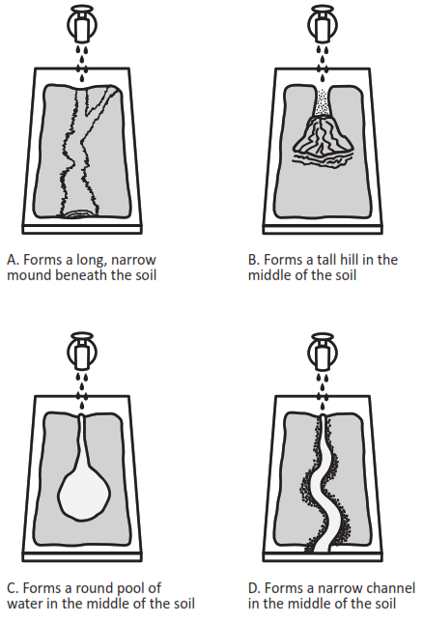
Part B.
Figure 2 shows another experiment with a stream table. This time, plants are growing in the soil. The water faucet is turned on, and water flows slowly from the faucet over the soil with rooted plants.

Figure 2. Stream Table with Soil and Plants
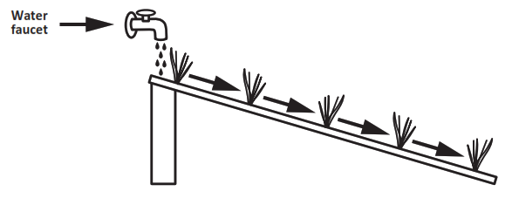
Identify if the results from the two experiments, one with bare soil and one with plants rooted in the soil, will be the SAME OR DIFFERENT. Circle your answer below AND then compare the two experiments to explain your answer.
The results of the experiments will be the SAME DIFFERENT.
When I compare the two experiments, I know this because _____________________________
______________________________________________________________________________
______________________________________________________________________________
______________________________________________________________________________

______________________________________________________________________________

Prompt 2
Each year, the Murdochs prepare the soil in their fields to be seeded. The soil is broken up and turned over to leave bare topsoil. This includes turning over the top layer of soil to remove weeds and native grasses. After the fields are prepared, there is nothing growing in the soil until the fields are planted.
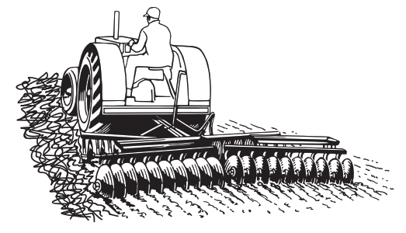
Previous experiments showed the effects of water erosion on the Murdoch’s fields. Figure 4 shows a model of another type of erosion that the Murdochs must consider.
Figure 4. Model of Interaction Between Two of Earth’s Spheres
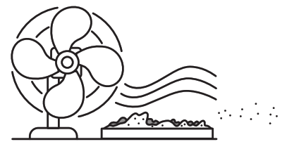
Part A.
Identify the type of erosion represented in Figure 4 and explain the interaction between the two Earth spheres.
______________________________________________________________________________
______________________________________________________________________________
______________________________________________________________________________
Part B.
Explain how this type of erosion, shown in Figure 4, will negatively affect the Murdoch’s crop production. Remember, fertile soil has a thick top layer where plant roots can take hold.
______________________________________________________________________________
______________________________________________________________________________
______________________________________________________________________________
______________________________________________________________________________

Prompt 3.
During the last few years, stronger winds from the west have blown across the field. The wind is blowing the fertile soil away. One solution to the problem is to build a windbreak of trees. A windbreak may be a stand of trees growing along the edge of the field.

Part A.
On which side of the field should the farmer plant a windbreak? Circle your answer.
North South East West

Part B.
Explain why the farmer should be able to grow more food if a windbreak is planted and grows on the side of the field you circled in Part A.
_____________________________________________________________________________
______________________________________________________________________________
______________________________________________________________________________
______________________________________________________________________________
______________________________________________________________________________
Part C.
Which design for a windbreak will provide the most effective solution to the farmer’s problem? Circle your answer.
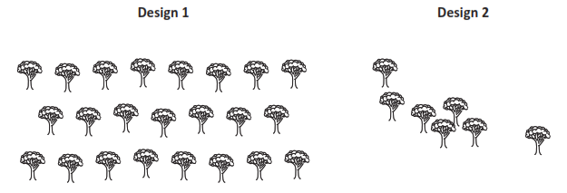
Explain the benefits of the design you chose.
______________________________________________________________________________
______________________________________________________________________________
______________________________________________________________________________
______________________________________________________________________________

Prompt 4
Remember, the Murdoch’s farm has experienced heavy rainfalls and strong winds during the last few years. This has caused soil erosion and the loss of fertile soil. The Murdochs want to be sure any solutions will reduce the water and wind erosion of their fertile soil from year to year.
The Murdoch family considers two solutions:
- Wait until the fields are almost ready to be seeded before they prepare the soil for planting.
- Plant a windbreak of trees.
Part A.
What measurements should the Murdochs collect to know if the solutions are working to prevent the erosion of the fertile topsoil?
______________________________________________________________________________
______________________________________________________________________________
______________________________________________________________________________
Part B.
If the solutions are working, what pattern would you expect to see in the data?
______________________________________________________________________________
______________________________________________________________________________
______________________________________________________________________________

SIPS Grade 5 Unit 3 EOU Assessment Task 3 Rubric (5-ESS2-1, 5-ESS3-1, 5-ETS1-2)
Prompt | Score Point 0 | Score Point 1 | Score Point 2 | Score Point 3 | Score Point 4
Prompt 1  Part A.  Scored Responses | No aspect of the response is correct | Response includes the following aspect:  - Selects D | NA | NA | NA
Prompt 1  Part B.  Scored Responses | No aspect of the response is correct | Response includes one (1) of the three (3) aspects | Response includes two (2) of the three (3) aspects | Response includes the following aspects:  - Selects “Different”  - The plant roots help keep the soil in place  - The soil with plants does not wash away | NA
Prompt 2  Part A. & Part B.  Scored Responses | No aspect of the response is correct | Response includes one (1) of the two (2) aspects | Response includes the following aspects:  Part A  - Identifies that wind erosion is represented by the interaction between the atmosphere (or wind) and the geosphere (or soil)  Part B  - A description of how the interaction of the atmosphere or wind and the geosphere or soil will result in a loss of topsoil or a reduction in crop production | NA | NA
Prompt 3 Part A. & Part B.  Scored Responses | No aspect of the response is correct | Response includes one (1) of the two (2) aspects | Response includes the following aspects:  - Selects “West”  - Explanation that describes how the windbreak will reduce the negative impact of the wind and help keep the soil in place | NA | NA
Prompt 3 Part C.  Scored Responses | No aspect of the response is correct | The response includes one (1) of the two (2) aspects | Response includes the following aspects:  - Selects “Design 1”  - Makes an accurate comparison between the two designs | NA | NA
Prompt 4  Part A. & Part B.  Scored Responses | No aspect of the response is correct | The response includes one (1) of the two (2) aspects | Response includes the following aspects:  - Measurement of the depth of the fertile topsoil  - Description of how maintaining a similar or improved depth of fertile topsoil over time shows how well the solution functions over time | NA | NA

Student Exemplar(s)
Student exemplars represent high-quality responses that align to full-point rubric scores. The exemplar responses are intended to assist educators’ understanding of the nature and expectations of each prompt. Note the exemplars serve as examples of high-quality responses, and students may respond with equally relevant, scientifically accurate responses and ideas that meet the expectations of a full-point rubric score.

Prompt 1
Part A.
Which shows the water's effect on the soil after flowing slowly down the stream table? Circle your answer.

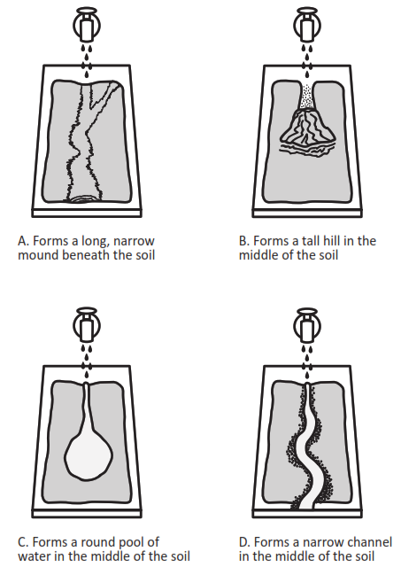
Part B.
Identify if the results from the two experiments, one with bare soil and one with plants rooted in the soil, will be the SAME OR DIFFERENT. Circle your answer below AND then compare the two experiments to explain your answer.
The results of the experiments will be the SAME DIFFERENT.
When I compare the two experiments, I know this because plants help break the force of falling rain before it hits the soil. Also, their roots absorb some of the water and help keep the soil in place. The soil with plants will move less than the bare soil will when the water flows over it.

Prompt 2.
Part A.
Identify the type of erosion shown in Figure 4 and explain the interaction between the two Earth spheres.
This is an interaction of the atmosphere and geosphere. When the wind blows on bare soil, the topsoil will blow away.
OR
This is an interaction of the wind and soil. When the wind blows on bare soil, the topsoil will blow away.
Part B.
Explain how this type of erosion, shown in Figure 4, will negatively affect the Murdoch’s crop production. Remember, fertile soil has a thick top layer where plant roots can take hold.
The Murdoch’s ability to grow food can be threatened by the wind. Wind can cause the soil to produce less food. This is because the most fertile part of the soil is blown away. When the soil blows away, it can collect into waterways around the plants.

Prompt 3.
Part A.
On which side of the field should the farmer plant a windbreak? Circle your answer.

North South East West

Part B.
Explain why the farmer should be able to grow more food if a windbreak is planted and grows on the side of the field you circled in Part A.
A windbreak is a row of trees that slow or stop the wind as it blows across the farmer's field. It is supposed to keep the soil from blowing away. If the wind is coming from the west, then the west edge is where the trees would block the most wind.
Part C.
Which design for a windbreak will provide the most effective solution to the farmer’s problem? Circle your answer.

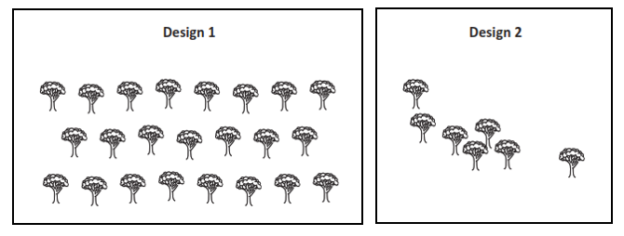

Explain the benefits of the design you chose.
Design 1 has more trees. This will help reduce the amount of wind that reaches the bare soil. Also, the trees are planted more closely together. In Design 2, the trees are too far apart to stop much of the wind.

Prompt 4.

Part A.
What measurements should the Murdochs collect to know if the solutions are working to prevent the erosion of the fertile topsoil?
The farmer should take measurements of the depth of the topsoil over time to check that less topsoil is being lost from water and wind erosion.

Part B.

If the solution is working, what pattern would you expect to see in the data?
If waiting to plow is slowing the water erosion and the windbreak is working to slow wind erosion, then the depth or amount of topsoil should stay about the same over time. That means the farmer’s solutions are working to prevent the fertile topsoil from eroding away over time.

