
Stackable Instructionally-
embedded Portable Science
(SIPS) Assessments Project

SIPS Grade 5 Unit 4 End-of-Unit Assessment Scoring Guide

May 2025

The SIPS Grade 5 Unit 4 End-of-Unit Assessment Scoring Guide was developed with funding from the U.S. Department of Education under the Competitive Grants for State Assessments Program, CFDA 84.368A. The contents of this paper do not represent the policy of the U.S. Department of Education, and no assumption of endorsement by the Federal government should be made.

All rights reserved. Any or all portions of this document may be reproduced and distributed without prior permission, provided the source is cited as: Stackable Instructionally-embedded Portable Science (SIPS) Assessments Project. (2025). SIPS Grade 5 Unit 4 End-of-Unit Assessment Scoring Guide. Lincoln, NE: Nebraska Department of Education.
Table of Contents
SIPS Grade 5 Unit 4 EOU Assessment Task 1: Here Comes the Sun .............................................................1
Task 1 Scoring Rubric .............................................................................................................................6
Task 1 Student Exemplars .....................................................................................................................9
SIPS Grade 5 Unit 4 EOU Assessment Task 2: Meet the Beetles! ..............................................................12
Task 2 Scoring Rubric ...........................................................................................................................17
Task 2 Student Exemplars ...................................................................................................................20
SIPS Grade 5 Unit 4 EOU Assessment Task 3: Turn, Turn, Turn ………........................................................22
Task 3 Scoring Rubric ...........................................................................................................................26
Task 3 Student Exemplars ...................................................................................................................29


SIPS Grade 5 Unit 4 EOU Assessment Task 1: Here Comes the Sun

Student Worksheet

This task is about patterns of daylight.

Task
If you want to know the time, you can use a watch or a clock. In ancient times, people used sundials to tell time. A sundial is a flat, round disc with a thin wedge standing in its center. Light from the sun causes the thin wedge to cast a shadow onto the disc. The position of the shadow on the sundial shows what time it is.
Picture 1. Ancient Sundial
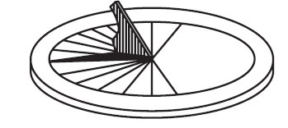
Prompt 1
Your class is studying patterns of shadows. You go outside and observe the position of a shadow at different times of the day. For each observation, you record:
- the position of the sun in the sky
- the position of the shadow of a tree at different times of the day
You stand in the same location for each observation. Figure 1 shows drawings of what you observed.

Part A.
Suppose you are not able to observe the position of the sun and the shadow at 3:00 p.m.
Draw the position of the sun AND the direction and length of the tree’s shadow to show what you would observe at 3:00 p.m. in Figure 1.
Figure 1. Drawing of Observations
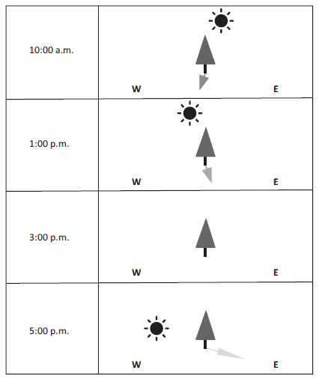

Part B.
The next day, you record the length of the shadow made by a post in the ground at each hour between 9:00 a.m. and 3:00 p.m. The data is shown in Table 1.

Table 1. Shadow Lengths During the Day
y
Time | 9:00 a.m. | 10:00 a.m. | 11:00 a.m. | 12:00 p.m. | 1:00 p.m. | 2:00 p.m. | 3:00 p.m. | 4:00 p.m.
Length of Shadow in Centimeters (cm) | 47 | 43 | 37 | 22 | 35 | 42 | 45 | ?

Graph 1 shows the relationship between the time of day and the length of the post's shadow. The graph shows data collected between 9:00 a.m. and 12:00 p.m.

Complete Graph 1 for 1:00 p.m., 2:00 p.m., and 3:00 p.m. using data from Table 1. Include a bar showing the predicted length of the post's shadow at 4:00 p.m.

Graph 1. Shadow Lengths During the Day

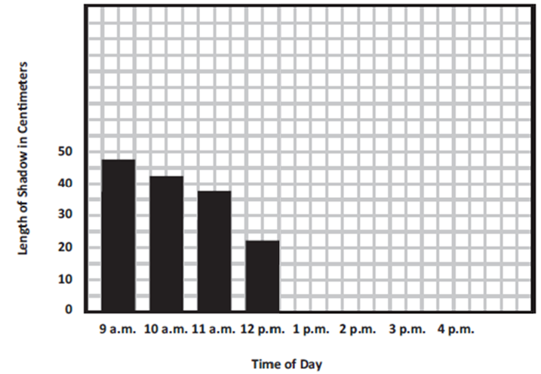

Part C.
Explain how you predicted the length of the shadow at 4:00 p.m.
_____________________________________________________________________________
_____________________________________________________________________________
_____________________________________________________________________________

Part D.
Use the word bank to complete the sentences below. Not all words need to be used and some can be used more than once.
Word Bank
just before sunset | angle | orbit
just after sunrise | long | axis
during the middle of the day | short | distance

- The shortest shadows are seen _________________________________________________.

- The pattern in Graph 1 shows that shadow lengths are ______________________________

in the morning, ______________________ in the afternoon, and then

__________________ again in the evening.

- The length of shadows is caused by the ______________________ of the light from the sun

when it strikes the surface of Earth as Earth rotates on its ___________________________.

Prompt 2
A sundial’s shadow will point north at 12:00 p.m. in the northern middle latitudes. This is true in any season. However, the length and direction of the shadow at other times of the day may vary depending on the season.

Figure 2 shows the position of the sun across the sky during summer and winter in the northern middle latitudes.
Figure 2. Apparent Path of the Sun
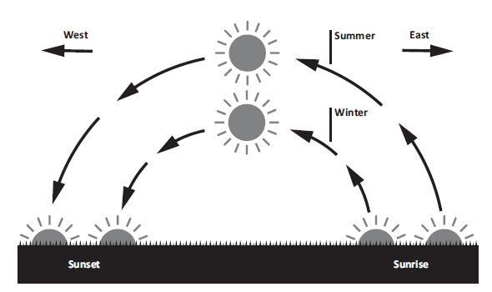
Circle the correct word to complete the sentence.
shorter longer
The length of the shadow on the sundial in the summer will be ___________________ than the length of the shadow in the winter.
Describe what causes the length of the shadow on the sundial to change from summer to winter.
______________________________________________________________________________
______________________________________________________________________________
______________________________________________________________________________
______________________________________________________________________________
______________________________________________________________________________
______________________________________________________________________________

SIPS Grade 5 Unit 4 EOU Assessment Task 1 Rubric (5-ESS1-1, 5-ESS1-2)
Prompt | Score Point 0 | Score Point 1 | Score Point 2 | Score Point 3 | Score Point 4
Prompt 1 Part A.  Scored Responses | No aspect of the response is correct | Response includes one (1) of the three (3) aspects | Response includes two (2) of the three (3) aspects | Response includes the following aspects:  - The sun is further down in the drawing than for the 1:00 p.m. drawing  - The shadow moves to the right (or aligns with the sun)  - The shadow length at 3:00 p.m. is longer than at 1:00 p.m. and shorter than at 5:00 p.m. | NA
Prompt 1  Part B.  Scored Responses | No aspect of the response is correct | Response includes one (1) of the two (2) aspects | Response includes the following aspects:  - Accurate representation for recorded observations at 1:00 p.m., 2:00 p.m., and 3:00 p.m.  - Accurate representation for the predicted observation at 4:00 p.m. | NA | NA
Prompt 1  Part C.  Scored Responses | No aspect of the response is correct | Response includes one (1) of the two (2) aspects | Response includes the following aspects:  - Reasonable prediction within 46 to 52 cm  - Prediction based on an observed pattern in data | NA | NA
Prompt 1  Part D.  Scored Responses | No aspect of the response is correct | Response includes one (1) of the three (3) aspects | Response includes two (2) of the three (3) aspects | Response includes the following aspects:  - Shortest shadows are seen during the middle of the day  - Evidence from Graph 1 shows shadows start long in the morning, get short in the afternoon, then get long again in the evening  - The length of shadows is caused by the angle of the sun’s light striking Earth’s surface as Earth rotates on its axis | NA
Prompt 2  Scored Responses | No aspect of the response is correct | Response includes one (1) of the two (2) aspects | Response includes the following aspects:  - The length of the shadow in the summer will be shorter than the length of the shadow in the winter  - Relates the angle of the sun’s light when it hits Earth’s surface is different in the summer and winter which affects the length of the shadow | NA | NA

Student Exemplars
Student exemplars represent high-quality responses that align to full-point rubric scores. The exemplar responses are intended to assist educators’ understanding of the nature and expectations of each prompt. Note the exemplars serve as examples of high-quality responses, and students may respond with equally relevant, scientifically accurate responses and ideas that meet the expectations of a full-point rubric score.
Prompt 1
Part A.
Draw the position of the sun AND the direction and length of the tree’s shadow to show what you would observe at 3:00 p.m. in Figure 1.
Figure 1. Drawing of Observations
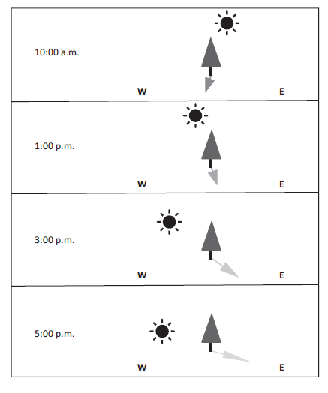

Part B.
Complete Graph 1 for 1:00 p.m., 2:00 p.m., and 3:00 p.m. using data from Table 1. Include a bar showing the predicted length of the post's shadow at 4:00 p.m.
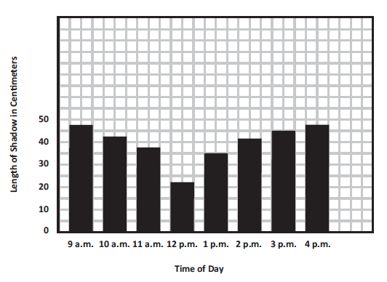
Graph 1. Shadow Lengths During the Day

Part C.
Explain how you predicted the length of the shadow at 4:00 p.m.
The pattern is that from morning until noon, the shadows get shorter. After noon, the shadows get longer. From noon the shadows lengthened by 7 cm and then by 3 cm. So, in the next hour, I predicted the shadow would increase another 3 cm to 48 cm.

Part D.
Use the word bank to complete the following sentences. Not all words need to be used and some can be used more than once.
- The shortest shadows are seen during the middle of the day.

- The pattern shown in Graph 1 shows that shadow lengths are long in the morning, short in the afternoon, and then long again in the evening.

- The length of shadows is caused by the angle of the light from the sun when it strikes the surface of Earth as Earth rotates on its axis.

Prompt 2
Circle the correct word to complete the sentence.
shorter longer
The length of the shadow on the sundial in the summer will be __________ than the length of the shadow in the winter.
Describe what causes the length of the shadow on the sundial to change from summer to winter.
In summer, the sun's path is high above the horizon. In winter, the sun’s path is low on the horizon. So, the length of the shadow at 2:00 p.m. during the summer would be shorter than the shadow at 2:00 pm during the winter. This is because, in winter, the angle of the sunlight hitting Earth’s surface is lower which makes the sundial’s shadow longer.

SIPS Grade 5 Unit 4 EOU Assessment Task 2: Meet the Beetles!

Student Worksheet

This task is about stars in the night sky.

Task
Long ago, humans traveled across Earth’s oceans. Maps and compasses were not invented. So, early sailors relied on the locations of stars and constellations to steer their ships.
Organisms on Earth, both humans and animals, use stars to know which way to go. Dung beetles are insects that travel by the stars. How do travelers use the locations of stars to know which way to go?
Prompt 1
On Earth, we experience repeating periods of day and night. At night, the sky is filled with stars, planets, and constellations.
Figure 1 shows the position of a constellation, the Big Dipper, in the night sky during different times of the year in the Northern Hemisphere. Each view is from the same location on Earth in each of the four seasons: winter, spring, summer, and fall.
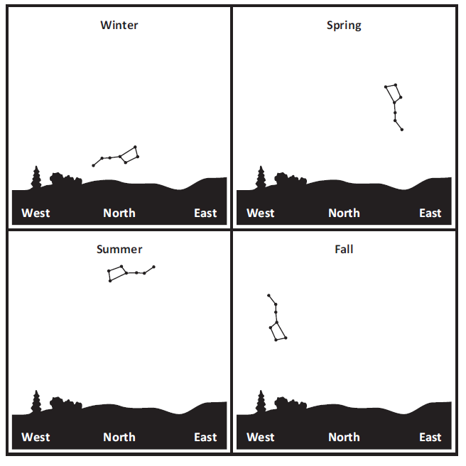
Figure 1. Positions of the Big Dipper in Different Seasons
Describe the pattern of movement of the position of the Big Dipper in the night sky. Use information from Figure 1.
_____________________________________________________________________________
_____________________________________________________________________________
_____________________________________________________________________________
Explain why the position of the Big Dipper appears to move in the night sky during the year.
_____________________________________________________________________________
_____________________________________________________________________________
_____________________________________________________________________________
_____________________________________________________________________________
_____________________________________________________________________________

Prompt 2
Part A.
Stars are so far away that a measure of distance, called light years, is used to describe their distances from Earth. One light year is equal to how far light can travel in one year.
Table 1 shows the distances and brightness of stars. Brightness from Earth is defined as how bright the star appears as viewed from Earth. Actual Brightness is how bright the star is from a fixed point of 33 light years away from Earth.
Table 1. Distance and Brightness of Stars
Star | Distance from Earth  (light-year) | Brightness from Earth | Actual Brightness
Sirius | 8.6 | -1.5 | 1.4
Sun | <1 | -26.7 | 4.8
Procyon | 11 | 0.3 | 2.7
Rigel | 860 | 0.1 | -8.1
Castor | 52 | 1.6 | 0.6
Pollux | 34 | 1.2 | 1.1
The values in Table 1 include negative numbers. Negative numbers are less than zero and have a negative sign (-) in front of them. Numbers greater than zero are called positive numbers.
Brighter stars have smaller values than dim stars. As values become larger, the star’s light gets dimmer. For example, the star Sirius (-1.4) is brighter than Castor (1.6) when seen from Earth’s night sky.
Castor
Sirius
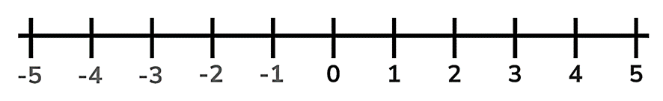
Brighter
Dimmer

Use Table 1 to order the stars from brightest to dimmest as seen from Earth.

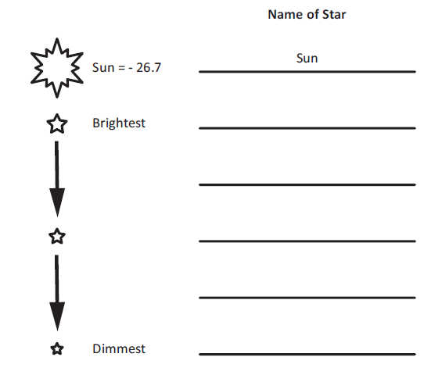
= - 26.7

Part B.
A student makes the following claim:
A star with greater actual brightness will always appear brighter than a star with less actual brightness when viewed from Earth.

Circle if you agree or disagree with the claim. Include evidence from Table 1 to support your response.
Evidence
Agree
Disagree

Part C.
Another student makes the following claim:
A star that is closer to Earth will always appear brighter than a star that is farther away when viewed from Earth.

Circle if you agree or disagree with the claim. Include evidence from Table 1 to support your response.
Evidence
Agree
Disagree

Prompt 3
At nighttime, a dung beetle feeds on animal dung. After finding a fresh pile of dung, the dung beetle must roll a small ball of dung away from other beetles so it does not get stolen. The safest way to protect its ball is to roll it away in a straight path in a short amount of time.
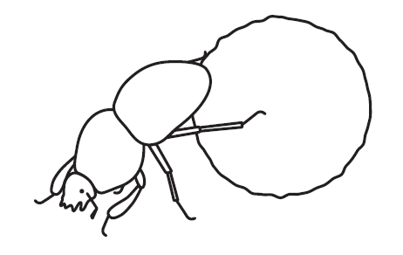
Table 2 shows how well the beetles are able to roll a dung ball to their nest during different conditions of the night sky.
Table 2. Results of Dung Beetle Observations
Conditions of the Night Sky | Do dung beetles roll their dung balls in a straight path?
When the sky is clear with many visible stars | Yes
When the sky is cloudy with no visible stars | No
When the night is moonless with many visible stars | Yes
When the moon is full and bright with few visible stars | No

Describe how dung beetles are able to roll a dung ball in a straight path at night. Use two pieces of evidence from Table 2 to support your answer.
_____________________________________________________________________________
_____________________________________________________________________________
_____________________________________________________________________________
_____________________________________________________________________________
_____________________________________________________________________________
_____________________________________________________________________________

SIPS Grade 5 Unit 4 EOU Assessment Task 2 Rubric (5-ESS1-1, 5-ESS1-2)
Prompt | Score Point 0 | Score Point 1 | Score Point 2 | Score Point 3 | Score Point 4
Prompt 1  Scored Responses | No aspect of the response is correct | Response includes one (1) of the two (2) aspects | Response includes the following aspects:  - Describes the pattern of movement as counter-clockwise during the year  - Explains how constellations can change positions and/or appear only at certain times of the year due to the Earth’s orbit around the sun | NA | NA
Prompt 2  Part A.  Scored Responses | No aspect of the response is correct | Response includes at least three (3) of the five (5) stars in the correct order | Response includes the following aspects:  - Places the apparent brightness of all five (5) stars in the correct order | NA | NA
Prompt 2  Part B. & Part C.  Scored Responses | No aspect of the response is correct | Response includes one (1) of the four (4) aspects | Response includes two (2) of the four (4) aspects | Response includes three (3) of the four (4) aspects | Response includes the following aspects:  Part B  - Disagrees with the claim  - Explains how the absolute or actual brightness of a star can “appear” different when viewed from Earth (e.g., the sun compared to Rigel) based on data from Table 1  Part C  - Disagrees with the claim  - Explains how the apparent brightness of a star may appear dimmer from Earth than a star that is ‘actually’ brighter (e.g., Rigel is brighter than the sun but appears dimmer from Earth) based on data from Table 1
Prompt 3  Scored Responses | No aspect of the response is correct | Response includes one (1) of the three (3) aspects | Response includes two (2) of the three (3) aspects | Response includes the following aspects:  - The beetles use positions of the stars in the night sky to roll a dung ball in a straight path at night OR beetles use constellations to track their own movements at night  - Evidence includes cloudy conditions when the effectiveness of dung rolling is decreased  - Evidence includes moonless conditions when the effectiveness of dung rolling is increased | NA

Student Exemplars
Student exemplars represent high-quality responses that align to full-point rubric scores. The exemplar responses are intended to assist educators’ understanding of the nature and expectations of each prompt. Note the exemplars serve as examples of high-quality responses, and students may respond with equally relevant, scientifically accurate responses and ideas that meet the expectations of a full-point rubric score.
Prompt 1
Describe the pattern of movement of the position of the Big Dipper in the night sky. Use information from Figure 1.
The big dipper moves counter-clockwise in its position in the sky from the seasons of winter, spring, summer, and fall.
Explain why the Big Dipper appears to move its position in the night sky during the year.
The place in the night sky where the Big Dipper appears is due to the change in Earth’s position at different times of the year depending on where Earth is in its orbit around the sun. Some constellations can be seen in the sky all year while others appear only at certain times of the year.

Prompt 2

Part A.
Use Table 1 to order the stars from brightest to dimmest as seen from Earth.
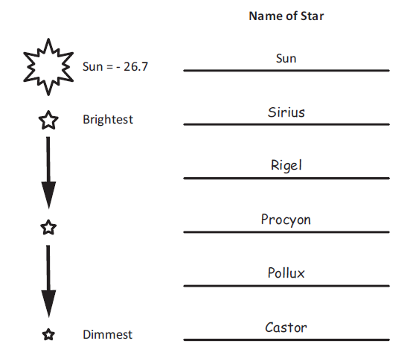

Part B.
Circle if you agree or disagree with the claim. Include evidence from Table 1 to support your response.
 | Evidence
Agree | I disagree with the claim because the sun appears to us as the brightest star (-26.7), but the actual brightness of the sun is the dimmest (4.2) of the six stars.
Disagree

Part C.
Circle if you agree or disagree with the claim. Include evidence from Table 1 to support your response.
 | Evidence
Agree | I disagree. Rigel is 860 light-years away from Earth but is much brighter in the night sky than Pollux which is 34 light-years away from Earth.
Disagree

Prompt 3
Describe how dung beetles are able to roll a dung ball in a straight path at night. Use two pieces of evidence from Table 2 to support your answer.
The dung beetles work at night, so they must be using the stars in the night sky somehow. I think this because the study shows they could not roll the ball in a straight path if it is cloudy. Also, on a moonless night, when stars are easier to see, they are able to move the dung ball away in a straight path faster.

SIPS Grade 5 Unit 4 EOU Assessment Task 3: Turn, Turn, Turn

Student Worksheet

This task is about calendars.

Task
People in ancient times developed calendars to keep track of days and seasons. By counting days, they could predict patterns of changes in the weather. They used these patterns to decide when to plant crops and predict when winter would come. What patterns can be used to predict seasons?
Prompt 1
On Earth, the rising and setting of the sun are quite predictable.
Table 1 shows the approximate sunrise and sunset times in a U.S. city during the year 2022. The length of the day is calculated by finding the number of hours and minutes between sunrise and sunset.
Table 1. Sunrise, Sunset, and Length of Day for a U.S. City in 2022
(H = Hours; M = Minutes)
Date | Jan 1 | Feb 1 | Mar 1 | Apr 1 | May 1 | Jun 21 | Aug 1 | Sept 1 | Oct 1 | Nov 15 | Dec 21
Length of Day | 9 H  30 M | 10 H 15 M | 11 H 20 M | 11 H 40 M | 13 H 50 M | 14 H 55 M | 14 H 10 M | 13 H | 11 H 50 M | 10 H  5 M | 9 H  20 M

Table 2 shows the date when each of the four seasons begins in 2022.
Table 2. Beginning Date of Seasons in 2022
Season | Date
Spring | March 20, 2022
Summer | June 21, 2022
Fall | September 22, 2022
Winter | December 21, 2022

Compare a pattern in the length of daylight during the year for two seasons. Include data from Table 1 and Table 2.
_____________________________________________________________________________
_____________________________________________________________________________
_____________________________________________________________________________
_____________________________________________________________________________
_____________________________________________________________________________

Prompt 2
Earth revolves around the sun, creating the predictable pattern of the seasons. The moon creates another predictable pattern as it revolves around Earth.
Part A.
People can observe four main phases of the moon (New Moon, First Quarter, Full Moon, Last Quarter) as the moon revolves around Earth.

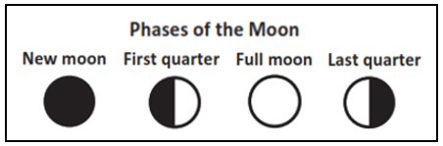

Table 3 shows the dates of each phase of the moon.
Table 3. Moon Phases for January through March 2022
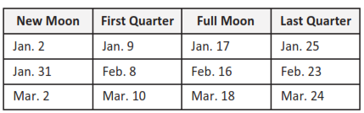

Use the dates in Table 3 to draw the moon phases (New Moon, First Quarter, Full Moon, Last Quarter) in Figure 2. The moon phases for the first row of dates in Table 3 are shown in Figure 2.
Figure 2. 2022 Calendar
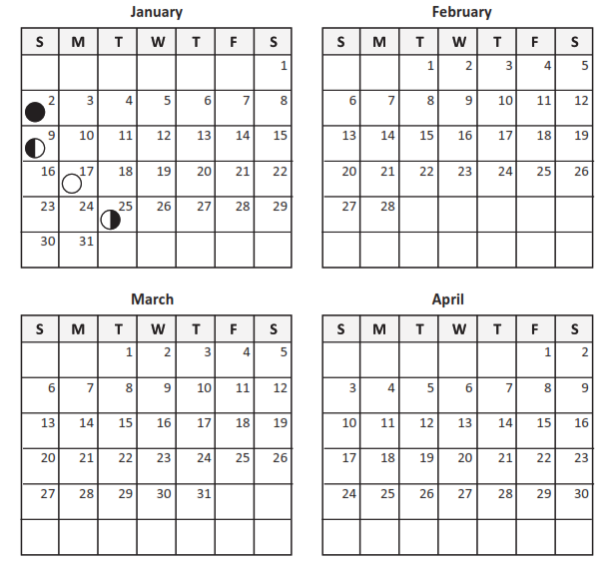Part B.

Predict the dates of the next New Moon, First Quarter, Full Moon, and Last Quarter in Table 4. Use information from your completed Figure 2 to support your prediction.
Table 4. Dates of Moon Phases
New Moon | First Quarter | Full Moon | Last Quarter
Part C.
A student makes the following claim:
If I see a full moon on the first day of the month in October, I will see the next full moon on the first day of November.

Circle one of the following:
I agree with the claim. I disagree with the claim.
Support your answer using evidence from Table 3 and Figure 2.
_____________________________________________________________________________
_____________________________________________________________________________
_____________________________________________________________________________
_____________________________________________________________________________

Prompt 3
Earth’s gravity pulls all of Earth's mass toward its center. So, due to gravity, Earth maintains its spherical shape.
How can a lunar eclipse provide evidence that Earth is shaped like a sphere?
_____________________________________________________________________________
_____________________________________________________________________________
_____________________________________________________________________________
_____________________________________________________________________________
_____________________________________________________________________________
_____________________________________________________________________________
_____________________________________________________________________________
_____________________________________________________________________________

SIPS Grade 5 Unit 4 EOU Assessment Task 3 Rubric (5-ESS1-1, 5-ESS1-2, 5-PS2-1)
Prompt | Score Point 0 | Score Point 1 | Score Point 2 | Score Point 3 | Score Point 4
Prompt 1  Scored Responses | No aspect of the response is correct | Response includes one (1) of the three (3) aspects | Response includes two (2) of the three (3) aspects | Response includes the following aspects:  - Applies the dates from Table 2 to determine the pattern in daylengths from Table 1 to the appropriate seasons  - Describes the general pattern of the changing length of daylight throughout the year  - Describes or compares the length of day between at least two (2) seasons | NA
Prompt 2  Part A. & Part B.  Scored Responses | No aspect of the response is correct | Response includes the following aspects:  Part A  - At least one (1) of the eight (8) moon phases is shown on a date that is one (1) more or one (1) less than the dates shown in the exemplar  OR  Part B  - One (1) of the four (4) predicted dates that may be up to two (2) more or up to two (2) less than the dates shown in the exemplar | Response includes the following aspects:  Part A  - At least four (4) of the eight (8) moon phases are shown on a date that is one (1) more or one (1) less than the dates shown in the exemplar  AND  Part B  - Two (2) of the four (4) predicted dates that may be up to two (2) more or up to two (2) less than the dates shown in the exemplar | Response includes the following aspects:  Part A  - At least six (6) of the eight (8) moon phases are shown on dates that are one (1) more or one (1) less than the dates shown in the exemplar  AND  Part B  - Three (3) of the four (4) predicted dates that may be up to two (2) more or up to two (2) less than the dates shown in the exemplar | Response includes the following aspects:  Part A  - Correct placement of the moon phases on the calendar for eight (8) dates that are one (1) more or one (1) less than the dates shown in the exemplar  AND  Part B  - Correct prediction of the dates of the moon phases for four (4) dates that may be up to two (2) more or up to two (2) less than the dates shown in the exemplar
Prompt 2  Part C.  Scored Responses | No aspect of the response is correct | Response includes one (1) of the two (2) aspects | Response includes the following aspects:  - Disagrees with the claim  - Refers to Table 3 and/or Figure 2 | NA | NA
Prompt 3  Scored Responses | No aspect of the response is correct | Response includes one (1) of the two (2) aspects | Response includes the following aspects:  - Statement of the arrangement of the sun, Earth, and moon during a lunar eclipse  - Explains how the curved shape of Earth’s shadow on the moon is evidence the Earth is a sphere | NA | NA

Student Exemplars
Student exemplars represent high-quality responses that align to full-point rubric scores. The exemplar responses are intended to assist educators’ understanding of the nature and expectations of each prompt. Note the exemplars serve as examples of high-quality responses, and students may respond with equally relevant, scientifically accurate responses and ideas that meet the expectations of a full-point rubric score.
Prompt 1
Compare a pattern in the length of daylight during the year for two seasons. Include data from Table 1 and Table 2.
Table 1 shows the length of daylight increases after January and then begins decreasing after June 21. Comparing summer to winter, the length of daylight decreases from over 14 hours on June 21 to only 9 hours on December 21. So, there are longer days in the summer and shorter days in the winter.

Prompt 2
Part A.
Use the dates in Table 3 to draw the moon phases (New Moon, First Quarter, Full Moon, Last Quarter) in Figure 2. The moon phases for the first row of dates in Table 3 are shown in Figure 2.
Figure 2. 2022 Calendar
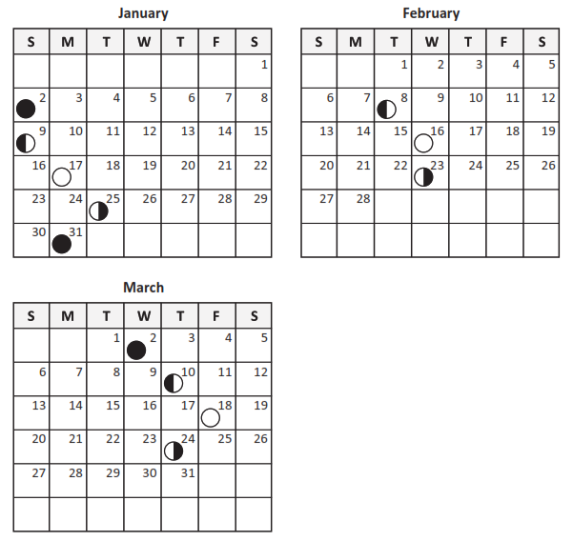
Part B.
Predict the dates of the next New Moon, First Quarter, Full Moon, and Last Quarter in Table 4. Use information from your completed Figure 2 to support your prediction.
Table 4. Dates of Moon Phases
New Moon | First Quarter | Full Moon | Last Quarter
Apr. 1 | Apr. 9 | Apr. 16 | Apr. 23

Part C.
Circle one of the following:
I agree with the claim. I disagree with the claim.
Support your answer using evidence from Table 3 and Figure 2.
I disagree with the claim because the cycle of moon phases repeats approximately every 28 or so days. If you count the days on the calendar or in the table, it is never exactly one calendar month. It is close to a month but not exactly.

Prompt 3
How can a lunar eclipse provide evidence that Earth is shaped like a sphere?
A lunar eclipse occurs when the sun, Earth, and moon align so that the Moon passes into Earth’s shadow. As the moon begins to cross in the path of Earth’s shadow, you can see the shadow is curved. So, we know that the Earth is a sphere.

